Employability Skills
linked with…
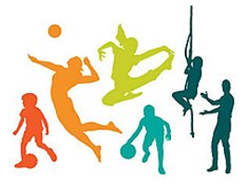
Sport
Communication | Leadership
Presentation skills | Time management and planning
Research and data analysis | Understanding of human body & nutrition
Decision-making and problem-solving skills | Verbal & written communication
Team building ability | Inspire others to exercise
Self-motivation | Determination to succeed
For further information please visit:
- nationalcareers.service.gov.uk/explore-careers
- prospects.ac.uk/job-profiles

