Employability Skills linked with…
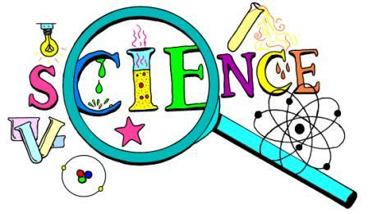
Research & evaluation | Analytical thinking & problem solving
Scientific & technical knowledge | Data-handling skills
IT & computer literate | Communication – report writing & presentations
Self-reliance & working on initiative | Organisation & time-management
Creative thinking | Construct logical arguments
Practical skills – using technical equipment | Teamworking & project management skills

For further information please visit:
- nationalcareers.service.gov.uk/explore-careers
- prospects.ac.uk/job-profiles

