Employability Skills
linked with…
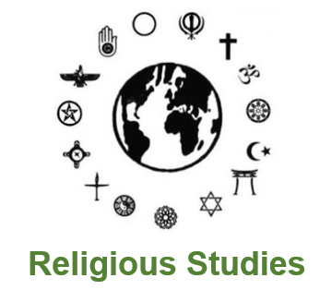
Religious Studies
Interpret information & formulate questions | Critical & analytical skills
Self-awareness & initiative | Appreciate different perspectives & take on board others' views
Creativity | Empathy and cultural sensitivity
Work methodically and accurately | Research & analysis
Able to build & develop a persuasive argument | Good time management
Strong writing skills | Methodical & accurate
For further information please visit:
- nationalcareers.service.gov.uk/explore-careers
- prospects.ac.uk/job-profiles

