Employability Skills linked with…
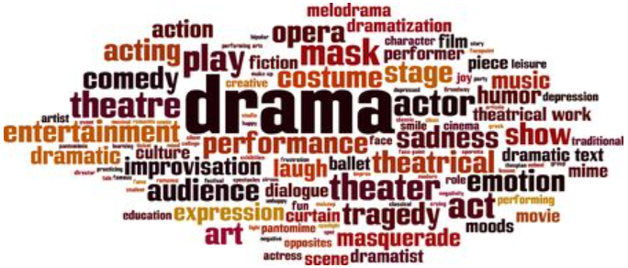
Collaboration & communication | Take direction & listen to instructions
Organised & good time-management | Confidence
Experiment with different ideas | Research and analysis
Innovative & creative thinking | Excellent presentation skills
Self-reflective | Resilience
Flexibility | Open-minded & experimental

