Employability Skills linked with…
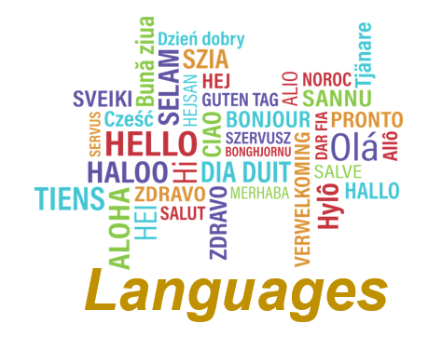
Languages
Social, cultural and global awareness | Assess and interpret information
Good verbal and written communication | Adapt to new situations
Lead and participate in group discussions | Organised and work to deadlines
Develop opinions and propose ideas | Pick out essential points from text
Self-motivation | Critical thinking
Research | Problem solving

