Employability skills linked with…
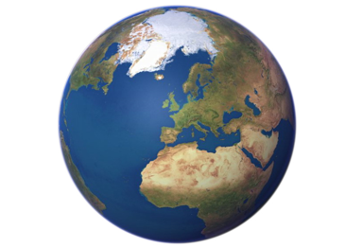
Geography
Research and present data | Analysis and evaluation
IT skills including databases and spreadsheets | Good communication
Planning and problem-solving | Self-motivated
Time management | Ability to meet deadlines
Project management | Use available resource to capture and extract information

