Employability Skills linked to…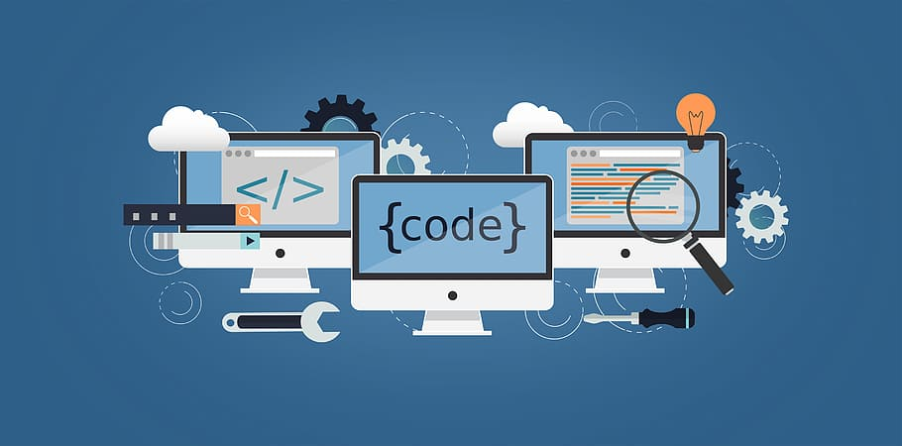
Computer Science
Confident IT user | Critically evaluating
Problem solving | Reflection and communication
Evaluation and testing | Analysing
Design and implementation | Understanding of various theories
Analytical thinking | Creating and understanding code
Confident in operating computer equipment | Decision making
Teamwork | Good communication
Self-management | Adaptability

