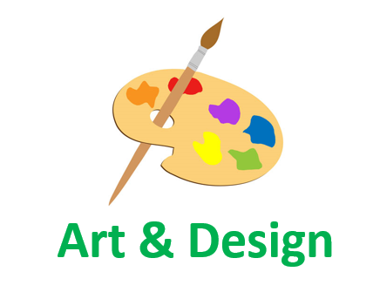
Employability Skills linked to…

Art & Design
Research | Self-motivation
Making connections | Using intuition
Wondering & questioning | Exploring & investigating
Challenging assumptions | Tolerating uncertainty
Daring to be different | Sharing the product
Cooperating | Reflecting critically
Developing techniques/strategies | Crafting and improving
Adaptability | Patience

