Employability Skills

linked with…

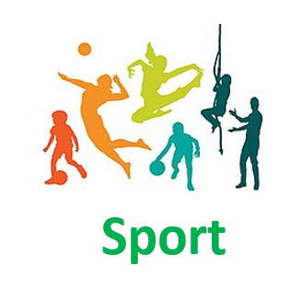

***Sport***

|  |  |
| --- | --- |
| **Communication** | **Leadership** |
| **Presentation skills** | **Time management and planning** |
| **Research and data analysis** | **Understanding of human body & nutrition** |
| **Decision-making and problem-solving skills** | **Verbal & written communication** |
| **Team building ability** | **Inspire others to exercise** |
| **Self-motivation** | **Determination to succeed** |

For further information please visit:

* nationalcareers.service.gov.uk/explore-careers
* prospects.ac.uk/job-profiles