Employability Skills linked with…

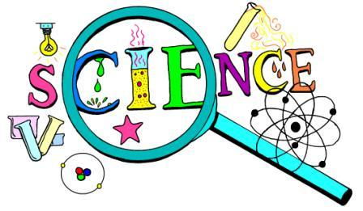

|  |  |
| --- | --- |
| **Research & evaluation** | **Analytical thinking & problem solving** |
| **Scientific & technical knowledge** | **Data-handling skills** |
| **IT & computer literate** | **Communication – report writing & presentations** |
| **Self-reliance & working on initiative** | **Organisation & time-management** |
| **Creative thinking** | **Construct logical arguments** |
| **Practical skills – using technical equipment** | **Teamworking & project management skills** |

For further information please visit:

* nationalcareers.service.gov.uk/explore-careers
* prospects.ac.uk/job-profiles