Employability Skills linked with…

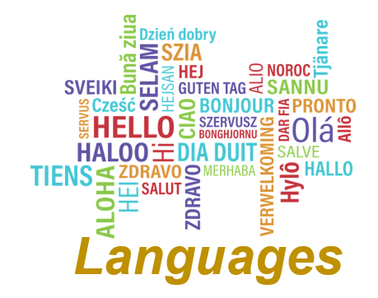

***Languages***

|  |  |
| --- | --- |
| **Social, cultural and global awareness** | **Assess and interpret information** |
| **Good verbal and written communication** | **Adapt to new situations** |
| **Lead and participate in group discussions** | **Organised and work to deadlines** |
| **Develop opinions and propose ideas** | **Pick out essential points from text** |
| **Self-motivation** | **Critical thinking** |
| **Research** | **Problem solving** |