Employability skills linked with…

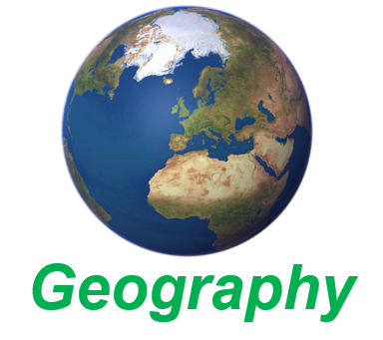

***Geography***

|  |  |
| --- | --- |
| **Research and present data** | **Analysis and evaluation** |
| **IT skills including databases and spreadsheets** | **Good communication** |
| **Planning and problem-solving** | **Self-motivated** |
| **Time management** | **Ability to meet deadlines** |
| **Project management** | **Use available resource to capture and extract information** |