Employability Skills linked to…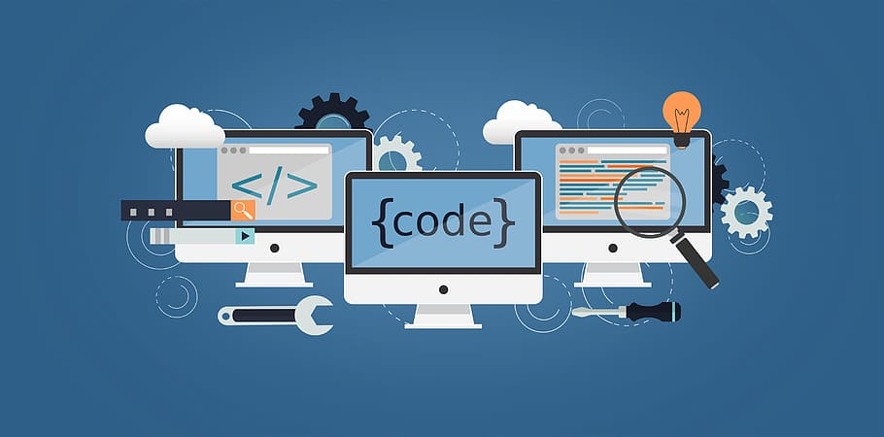

***Computer Science***

|  |  |
| --- | --- |
| **Confident IT user** | **Critically evaluating** |
| **Problem solving** | **Reflection and communication** |
| **Evaluation and testing** | **Analysing** |
| **Design and implementation** | **Understanding of various theories** |
| **Analytical thinking** | **Creating and understanding code** |
| **Confident in operating computer equipment** | **Decision making** |
| **Teamwork** | **Good communication** |
| **Self-management** | **Adaptability** |