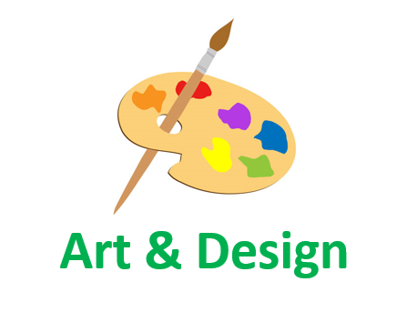Employability Skills linked to…

**Art & Design**

|  |  |
| --- | --- |
| **Research** | **Self-motivation** |
| **Making connections** | **Using intuition** |
| **Wondering & questioning** | **Exploring & investigating** |
| **Challenging assumptions** | **Tolerating uncertainty** |
| **Daring to be different** | **Sharing the product** |
| **Cooperating** | **Reflecting critically** |
| **Developing techniques/strategies** | **Crafting and improving** |
| **Adaptability** | **Patience** |