[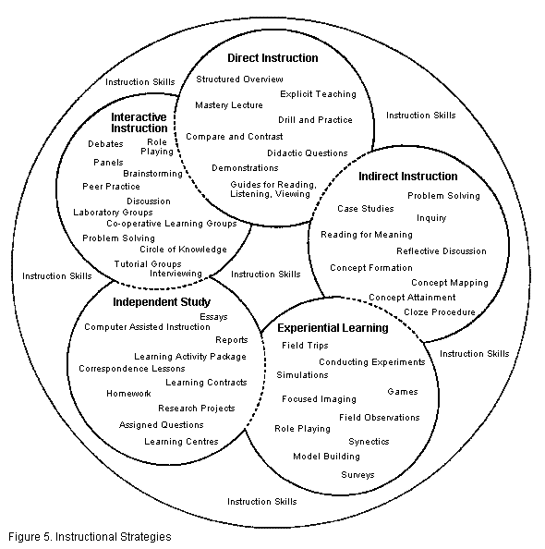](http://www.sasked.gov.sk.ca/docs/policy/approach/instrapp03.html#strategies)