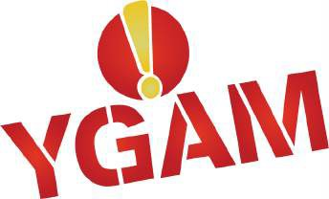

In The Know
Building Resilience Around Gambling and Gaming-Related Harms

Delegate Workshop Booklet

© YGAM 2020. ALL RIGHTS RESERVED

In The Know | Delegate Workshop Booklet 2

“The workshop will not only help in my work life but also in my personal life.

— MIDDLESBROUGH DELEGA TE
In The Know | Delegate Workshop Booklet 3

Welcome!

Thank you for attending a YGAM workshop. This booklet is here to help you to inform, educate and safeguard the young people you work with, enabling them to develop resilience and understand the potential harms caused by gaming and gambling.

Anyone who works directly with young people (7-25) can use this booklet and the accompanying online resources which have been developed by professionals.

A guide to using this book

We offer a pick-and-mix approach where you can choose from a selection of challenges that can be embedded into your programme. We have provided 30 shorter but impactful tasks and 30 richer tasks which require greater levels of application from the learner.

Many of the challenges can be mapped to the Wider Key Skills at Levels 1, 2 and 3 – Working With Others and
Performance, Improving Own Learning and Problem Solving.

For teachers, the challenges also present opportunities for cross-curricular learning.

Throughout the book, our different challenges are colour-coded to match with specific skill sets. See the guide
below for how this works:

RED BLUE GREEN ORANGE YELLOW

Leadership & Teamwork
Learning & Sharing
Creative Thinking & Exploration
Research &
Presentation
Preparation & Discussion

These colour-coded challenges are available at two different levels of learning:

Short High-impact Challenges Greater Depth Challenges

These are short, impactful tasks which can be completed in one to two hours and are perfect for an introduction to the topic.
You can find all these in the table of contents
to the right.
These are longer tasks which you may wish to deliver as part of a project over several
days or a term, designed at an advanced level for consistent reinforcement and sustained embedding of learning. You can find all these in the table of contents to the right.

This workbook is subject to Copyright by YGAM 2020. All rights reserved. No part of this publication may be reproduced, stored in a retrieval system, or transmitted, in any form or by any means, (electronic, mechanical, photocopying, recording or otherwise) without prior permission from the Young Gamers and Gamblers Education Trust. No income should be generated from this workbook or from attendance at our workshops.

4 In The Know | Delegate Workshop Booklet

Table of Contents

YGAM ACTIVITIES: Short High-impact Challenges
Why People Gamble/Game 8
Probability & Luck 9
The Gambling Industry 10
The Gaming Industry 11
Money & Debt 12
Addiction & Mental Health 13
YGAM ACTIVITIES: Greater Depth Challenges
Why People Gamble/Game 16
Probability & Luck 17
The Gambling Industry 18
The Gaming Industry 19
Money & Debt 20
Addiction & Mental Health 21
Primary School Curriculum & Challenges
Student Activities 26
Discussion Points 27
Parent & Carer Resources
School/Parent Focus 30
Family Activities 31
Meeting OFSTED Requirements
Personal Development, Welfare and Behaviour 34
Principles of Effective PSHE Education
Meeting the Principles 38
Teacher & Practitioner Guidance
About our Curriculum 42
Signposting and Help
Getting Help with Problem Gambling 43
www.ygam.org
FIND ALL OF OUR RESOURCES ONLINE AT
ygam.org

Now that you have attended a YGAM workshop, you will have been given your own unique login so that you can access all of our resources online.
On the homepage at ygam.org, click on “YGAM Resources” and you’ll be asked to login. Once there, you’ll be able to access a collection of different teaching resources that will enable
you to deliver the YGAM programme successfully in your organisation.
Please record your username and password here, once you’ve received it, for safekeeping:

Username:

Password:

If you have any problems logging in, please contact us at admin@ygam.org

5

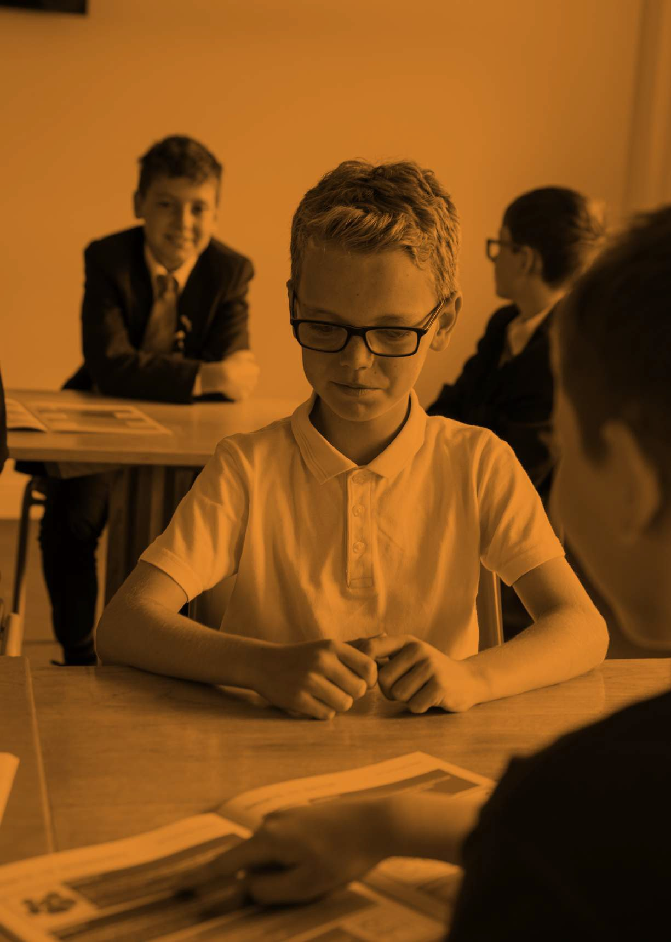
6 In The Know | Delegate Workshop Booklet

In The Know | Delegate Workshop Booklet 7
Short High-impact Challenges

Short High-impact Challenges: Why People Gamble/Game

YGAM Activities

Challenge 1.1:
As a group create and develop a short awareness project around the theme of ‘Why People Gamble’ and/or ‘Why People Game’ with a focus on your own centre, school or college. Create publicity materials or a short video to show your work.

English National Curriculum Links: PSHE, English Language, Computing

Challenge 1.2:
Consider the motivations of young people who game or gamble and potential risks involved. Carry out a series of interviews or conduct a questionnaire to explore the motivations of your class/school/youth group. Create learning materials to demonstrate your findings.

English National Curriculum Links: PSHE, English

Challenge 1.3:
Create a leaflet which focuses on why people gamble and/or game. You could look at different areas of gambling and/or gaming. Provide information which will inform, educate and safeguard young people with respect to this.

English National Curriculum Links: PSHE, English

Challenge 1.4:
Design a questionnaire to find out why some young people begin gambling and/or gaming and whether it is a significant issue in your centre, school or college. Collect data and statistics and prepare a written or spoken report on your findings.

English National Curriculum Links: PSHE, Mathematics, English

Challenge 1.5:
Following some preparation on the subject, discuss how and why some young people become involved in gambling and/or gaming. Produce a wall display to show
your findings. Consider the risks and make note of how and where people can get help.

English National Curriculum Links: PSHE, English

8 In The Know | Delegate Workshop Booklet

Short High-impact Challenges: Probability & Luck

YGAM Activities

Challenge 2.1:
As a group, design a project around the key ideas of probability and luck. Treat the project as a short investigation or experiment to test a hypothesis. Record your answers, analyse the data and publish your findings in a report which can be shared.

English National Curriculum Links: PSHE, Mathematics, English

Challenge 2.2:
Learn about the rules of probability and create a lesson plan for a teacher or tutor which helps express the basic principles to younger learners, as part of a Mathematics process. Try to make your lesson original and interesting.

English National Curriculum Links: PSHE, Mathematics

Challenge 2.3:
Design and carry out a coin toss or card game to test the rules of probability. Record the rules of play and analyse the odds of different outcomes within the game.

English National Curriculum Links: PSHE, Mathematics

Challenge 2.4:
It is often said that ‘the House always wins’ in gambling. But what does this actually mean? Create a digital presentation to share with the rest of your group.

English National Curriculum Links: PSHE, Mathematics

Challenge 2.5:
Find out how casinos work and discuss as a group why they can be so popular. What are the key dangers faced by young people with regard to the probability of their winning? Record your group findings on a grid and share with others.

English National Curriculum Links: PSHE, Mathematics, English

www.ygam.org 9

Short High-impact Challenges: The Gambling Industry
YGAM Activities

Challenge 3.1:
As a group, prepare a leaflet or poster which looks at the potential risks to young people accessing the gambling market. Discuss your content as a group and decide on the best way of presenting this information.

English National Curriculum Links: PSHE, English

Challenge 3.2:
How much money does the online gambling market make each year? Where does the
money go? Share your findings.

English National Curriculum Links: PSHE, Mathematics, Computing

Challenge 3.3:
How does gambling advertising work? Investigate several leading brands and find out about the processes involved. How have things changed over time? Share your findings using photographs and/or diagrams.

English National Curriculum Links: PSHE, Design Technology, Computing, Mathematics

Challenge 3.4:
Whose responsibility is it to safeguard people in relation to gambling. Consider, self, family, media, marketing, gambling industry, financial institutions and any other organisations who may have a role to play.

English National Curriculum Links: PSHE, English, Mathematics

Challenge 3.5:
How has the internet changed our view of the gambling industry? How has it changed the way people gamble? Research some views from appropriate sources. Make a short film to share with others.

English National Curriculum Links: PSHE, Computing

10 In The Know | Delegate Workshop Booklet

Short High-impact Challenges: The Gaming Industry

YGAM Activities

Challenge 4.1:
How is Social Media used to influence young people’s attitudes and behaviours around gaming? Share your findings.

English National Curriculum Links: PSHE, English, Business Studies

Challenge 4.2:
How much does the gaming industry spend on advertising? What methods are used to ensure players continue to purchase the latest titles/items?

English National Curriculum Links: PSHE, Business Studies

Challenge 4.3:
Invent/create an idea for a safe or cost free game which will be attractive to young people. Think about aspects of safety and responsible behaviour in your design.

English National Curriculum Links: PSHE, Computing

Challenge 4.4:
Build a survey, focussing on the games young people play. How much time do they spend
on these? Do they pay to play? Present findings.

English National Curriculum Links: PSHE, English, Mathematics

Challenge 4.5:
Gaming is a sociable and inclusive activity that comes without risk. Debate.

English National Curriculum Links: PSHE, English, Computing

www.ygam.org 11

Short High-impact Challenges: Money & Debt
YGAM Activities

Challenge 5.1:
Write and perform a five-minute drama around debt brought on by gambling problems for a young person or young people. You can base this on money and debt issues or other appropriate financial problems.

English National Curriculum Links: PSHE, English, Drama

Challenge 5.2:
Create a vocabulary list which is centred around key aspects of money and debt. Use the internet or other source to compile a list of 25 key words. Explain your list to a partner using your own understanding and definitions.

English National Curriculum Links: PSHE, Computing, English

Challenge 5.3:
Consider the average amount of money spent on gambling by 11-16 year olds. How else
could this money be spent? Set yourself a short-term and long-term financial plan.

English National Curriculum Links: PSHE, Mathematics

Challenge 5.4:
What are the immediate risks of getting into debt? How can you protect yourself and how can others help?

English National Curriculum Links: PSHE

Challenge 5.5:
How would a gaming or gambling debt impact on your future life aspirations? You will need to consider the challenges and restrictions that may arise from debt. Try to relate these to your own goals and aspirations. You may consider employment, buying a car or a house.

English National Curriculum Links: PSHE, Mathematics, English

12 In The Know | Delegate Workshop Booklet

Short High-impact Challenges: Addiction & Mental Health YGAM Activities

Challenge 6.1:
Research mental health issues around gaming and gambling to make a video, highlighting the key issues and identify where people can go to get help.

English National Curriculum Links: PSHE, Computing

Challenge 6.2:
Choose 10 images you associate with gaming and/or gambling addiction, mental health issues and social problems. Create a collage and share your thoughts, use key words to support your images.

English National Curriculum Links: PSHE, English

Challenge 6.3:
Design an awareness campaign on how to spot the signs of gaming and/or gambling addiction. This could range from a simple poster to a more substantial booklet or presentation. Create a slogan, image and message which you think is most helpful.

English National Curriculum Links: PSHE, Art, English

Challenge 6.4:
Define addiction. Why might a young person develop addictive behaviours that are linked
to gaming and/or gambling addiction(s)? How does it affect different health aspects?
Research these areas and find a case study to support your findings.

English National Curriculum Links: PSHE

Challenge 6.5:
What measures are currently in place to protect people from gambling and/or gaming- related harms? Create a support tool that young people can access in order to gain help and guidance. You may wish to create a video or write an article for the school newspaper/newsletter

English National Curriculum Links: PSHE, English

www.ygam.org 13

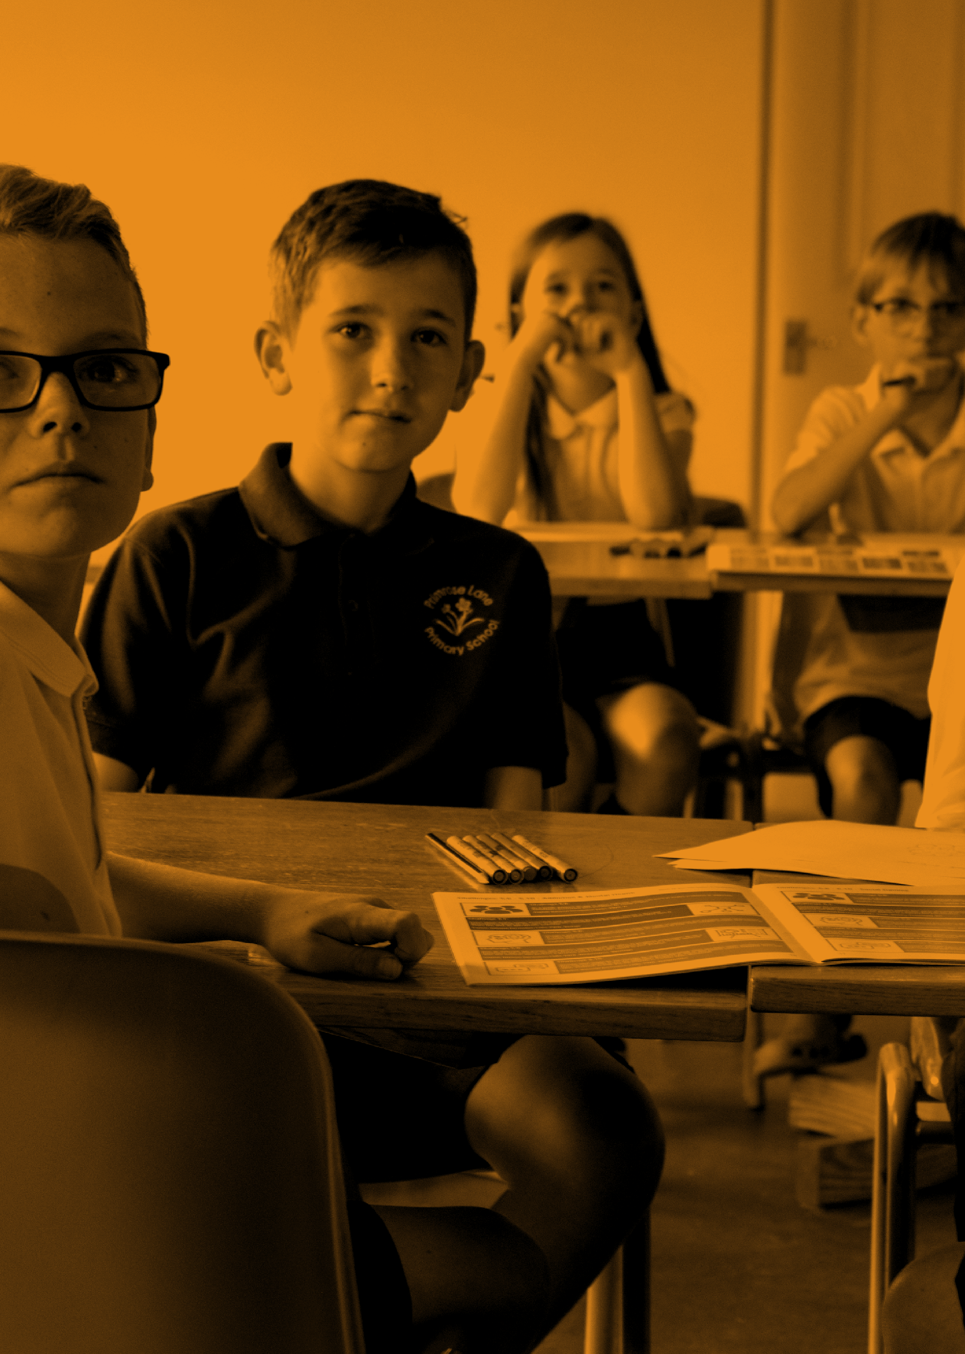

“Excellent workshop, would highly recommend. Will 100% use resources across KS2, 3 and 4 throughout PSHE and Tutor time.

— NEWCASTLE DELEGA TE
In The Know | Delegate Workshop Booklet 14

In The Know | Delegate Workshop Booklet 15
Greater Depth Challenges

Greater Depth Challenges: Why People Gamble/Game YGAM Activities

Challenge 1.6:
Co-ordinate and plan a ‘Gambling Awareness Week’ or a ‘Gaming Awareness Week’. As a group manage a series of events and provide information, which will see your project have maximum impact in your school, centre or college.

English National Curriculum Links: PSHE, English, Business Studies

Challenge 1.7:
Produce a handbook with information on organisations which deal with the prevention of gambling and gaming-related harms and other organisations who help those already addicted. Use illustrations and photographs to convey your message.

English National Curriculum Links: PSHE, English, Art, Computing

Challenge 1.8:
Create a piece of artwork using the title ‘Why People Gamble’ or ‘Why People Game’. Explain the reasons behind your work.

English National Curriculum Links: PSHE, Art, English, Drama

Challenge 1.9:
Carry out a study on the history of gambling and/or gaming. Look at different cultures and histories and prepare a presentation.

English National Curriculum Links: PSHE, History, Sociology

Challenge 1.10:
Invite a cross-section of speakers from organisations which deal with addictive behaviours. This should be done over a number of weeks and will include research, booking and logistical issues for the group members. Afterwards, take part in a question and answer session or group discussion.

English National Curriculum Links: PSHE, Citizenship

16 In The Know | Delegate Workshop Booklet

Greater Depth Challenges: Probability & Luck YGAM Activities

Challenge 2.6:
Make a film about ‘luck’, ‘probability’ and ‘random number generators’. Consider how these are used by the gambling industry. Share your findings.

English National Curriculum Links: PSHE, Mathematics, Computing

Challenge 2.7:
Investigate the odds associated with a specific area of gambling. You may wish to choose sports betting, scratch cards, fruit machines, horse racing or an area of your choice. Produce a PowerPoint with evidence of your findings. Consider whether your findings make a particular form of gambling more or less attractive (and potentially harmful) than another.

English National Curriculum Links: PSHE, Mathematics

Challenge 2.8:
Investigate a game that is popular within your class. Explore the probability of buying a particular item/player. How likely are you to get the ‘dream item’? Create an information sheet to inform players on the probability of them gaining the coveted item

English National Curriculum Links: PSHE, Mathematics

Challenge 2.9:
Do people actually understand ‘the odds’? You could relate this to both gaming and
gambling. Prepare a 15-minute talk to share with your class.

English National Curriculum Links: PSHE, Mathematics

Challenge 2.10:
Do people actually understand ‘the odds’? As a group investigate a range of gambling habits and share your views through a discussion. Make detailed comparisons and record your findings in an appropriate manner.

English National Curriculum Links: PSHE, Mathematics

www.ygam.org 17

Greater Depth Challenges: The Gambling Industry YGAM Activities

Challenge 3.6:
Work as a group to create a newsletter which outlines the potential dangers of gambling for young people. Include up-to-date factual reports, case studies and other appropriate material.

English National Curriculum Links: PSHE, English, Computing

Challenge 3.7:
How and when did gambling begin? Produce a flow chart to highlight key moments. Identify and research an event you regard as being significant in the evolution of gambling.

English National Curriculum Links: PSHE, History, English, Computing

Challenge 3.8:
Are new forms of gambling appearing? Will we buy more? What will be the next big thing? Investigate the current situation and suggest what will happen in the future. Produce a written report with your findings and predictions.

English National Curriculum Links: PSHE, English

Challenge 3.9:
Where does all the money from gambling really go? Carry out research on what happens to some or all of the money spent on the gambling industry and analyse the data and statistics. Draw some conclusions and record them in an appropriate manner.

English National Curriculum Links: PSHE, Citizenship, Mathematics

Challenge 3.10:
Some forms of gambling are more acceptable than others. Debate.

English National Curriculum Links: PSHE, English

18 In The Know | Delegate Workshop Booklet

Greater Depth Challenges: The Gaming Industry YGAM Activities

Challenge 4.6:
Produce a documentary or booklet on the different types of video games, exploring the consequences of spending too much time and money.

English National Curriculum Links: PSHE, English, Computing

Challenge 4.7:
Investigate the history of gaming and explore how some characteristics encourage people to play longer and spend more money. What do you think the future of gaming will look like? Present your findings.

English National Curriculum Links: PSHE, History, Technology, Computing

Challenge 4.8:
Produce a piece of art, write a play or poem or compose a piece of music inspired by the title ‘Keep gaming fun or...’ Explain the inspiration behind your work.

English National Curriculum Links: PSHE, Drama, Art, Music, English

Challenge 4.9:
What different types of micro transactions can we make in games? Are there any risks associated with these purchases? Do they make games more or less appealing? Present your findings.

English National Curriculum Links: PSHE, English, Computing

Challenge 4.10:
Is eSports a positive career choice? Investigate the opportunities presented by the industry and the potential risks associated with it and debate. If possible, involve the wider community in this discussion.

English National Curriculum Links: PSHE, English, Computing

www.ygam.org 19

Greater Depth Challenges: Money & Debt YGAM Activities

Challenge 5.6:
Create a board game based on the dangers of losing money on gaming and/or gambling. Play your game with others to test its success.

English National Curriculum Links: PSHE, Mathematics

Challenge 5.7:
Interview or research a number of young people (who can remain anonymous) focussing on the debt they have incurred due to gaming and/or gambling. Discuss what lessons can be learned and share your findings.

English National Curriculum Links: PSHE, English

Challenge 5.8:
Should playing the stock market be considered as a form of gambling? Collect statistics and data from both of these activities and highlight the key differences and similarities. Share your findings.

English National Curriculum Links: PSHE, Mathematics, Business Studies

Challenge 5.9:
Investigate what happens when people get into debt. Explore the different stages of debt
and the consequences. Use role-play to present your findings.

English National Curriculum Links: PSHE, Mathematics

Challenge 5.10:
Can responsible gambling be linked to good financial management? Debate.

English National Curriculum Links: PSHE, Mathematics

20 In The Know | Delegate Workshop Booklet

Greater Depth Challenges: Addiction & Mental Health YGAM Activities

Challenge 6.6:
As a group, produce an app or other indicator which can warn of health problems or addictive behaviours associated with gambling and/or gaming by young people.

English National Curriculum Links: PSHE, Computing

Challenge 6.7:
Learn about health issues associated with gambling and/or gaming by young people. Create a detailed documentary based on the signs of addictive behaviour and the problems associated with it. Share this with an appropriate audience.

English National Curriculum Links: English, PSHE, Biology, Computing

Challenge 6.8:
Design a website to show the cycle of addiction and possible ways of breaking it.

English National Curriculum Links: PSHE, Computing

Challenge 6.9:
Investigate the age and gender breakdown of gambling and/or gaming addiction(s). Use role-play to present your findings, whilst also taking into consideration the impact beyond the individual.

English National Curriculum Links: PSHE, Mathematics, Sociology

Challenge 6.10:
What makes people want to game and/or gamble? When does it become a problem and what are the signs? Research, collect source material, data and other evidence to help you participate in a whole class discussion.

English National Curriculum Links: PSHE, Mathematics

www.ygam.org 21

Lesson Plan
Learning Objective: To understand why people gamble

To find out what motivates people to gamble and/or game

To find out who is at risk from problem- gambling and/or gaming

To find out what
the main types of gambling/gaming are in the UK

To understand what is meant by safer gambling and gaming

Learning Outcomes

I can describe why some people gamble/game.

I can identify those most at risk from problem gambling/gaming.
I can define safer gambling and/or gaming.

I can work successfully as part of a team.

Resources

PowerPoint ‘Why People Gamble/Game’

Data Sheet ‘Why People Gamble/Game’
Pens/Paper

Optional
Access to computers and internet.
Video camera/ recording equipment

22 In The Know | Delegate Workshop Booklet

Lesson Plan
Starter
(20 minutes total)
What is gambling?
Ask students to define what they consider to be gambling. Share the gambling commission definition.

Gambling vocabulary Work in pairs to think of words you might associate with gambling and record.

What is meant by responsible gambling? Is there such a thing as responsible gambling? Discuss in pairs.

Record and share your answers.

Main Activity
(30 minutes total)
Why might young people gamble?
- Look at activities participated in by young people and consider why young people are regularly gambling.
- Consider advertising, accessibility, social and cultural norms and attitudes. Are young people targeted through social media platforms?
- Look at different gambling activities and consider why the UK allows young people to access certain types of gambling? Do you agree with this?
- You can use the why Might People Gamble Data sheet and internet to research. Consider who is at risk of developing gambling problems.
- Record your findings as either a news report or documentary style presentation.

Plenary
(10 minutes total)
What have we learned?
From your research discuss why young people are at risk from the potential harms of gambling?

What further measures could be put in place to safeguard young people?
Extended Learning

Develop findings to share
in an assembly.
Create an information sheet to inform parents and carers about gambling amongst young people.

Evaluation
Use the learning outcomes to measure and assess the impact of the lesson.

Practitioner Notes and Next Steps

www.ygam.org 23

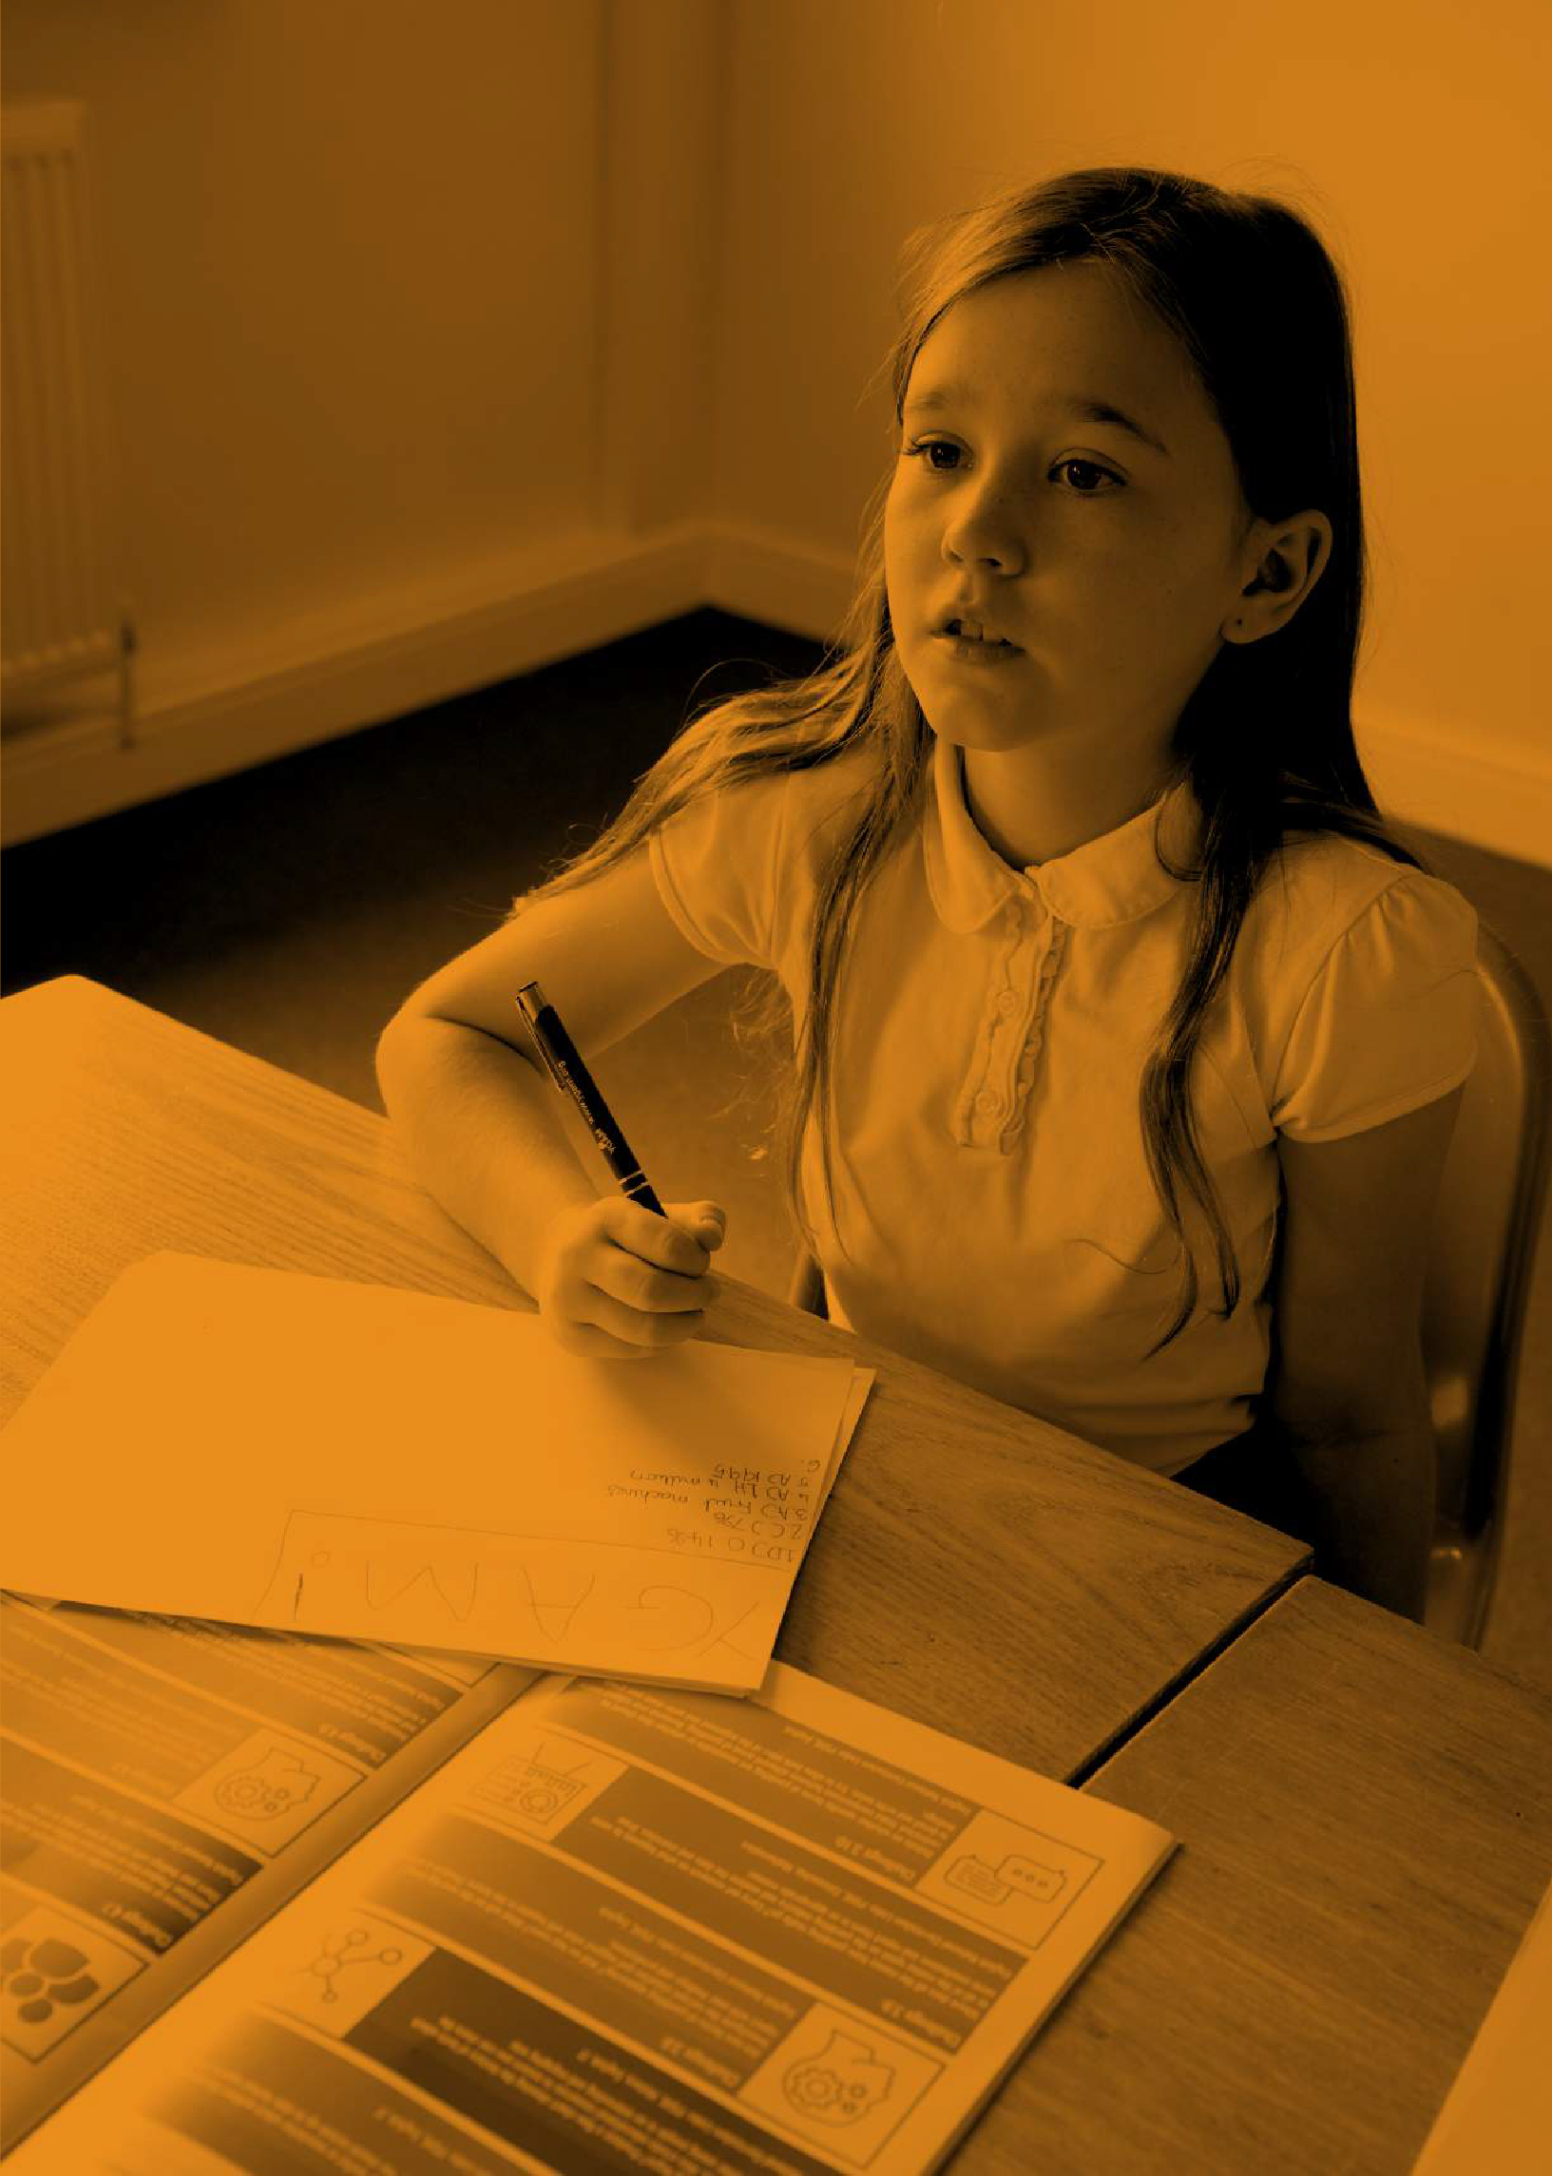
In The Know | Delegate Workshop Booklet 24

Primary School Curriculum & Challenges

Primary School Curriculum - Years 5 & 6 Focus

This curriculum can start with the discussion topics below or any of the activities on the opposite page. They are
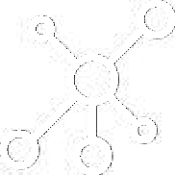all based on experiential learning and we have colour coded the challenges to specific skill sets:
Leadership & Teamwork

Learning & Sharing | 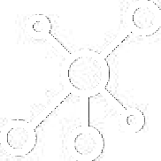
Creative Thinking & Exploration
Research & Presentation
Preparation & Discussion

Discussion Points

- When did you receive your first electronic device?
1
- What was it and did it feature any parental controls?
- Have these parental controls been activated?
- Who pays for any games and any in-game purchases?
- How much do you spend per month on gaming?

- How much time do you spend on gaming per month?
- How much time do you spend on your phone per month?
- What skills and knowledge can be developed through gaming?
- Do you compete against your peers online?
- Do you compete against strangers online?
- Do you watch other people gaming?
2

- Where does your electronic device live at night time?
3
- What is your favourite game?
- Does it have in-app purchases?
- What is the PEGI rating?
- What could you do instead of gaming?

26 In The Know | Delegate Workshop Booklet

Student Activities

These are designed to appeal to both students and teachers and can be completed in any order over an agreed amount of time.

Activity Title | Main Actions | Skills
What’s Happening? | Design a questionnaire to show who is doing what in my schools/class/youth group in relation to gaming.
Gaming Safely | Design a safe game for other students. Consider how gaming sites are designed and how we are kept safe. Think of a new, exciting game which also protects the people who play.
Safer Gaming Campaign | Run a campaign about how to stay safe when gaming. What are the main issues?
Activity Journal | Keep a diary of your gaming activity and log your gaming activity over a two week period. Consider how long you spend gaming compared to other activities. Share your findings.
Gaming - Pros and Cons | Collect images of gaming and the keywords associated with it. Create a wall display.
Playing the Game | Create a short piece of drama focussing on gaming. Consider the good and the bad in relation to friendship, money, health and family.
Mathematical Mission | As a group conduct a coin toss, dice throw, card pick or other mathematics experiment to see how the numbers work. Record your results.
Device Discussion | Prepare an assembly for your peers, focussing on the issues surrounding electronic device usage.
Gaming Ownership | As a class research the history of gaming and create project identifying key aspects and developments.
Mixing Things Up | What can we do instead of gaming to balance our time and money? What else could we do? Create a diary/itinerary for how you could spend your time

www.ygam.org 27

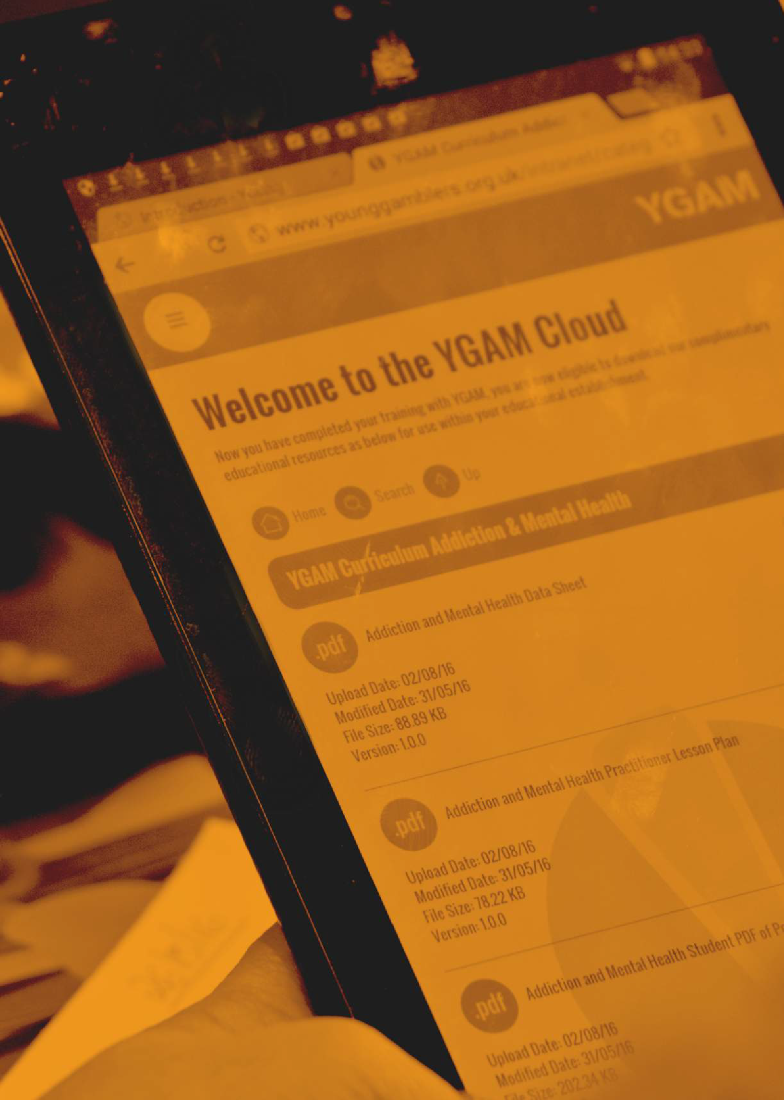
In The Know | Delegate Workshop Booklet 28

In The Know | Delegate Workshop Booklet 29
Parent & Carer Resources

Parental & Carer Resources – Primary/Secondary Focus

These resources can be used to run a presentation to parents or carers directly, or the PowerPoint can be
offered by the school online through its website or via a leaflet.

They can also be used by parents and carers as a conversation starter.

Slide 1
- When did you buy your child their first electronic
device?
- What was it and did it feature any parental controls?
- Have these parental controls been activated?
- Who pays for any games and any in-game purchases?
- How much does your household spend per month on gaming?

Slide 3
- What skills and knowledge can be developed through gaming?
- Do you have family gaming time?
- Does your child compete against their peers online?
- Does your child compete against strangers online?

Slide 2
- How much time does your child spend on gaming per month?
- How much time does your child spend on their phone per month?
- How much time do you spend on gaming per month?
- How much do you spend per month on your phone?
- How do these figures compare with other families?

- Does your child watch other people gaming? Slide 4
  - If your child has an electronic device, where is it located?
  - What is your child’s favourite game?
  - Does it have in-app purchases?
  - What is the PEGI rating?
  - What could your child be doing instead?

30 In The Know | Delegate Workshop Booklet

Family Activities - Overview

Activity Title Main Actions
A Family Diary | Record how much time you spend on any form of social media and gaming. Compare your own  findings with other family activities. Can you draw  any conclusions?
Positive Distractors | What can we do to spend less time gaming? Make a list or booklet which can be shared with other  families including fun activities which do not include the use of gaming.
Calculator | Compare the time you spend on social media and gaming to other activities. How much time would you spend gaming over a lifetime?
Family Challenge | Take action as a family and switch off all electronic devices in your home. What else could you do instead?
Family Discussion | Topics for discussion as follows:  What did people do before mobile phones? Is some gaming a good thing?  How long can I safely spend gaming?
Switch Off Challenge | How do we feel when we switch off the WiFi? The Xbox? The TV? How do we react? Keep a record or blog about your family experience.
Our Agreement | Discuss as a family sensible limits on time and use of phones, iPads and other electronic devices. Fill in and sign a document around safe digital behaviours. What can all members of the family agree to do?
Feeling Better | Have you noticed any changes in how you feel when you are not gaming or online? Keep a diary over a week.
Need... | Make up some ‘I need...’ labels which help family members understand how you feel about gaming and what they can do to support you.
Family Questions | Come up with some questions about something which you are unsure of about gaming. Swap the questions with other family members and try to find some answers.

www.ygam.org 31

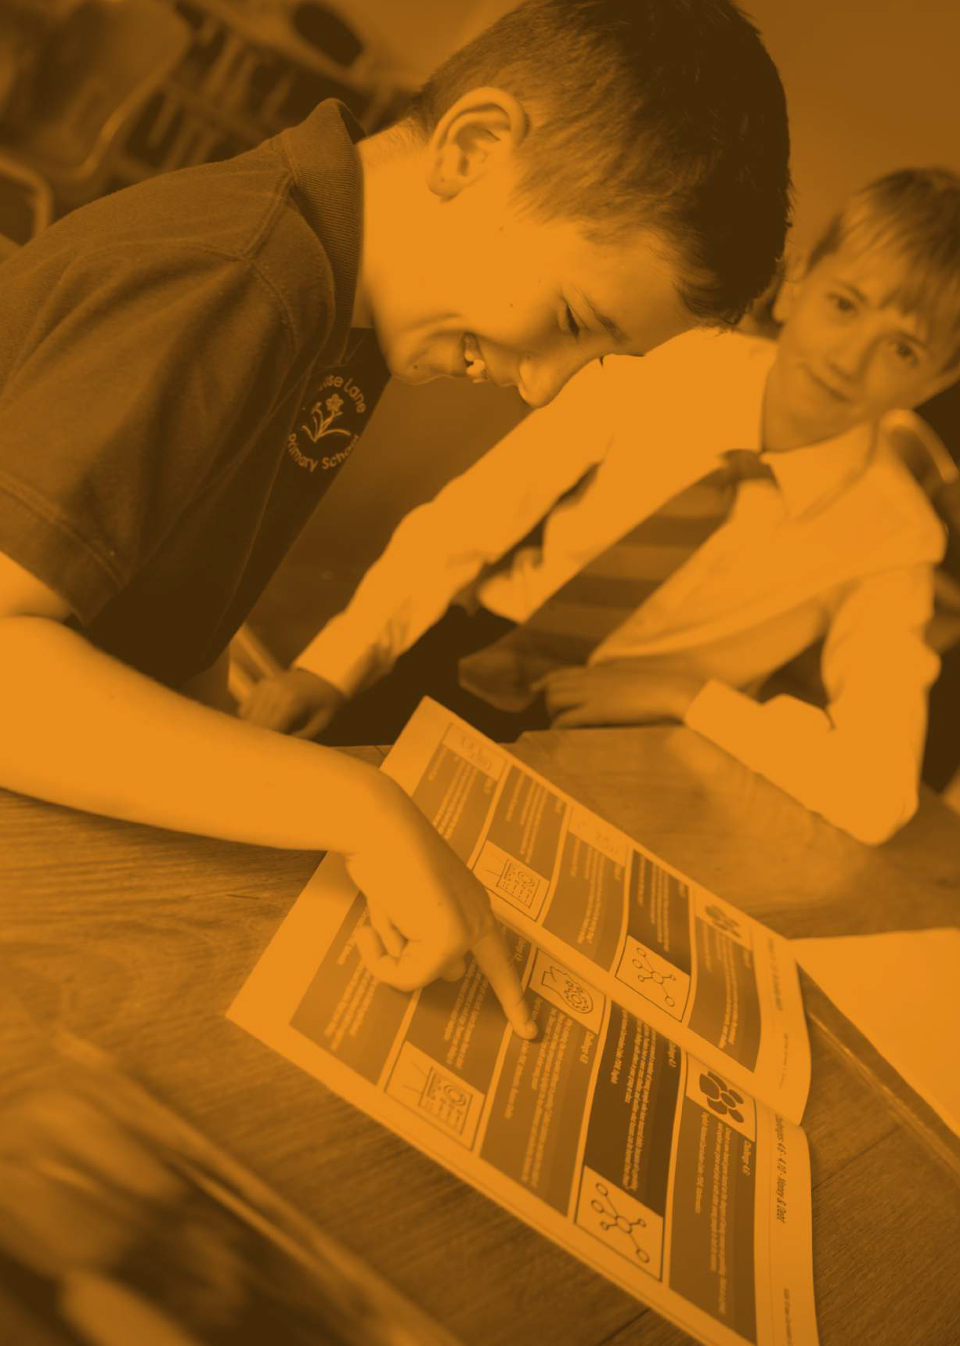

In The Know | Delegate Workshop Booklet 32

In The Know | Delegate Workshop Booklet 33
Meeting Ofsted Requirements

How YGAM can help you meet Ofsted’s requirements - Personal Development, Behaviour and Welfare

In the most recently updated version of Ofsted’s guidance of successfully meeting its school inspection targets, a greater emphasis has been placed on student well-being and safeguarding.

The YGAM curriculum and challenges allow teachers to evidence elements of this at both KS3 and KS4. These include:
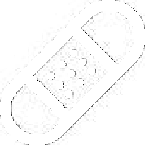
Good mental health issues
Understanding risk
Digital literacy
Ethical and moral understanding
Minimising harmful behaviours
Financial understanding
Developing mentoring skills
Developing soft skills

34 In The Know | Delegate Workshop Booklet

An Outstanding School would be served by the YGAM curriculum as below:

Pupils are confident, self-assured learners. Their excellent attitudes to learning have a strong, positive
impact on their progress. They are proud of their achievements and of their school.

Pupils discuss and debate issues in a considered way, showing respect for others’ ideas and points of view.

Pupils understand how their education equips them with the behaviours and attitudes necessary for success in their next stage of education, training or employment and for their adult life.

The school’s open culture actively promotes all aspects of pupils’ welfare. Pupils are safe and feel safe
at all times. They understand how to keep themselves and others safe in different situations and settings. They trust leaders to take rapid and appropriate action to resolve any concerns they have.

Pupils can explain accurately and confidently how to keep themselves healthy. They make informed choices about healthy eating, fitness and their emotional and mental well-being. They have an age-appropriate understanding of healthy relationships and are confident in staying safe from abuse and exploitation.

Pupils have an excellent understanding of how to stay safe online and of the dangers of inappropriate use of mobile technology and social networking sites.

www.ygam.org 35

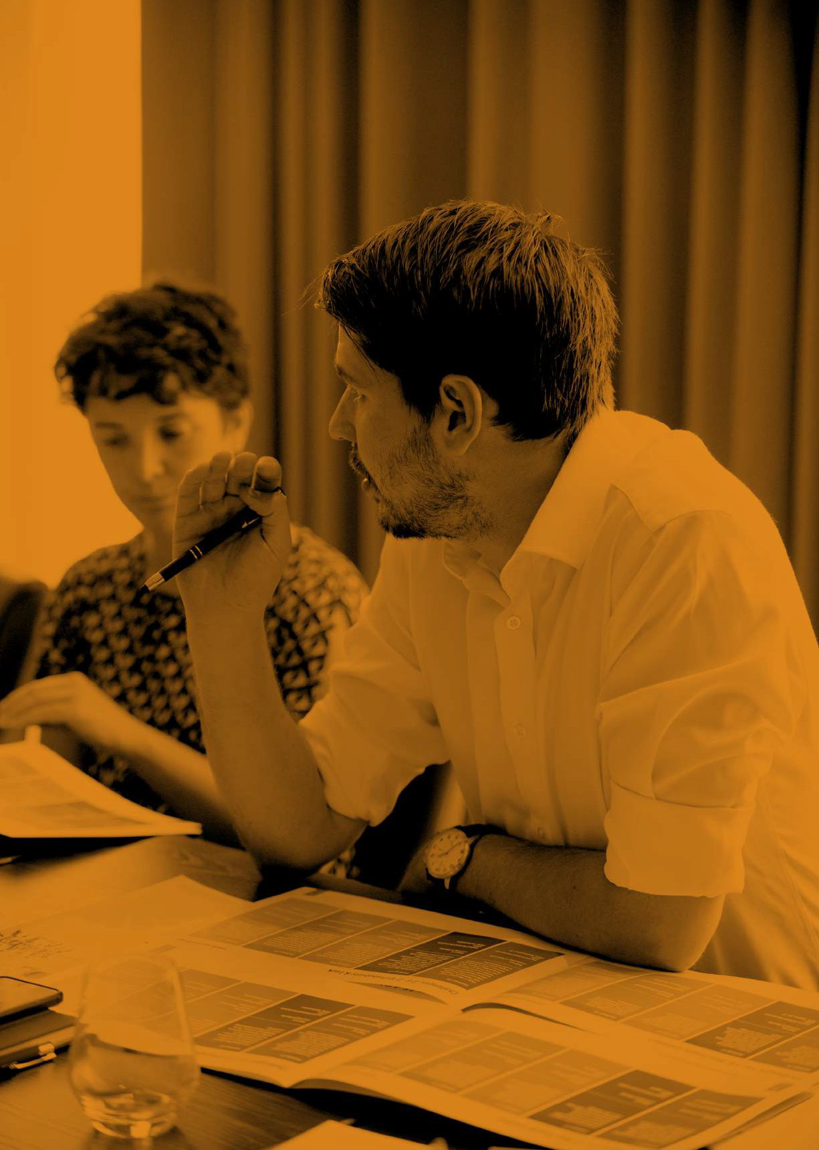

“It was very informative, and the resources are very well designed and useful. I will certainly be using them with our young carers and their parents in the future.”

— L ONDON DELEGA TE

In The Know | Delegate Workshop Booklet 36

Principles of Effective
37

Booklet
orkshop W

Delegate
|
w
Kno
The
n I
PSHE Education

How YGAM ‘In The Know’ curriculum meets the ten principles of effective PSHE Education

YGAM is proud to have worked with the PSHE Association to develop the educational resource ‘In The Know’. This resource meets the PSHE Association’s evidence-based, ten principles of effective PSHE education.

Start where children and young people are: find out what they already know, understand, are able to do and are able to say. For maximum impact involve them in the planning of your PSHE education programme.

The YGAM programme begins with baseline testing of knowledge and gauges how students feel about the subject of gambling and gaming. The flexible nature of the programme allows students to be involved in the shaping of its content.
1

Plan a ‘spiral programme’ which introduces new and more challenging learning, while building on what has gone before, which reflects and meets the personal developmental needs of the children and young people.

YGAM has devised a programme that includes 10 minute taster lessons, short focused activities and richer activities so that teachers and tutors can build a ‘spiral programme’ as part of the Scheme of Work.
2

Take a positive approach which does not attempt to induce shock or guilt but focuses on what children and young people can do to keep themselves and others healthy and safe and to lead happy and fulfilling lives.

The YGAM programme is designed to be student-centred and investigative with a positive approach to the subject of problem gambling and gaming, and the potential risks.
3
Offer a wide variety of teaching and learning styles within PSHE education, with an emphasis on interactive learning and the teacher as facilitator.

The range of learning styles is embraced by the YGAM programme, so that all students can access it appropriately. Each activity is also linked to a soft skill so that students learn as they experience the curriculum. Learning outcomes are also varied and can be used across the curriculum as appropriate.
4

Provide information which is realistic and relevant and which reinforces positive social norms.

YGAM provides high-quality and reliable information, using trusted sources for materials, appropriate and relevant learning materials and up-to-date statistics and data. These are all used to reinforce positive social norms with regard to both gambling and gaming by young people.
5

38 In The Know | Delegate Workshop Booklet

Encourage young people to reflect on their learning and the progress they have made, and to transfer what they have learned to say and to do from one school subject to another, and from school to their lives in the wider community.

Each activity has an appropriate planning and reviewing sheet so that students are able to reflect on the learning and to see how it transfers across subject areas. Extension tasks allow them to share learning with other students, teachers and the wider community.
6

Recognise that the PSHE education programme is just one part of what a school can do to help a child to develop the knowledge, skills, attitudes and understanding they need to fulfil their potential. Link the PSHE education programme to other whole school approaches, to pastoral support, and provide a setting where the responsible choice becomes the easy choice. Encourage staff, families and the wider community to get involved.

YGAM is committed to using its programme to enhance students’ potential through the learning at the heart of its curriculum; it encourages students to know the risks associated with gambling and gaming and to make responsible choices. The activities are often related to sharing findings both within school and with the wider community through the different outcomes across the curriculum.
7
Embed PSHE education within other efforts to ensure children and young people have positive relationships with adults, feel valued and where those who are most vulnerable are identified and supported.

As well as offering an educational programme, the YGAM curriculum allows students who may have issues with gambling and/or gaming to learn more about the issues and to be directed towards external help services. YGAM is also designed to be a familiar and necessary part of the school day and can be successfully embedded across year groups.
8
Provide opportunities for children and young people to make real decisions about their lives, to take part in activities which simulate adult choices and where they can demonstrate their ability to take responsibility for their decisions.

YGAM provides a safe environment for exploring the issues of the adult world with relation to problem gambling and/or gaming. With regard to digital literacy and gaming, students can make real and informed choices to keep them safe.
9
Provide a safe and supportive learning environment where children and young people can develop the confidence to ask questions, challenge the information they are offered, draw on their own experience, express their views and opinions and put what they have learned into practice in their own lives.

The YGAM curriculum allows students the opportunity to explore, discuss, question, challenge and learn in a safe and supportive learning environment. The programme allows them to look at ideas such as stigma, ethics and morals and to draw conclusions on how these relate to gambling and/or gaming in a non-judgemental way.
10

www.ygam.org 39

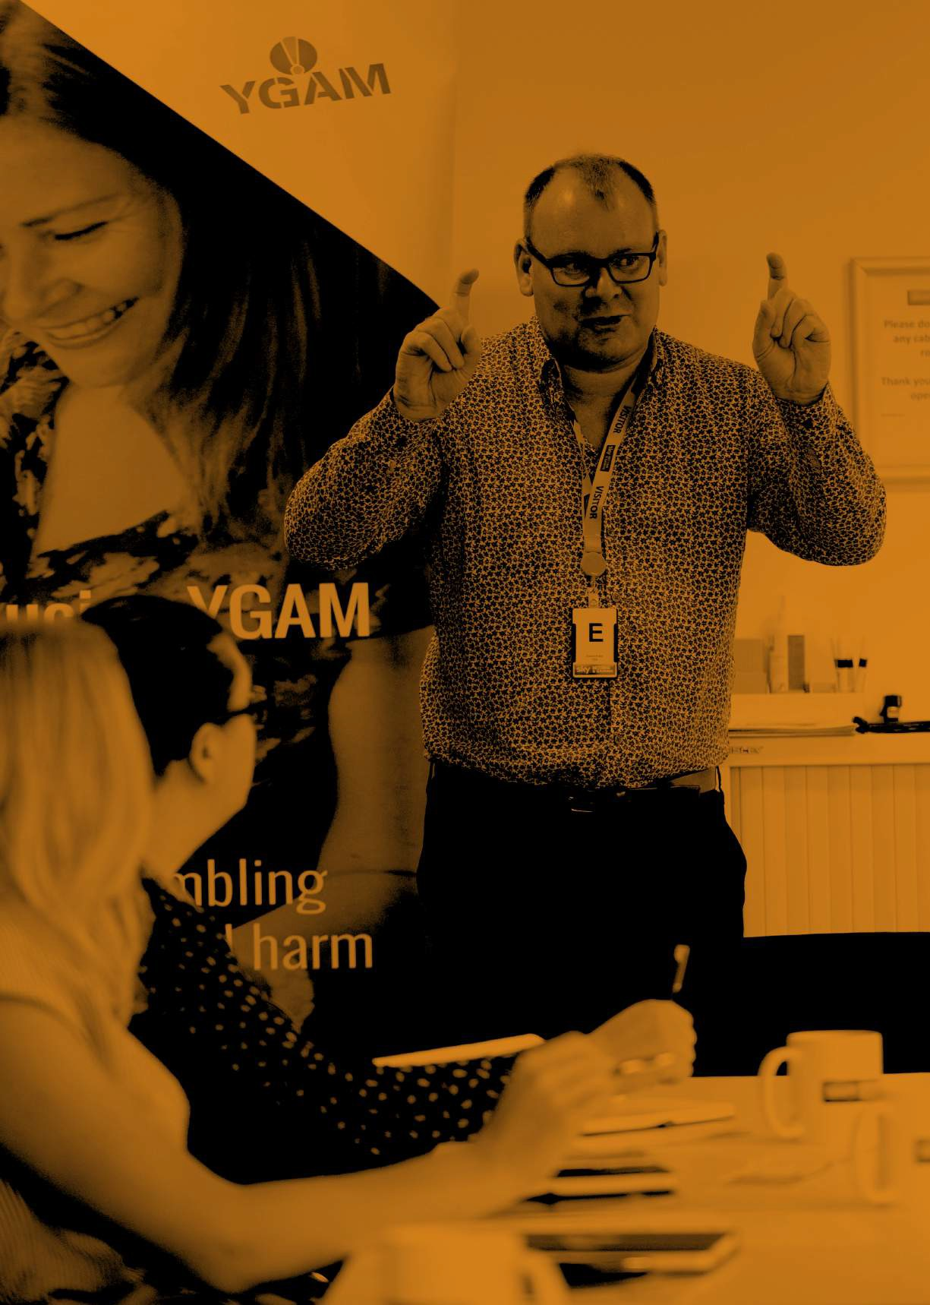

“Engaging and informative learning which has really expanded my knowledge. I will use this both in my work but also through my
volunteering with the scouts.”

— LEEDS DELEGA TE
In The Know | Delegate Workshop Booklet 40

In The Know | Delegate Workshop Booklet 41
Teacher & Practitioner Guidance

Overall Guidance For Teachers and Practitioners about the YGAM ‘In The Know’ curriculum

The programme has been developed with advice from the PSHE Association, City & Guilds and ASDAN Education, following a pilot with PSHE leads, youth workers, mental health professionals and young people. This booklet aims to answer some of the key questions you may have.
Learning is student-led and experiential
We believe young people will be most interested in a programme which they have helped to design and would encourage you to share the programme and tasks with them enabling you to create a suitable programme of study. We encourage participation from students allowing them to explore ideas and themes to find creative solutions.
Progression and differentiation
The programme helps you to assess knowledge acquisition and application and is inclusive for learners at KS3 and 4. Our primary resources are suitable for learners at KS2. The baseline quiz and attitudes document allow you to illicit information and understand young people’s existing knowledge; allowing you to develop a suitable Programme of Study. We have included short high impact activities and richer activities which can be aligned to the young peoples’ needs. For more able students there are extension activities available to support extended learning projects. It is also possible to map the programme to the wider curriculum.
Development of skills
Students will develop the skills and knowledge of the potential harms around gaming and gambling enabling them to make informed choices. Each activity allows the development of softer skills, so that young people gain experience of these and become confident learners.
IT-friendly programme with downloadable resources
Our materials are IT friendly and can be downloaded from our website and include lessons plans, skill sheets, additional information and letters.
YGAM meets elements of PSHE Education at KS3 and 4

The programme addresses key learning opportunities within the PSHE Associations’ programme of Study (www.pshe- association.org.uk) at KS3 and 4. Core Themes 1: Health and Well-being.

Activities can be covered throughout the curriculum and we also provide suggestions on how you might achieve this in our workshops and on our website.
Meets Ofsted requirements around safeguarding and well-being
We have produced a leaflet to explain how the programme can help you meet Ofsted requirements. You can find this
on pages 27-28 and on our website.
Offers full support materials and resources for teachers
We have produced a range of support materials, infographics, letters and helpful links to websites to support delivery. The focus is on the educating young people through research and discussion. The programme allows them to recognise and understand facts, explore opinion and develop skills needed to support informed decision-making. The programme encourages young people to make their own judgments at each stage of the process.
We hope your students, young people and you really enjoy the YGAM programme!

42 In The Know | Delegate Workshop Booklet

Getting Help

www.gamcare.org.uk

www.bigdeal.org.uk/

The National Gambling HelpLine provides confidential information, advice and support for anyone affected by
problem gambling in England, Scotland and Wales.

You can speak with their Advisers over the phone or via live chat every day of the year, from 8am – Midnight. They will be able to listen to what’s going on for you, and can talk you through all of the options available to you for support in your local area, online or over the phone.

Freephone: 0808 8020 133

Live chat: www.gamcare.org.uk/get-support/talk-to-us-now/

What does it cost?
Calls to the National Gambling HelpLine are free from landlines and mobile phones within the UK and do not appear on itemised bills. Calls from BT phone boxes are free, however some other public phone operators may charge you to call.

Who am I talking to?
You will be talking to a GamCare Adviser who is trained to listen and help people affected by problem gambling. The Adviser will listen to you carefully and encourage you to talk about your concerns.
Sometimes just telling someone can be a relief, and it is an important first step towards dealing with the problem. The Adviser can also connect you with GamCare treatment services across Great Britain, either face-to-face, online or over the phone.

Is it confidential?
Whatever you say will be just between you and GamCare, unless you request otherwise in writing. You can feel safe talking to them, knowing that they will not pass on personal information without letting you know.

But sometimes, if they’re worried about your safety, they may need to get you help. They’d only get help or take action if: (i) you ask them to; (ii) they believe your life, or someone else’s life, is in danger; (iii) you’re being hurt by someone in a position of trust, like a partner, carer or friend or you tell them that you’re seriously harming another person / people.

Who are the Big Deal?

BigDeal are part of GamCare. Whether young people have never gambled before, like a game of poker with your friends or just buy the odd scratchcard, they’re there to help them understand how it all works, recognise when things might become a problem and provide support if you need it.

www.ygam.org 43

Notes

44 In The Know | Delegate Workshop Booklet

Notes

www.ygam.org 45

“The course has been very informative. We will use the activities with our students to hopefully raise their awareness about their own habits.”

— MANCHESTER DELEGA TE
In The Know | Delegate Workshop Booklet 46

In The Know | Delegate Workshop Booklet 47

This workbook is subject to Copyright by YGAM 2020

All rights reserved. No part of this publication may be reproduced, stored in a retrieval system, or transmitted, in any form or by any means, (electronic, mechanical, photocopying, recording or otherwise) without
prior permission from the Young Gamers and Gamblers Education Trust. No income should be generated from this
workbook or from attendance at our workshops.

Young Gamers and Gamblers Education Trust, 71 – 75 Shelton Street, Covent Garden, London, WC2H 9JQ. www.ygam.org | hello@ygam.org | 0203 837 4963 |
Registered Company no: 09189998 | Registered Charity no. 1162425.

YGAMTM is the trading name of Young Gamers and Gamblers Education Trust and registered Trademark: UK00003114184.

@YGAMuk @YGAMuk /YGAM
In The Know | Delegate Workshop Booklet 48

