What Colour are you?
Name …………………………………………………………….

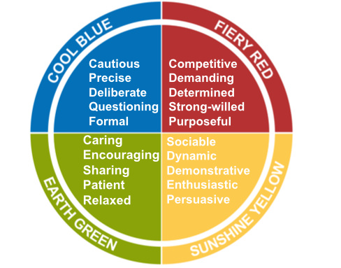

Look at the four colour quarters above. Each set of words describes a preferred behavioural style.
Which set describes you the most? ………………………………………
Then next? ………………………………………….
Then third? …………………………………………
Then least? …………………………………………
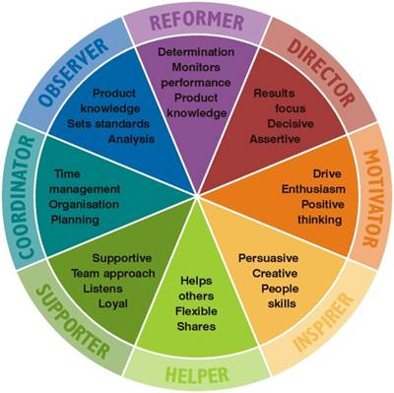

Your Colour Order |  |  |  | Jungian “8” Types
 |  |  |  | Reformer | creative
 |  |  |  | Reformer
 |  |  |  | Director
 |  |  |  | Director
 |  |  |  | Motivator
 |  |  |  | Motivator | creative
 |  |  |  | Motivator | creative
 |  |  |  | Motivator
 |  |  |  | Inspirer
 |  |  |  | Inspirer
 |  |  |  | Helper
 |  |  |  | Helper | creative
 |  |  |  | Motivator | creative
 |  |  |  | Motivator
 |  |  |  | Inspirer
 |  |  |  | Inspirer
 |  |  |  | Helper
 |  |  |  | Helper | creative
 |  |  |  | Coordinator | creative
 |  |  |  | Coordinator
 |  |  |  | Observer
 |  |  |  | Observer
 |  |  |  | Reformer
 |  |  |  | Reformer | creative

Note: Creative types are those whose first and second colour energies are opposites (red followed by green for instance).

When working in a team, this what your colour may help you to contribute:
The Observer
When others need the facts to make a decision, observers are usually the person they ask. Good at setting standards and providing the knowledge required for the task.
The Supporter
Supporters have a true team approach. Their expert listening skills can uncover others’ true needs and they are loyal to their teammates
The Inspirer
Inspirers have well developed people skills and constant need to enjoy interactions with others. They are persuasive and their quick minds can produce creative.o problems
The Director
Directors tend to focus on results. They decide what they want, then set a strategy to achieve it. Their natural assertiveness means they will push themselves and others to achieve goals. They are not put off by setbacks.
The Coordinator
Coordinators can pull all the loose ends together to organise themselves and others in a structed manner. Their planning and time management skills make them thorough and reliable.
The Helper
Helpers have a genuine desire to help others and put their needs first. This makes them flexible and adaptable, with a natural ability to share ideas and knowledge.
The Motivator
Motivators have plenty of enthusiasm to share with those around them, and their drive to succeed gives them a high level of motivation. They are not easily put off and tend to think positively in most situations.
The Reformer
Reformers have a natural desire to monitor and judge performance. They tend to take a disciplined and logical approach, backed up with determination to succeed.

