For these tutorials you will be using the ETF Side by Side Online Prevent Duty and British Values course for learners

Side by Side: a free Prevent duty online module for learners

To access these resources click on the link or type in www.etflearner.org.uk

Side by Side contains four modules
- Radicalisation and extremism
- Online safety
- What can you trust?
- British values
Apprentices, trainees, and students could go through these modules independently on a PC, tablet, or mobile phone. For tutorials, there is also a smart board or projector version to use in a group setting (see links below).
There is a facilitator guide with advice and additional activities for use with groups or for use one to one. We have also created this into HA session plans to run this as four tutorial sessions. These are available in the tutorial folder on SharePoint.
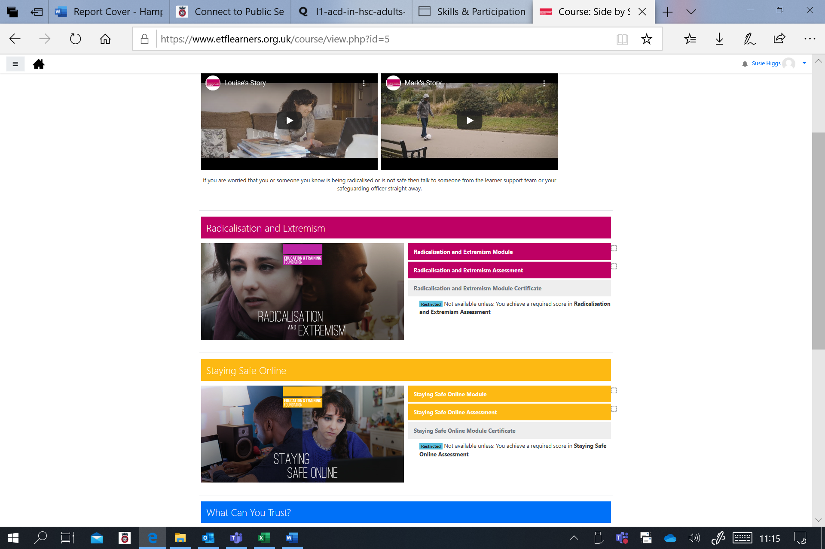

Display version of the modules
The modules accessed through the Side by Side box on the landing page have been designed for display on a desktop, tablet, or mobile phone. To enable improved viewing when displaying the modules through a projector or on a smartboard we have also created a display version. On this version the onscreen instructions are in a sharper font and the navigation buttons have been moved.
- Radicalisation and Extremism - Facilitators URL
- Staying Safe Online - Facilitators URL
- What can you trust? - Facilitators URL
- British Values - Facilitators

