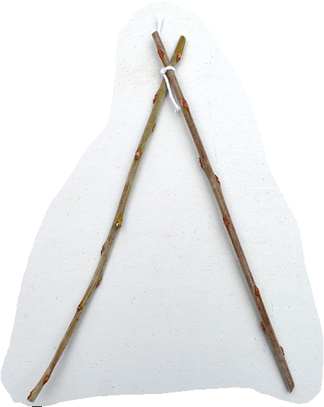
1. Lash 2 sticks together. Separate to form a teepee shape
1
2

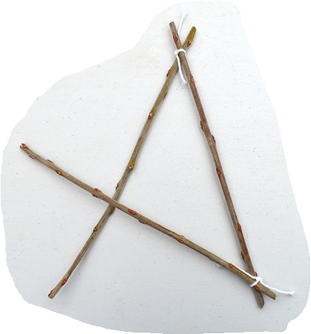

1
2. Lash the third stick so that it passes over the first stick
3

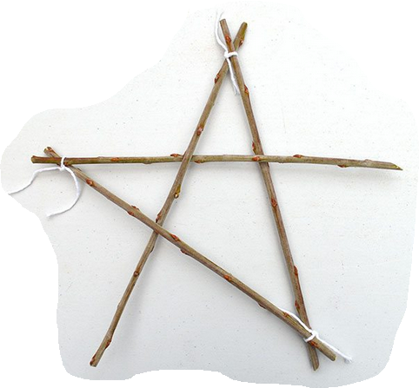

1
2

3. Add the fourth stick so that it passes underneath the first stick and over the second.
4

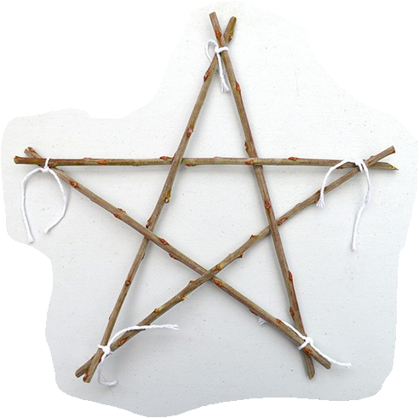

2

4. Lash the last stick so that it passes over stick 3 and under stick 2
3
5

Use the wool to decorate your star.
Attach a loop to the top and hang your star from a tree branch or hook.

