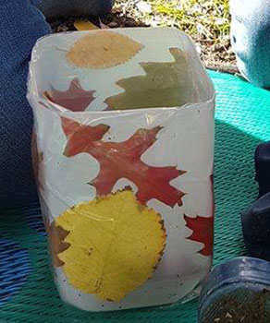
Recycled Plastic Lantern
Materials
- A recycled plastic container.
- Clear contact.
- A collection of leaves or flowers
- Scissors.
- Tea light candle.

To make your lantern simply;
- Cut the top end off so you have a straight edge.
- Cut a strip of contact that is the same width and length as your container.
- Remove the adhesive and lie it down with the sticky side, facing upwards.
- Place your leaves and flowers on the sticky side.
- Carefully pick it up and wrap it around your container.
- Place your tea light candle in the middle!

