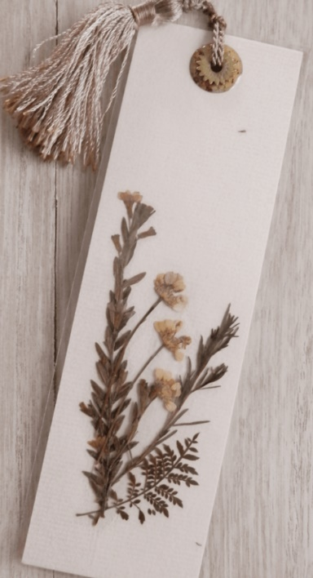
Pressed Flower bookmarks
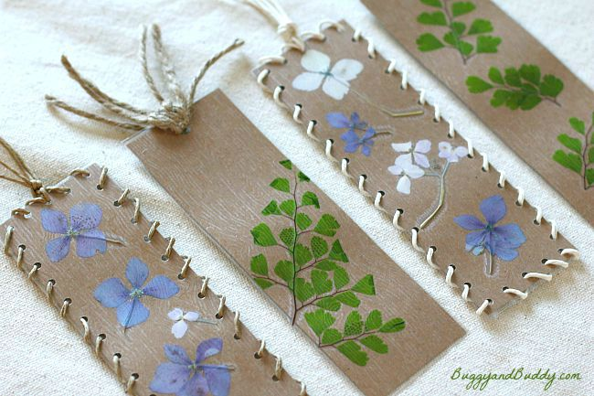
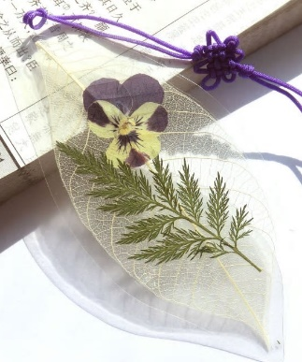

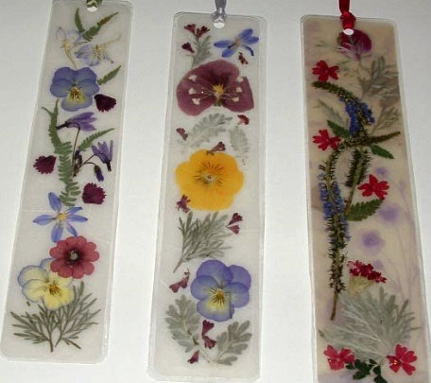
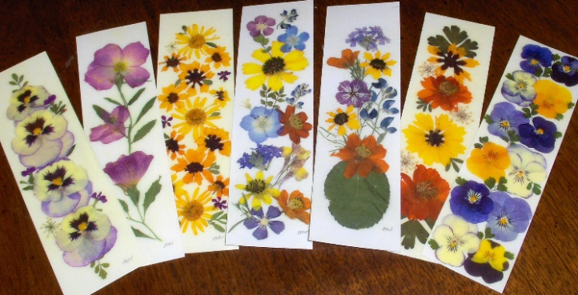

Materials
- Various leaves and flowers
- Card
- Scissors
- Glue
- Contact paper or laminator
- Hole punch
- Yarn, string, or raffia ribbon
Directions for Bookmark Craft for Kids
1. To make this bookmark craft, you’ll need some pressed leaves and flowers that have been left to dry.
2. Cut some cards the size you’d like your bookmark to be. (6 inches x 2 inches.)
3. Use your pressed flowers and leaves to make a design on your card. Once you’re happy with the design, you’ll want to lightly attach the flowers and leaves with glue.
4. Next you’ll want to cover the bookmarks with plastic to protect them during use. You can use a laminator or you could cover your bookmark with clear contact paper.
5. Once you’ve covered your bookmark, trim off the excess plastic.
6. Use a small hole punch to punch holes around the border of bookmark. If you want to, thread some hemp cord, string or wool around the border and tied it off at the top.

