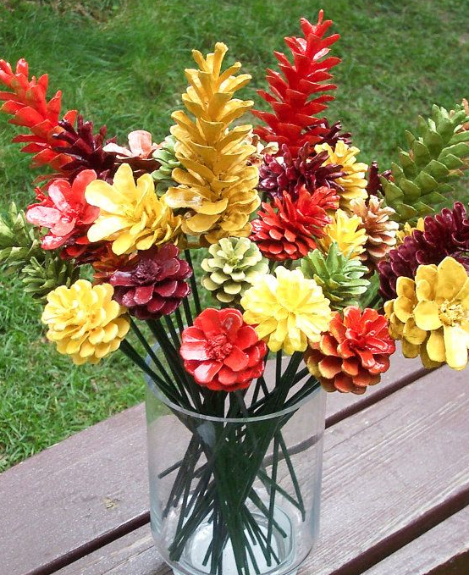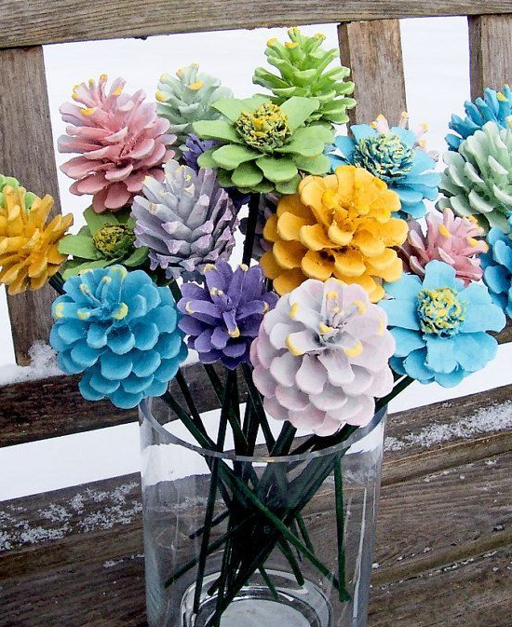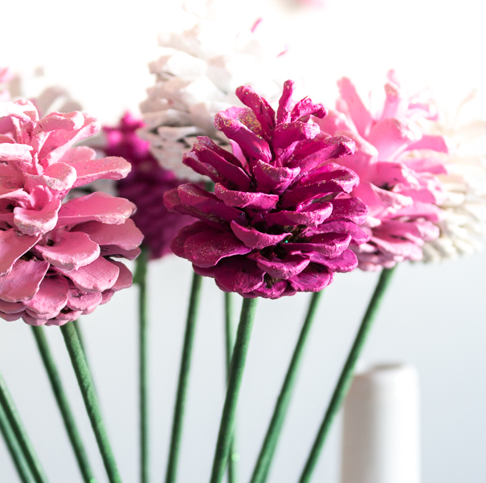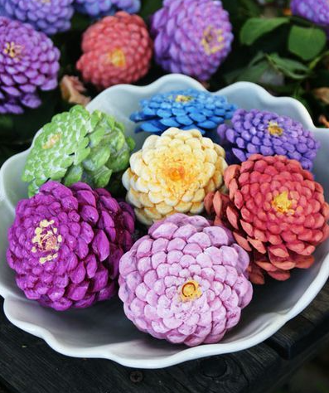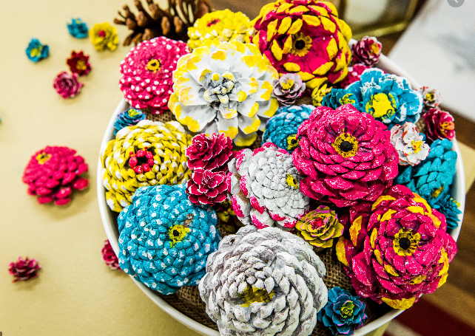

Supplies Needed:
Pine Cones
Sticks
Glue Gun – or VERY strong glue
Paint
Paintbrushes
Instructions:
- Paint a variety of pine cones in a variety of colours. Add glitter if you want.
- Cut and paint the sticks.
- Allow both to dry.
- Glue pine cone to stick and arrange in vase.
  - Alternatively, avoid using the sticks and just arrange in a bowl.

