You need:
1 metre of paracord, Scissors, candle or lighter

1 Cut about a 3 inch piece of paracord for the legs, and melt the ends (get an adult to help you with this).
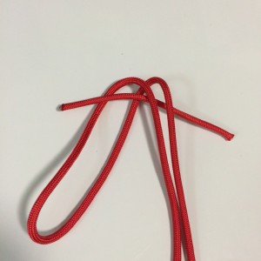
1

2 Fold the long length in half
3 Fold the long length over the short piece
(pic 1)

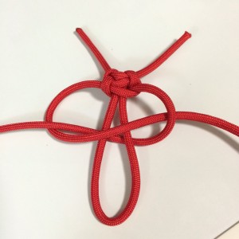
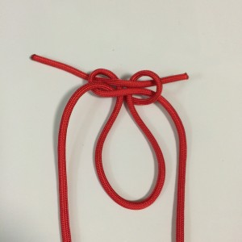
3
2

4 Tie a cobra knot (pic 2- 3)

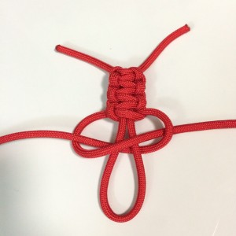
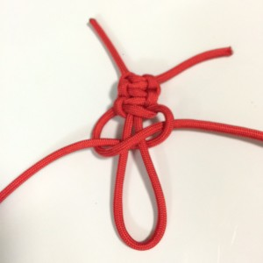
5 Continue tying cobra knots until the head is about a quarter of the length of the body (pic 4-5)
4
5

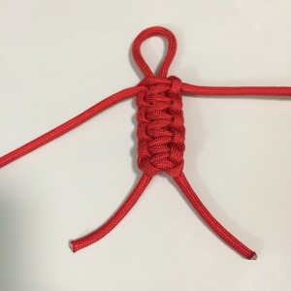
6

6 Cut off and melt the ends to make the arms. (pic 6)

Your person is finished
