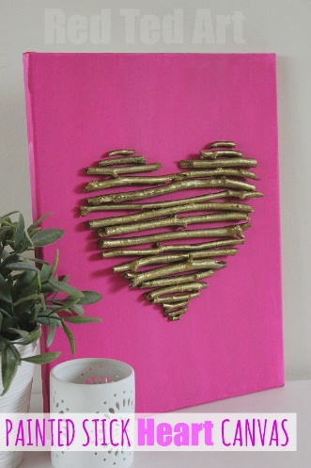
Painted Heart Card/Canvas

What you will need:
Card/canvas
Paint in two or more colours of your choice
Sticks in various lengths
Glue
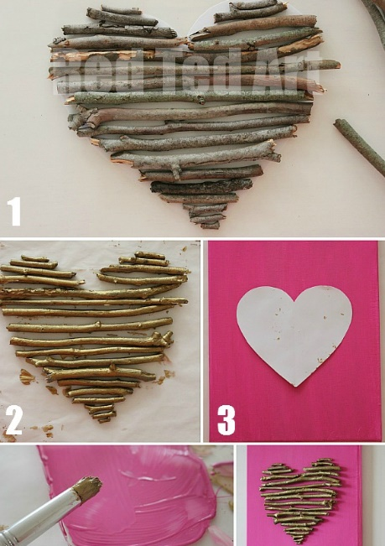
Pencil
Paper
Scissors
How to make a painted stick heart canvas
1. Paint your canvas or card. You may need to paint two coats to achieve a nice colour. Set aside to dry.
2. Prepare a heart shaped template on card. This will act as a guide when arranging draw a heart on a piece of paper and cut it out. To make a symmetrical heart just fold your paper in half and with the fold on the left, draw the line you have drawn, open up the folded paper and voila! A perfect heart.
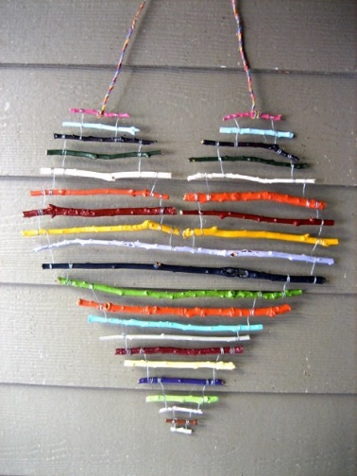
3. Arrange the sticks in a heart shape. Place your heart shaped paper surface and place your sticks on top. When selecting sticks, try to use ones same thickness and fairly straight.
4. Paint the sticks. When you are satisfied with the arrangement of the colour of choice. Tip: As you paint each stick, lay them to dry in the same arrangement the template.
5. Mark your starting point on the card/canvas. When the canvas is dry, place over it and make a VERY FAINT pencil mark. This will show you exactly where to start placing the sticks on the canvas.
6. Arrange the sticks on the card/canvas to form the shape.
7. Glue the sticks onto the canvas/card. Keep the card/canvas flat until completely dry.

You can also make a heard without card. Just use string to connect together.

