Flower mandala designs
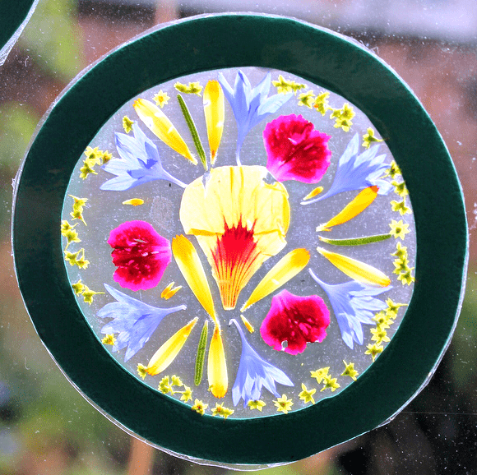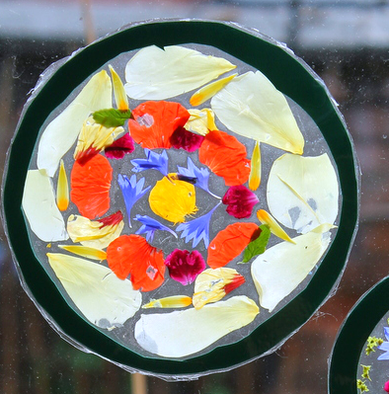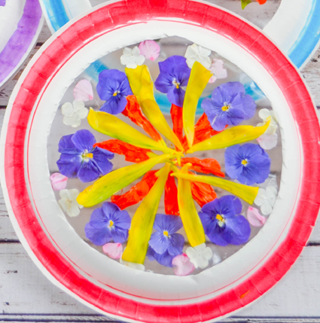
- Start by drawing out a circular/square/heart frame on a piece of card.
- Place your card frame on a piece of contact paper (sticky backed plastic), trim round the outer circumference with scissors, and you’ve made your sticky canvass on which to create your mandala design.
- Collect some flowers and leaves and carefully separate your flower petals and then you can begin to design your mandala wheel.
  - You could divide your circle into fractions and fill each with a different flower.
  - Or play with symmetry.
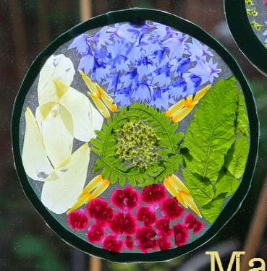
  - Or make concentric circles or repeating patterns. A great thing about working with contact paper is that you can gently peel flowers off and replace them, changing your mandala design until you are happy with it.
- Once you have created your finished design, stick another layer of contact paper over the petals, so they are encased inside. Cut around the edge of the shape.

