Dream Catcher History & Legend
Dream catchers are one of the most fascinating traditions of Native Americans. The traditional dream catcher was intended to protect the sleeping individual from negative dreams, while letting positive dreams through. The positive dreams would slip through the hole in the centre of the dream catcher, and glide down the feathers to the sleeping person below. The negative dreams would get caught up in the web, and expire when the first rays of the sun struck them.
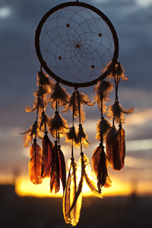
The dream catcher has been a part of Native American culture for generations. One element of Native American dream catcher relates to the tradition of the hoop. Some Native Americans of North America held the hoop in the highest esteem, because it symbolized strength and unity.
Dream Catcher Lore:
Native Americans believe that the night air is filled with dreams both good and bad. The dream catcher when hung over or near your bed swinging freely in the air, catches the dreams as they flow by. The good dreams know how to pass through the dream catcher, slipping through the outer holes and sliding down the soft feathers so gently that the sleeper does not know that they are dreaming. The bad dreams not knowing the way get tangled in the dream catcher and vanish with the first light of the new day.

