Build a bug hotel
ID cards
To play this variation on the classic Kim’s Game, go out and gather a small collection of items from the local environment, like feathers, pine cones, pebbles and leaves.
Your child’s challenge is to search the area for the same objects, and then come back to see how many they’ve managed to collect.
Potato peeler whittling
Clay play
Build a den
Twists
Giant bubbles
This hands-on science activity is much more fun than blowing bubbles from a tiny pot.
Combine six cups of water, one cup of washing-up liquid, and half a tablespoon of glycerine (the magic ingredient, available from chemists).
Tie a piece of string of any length into a circle, dip it into the bubble mix and waft it around to make giant bubbles.
Your child can experiment with how much to mix the solution to make the best bubbles, and see which weather conditions are the best for bubble-blowing.
Nature bookmarks
Bow and arrow
Tracking
Nature art
Stool making
Wind chimes
Kite making
Blindfold walk
Leaf rubbing
Kims game
Wood whistle
Model birds nests
Colours and natures palette – card and double sided sticky tape

atural painting
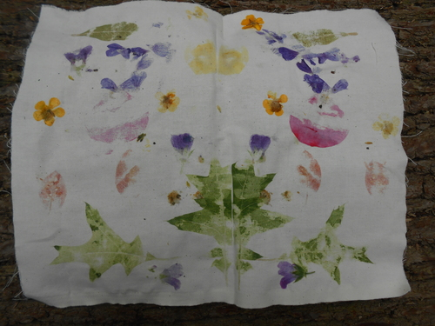

Create an original artwork by bashing petals and leaves onto cloth
Materials required:
- Cotton cloth cut into pieces (old sheets or pillow cases work well, or you can by cotton by the metre
- A mallet, hammer or log
- Freshly picked leaves and petals
Method: Place the petals and leaves onto the cloth and bash them with the mallet! take care not to hit your head, hands or other people around you. For a symmetrical design, place all of the petals and or leaves on one side of the cloth and then fold it over before you begin bashing.
Wild weaving

