**Understanding the parts of a flower**

To understand pollination of flowers we need to understand the different parts of a flower. Pollinators such as solitary bees and butterflies visiting a flower carry pollen from neighbouring flowers allowing the ‘pollination’ of the flower resulting in the production of seeds.

Can you label the diagram? Can you match the definitions for each of the flower parts?

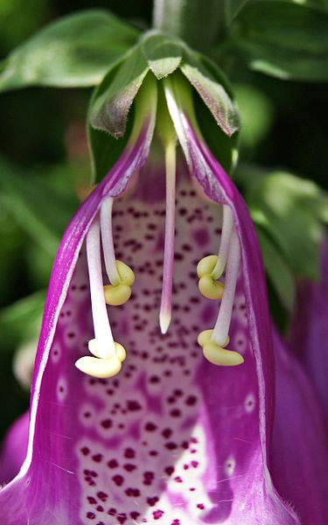

Foxglove flower diagram

Danny Steven S.

from Wikimedia Commons

Sepals

Stigma

Petals

Pollen

Stamen

Anther

Are usually green like tiny petals that support the flower.

The sticky end (helps it collect pollen) of the female part of the flower

Modified leaves surrounding the reproductive part of the flower, often colourful to attract pollinators

A fine powder of tiny grains produced on the anther of a plant.

The stem of the male reproductive part of a flower.

The tip of the male reproductive part which produces pollen