LOCAL TRAINING PROVIDERS FOR:

* **Gosport**
* **Havant**
* **Fareham and surrounding areas.**

## This booklet will include all the local training providers in the Gosport, Fareham and Havant areas.

## It will include some helpful information, company background info and some important contacts.

**PETA:**

### PETA are a local training provider in Havant and the surrounding Portsmouth areas. They are a local charity who specialise in engineering, customer service and business working closely with local businesses.

### In Havant they have a dedicated engineering training centre where young people can attend apprenticeships and engineering related courses.

### In central Portsmouth PETA have the business centre where young people can attend apprenticeships and local courses. Just outside of Portsmouth they have the management, training and conference centre.

### PETA can support young adults in gaining qualifications including functional skills.

## Contacts:

## Jodie Fair: JFair@peta.co.uk

[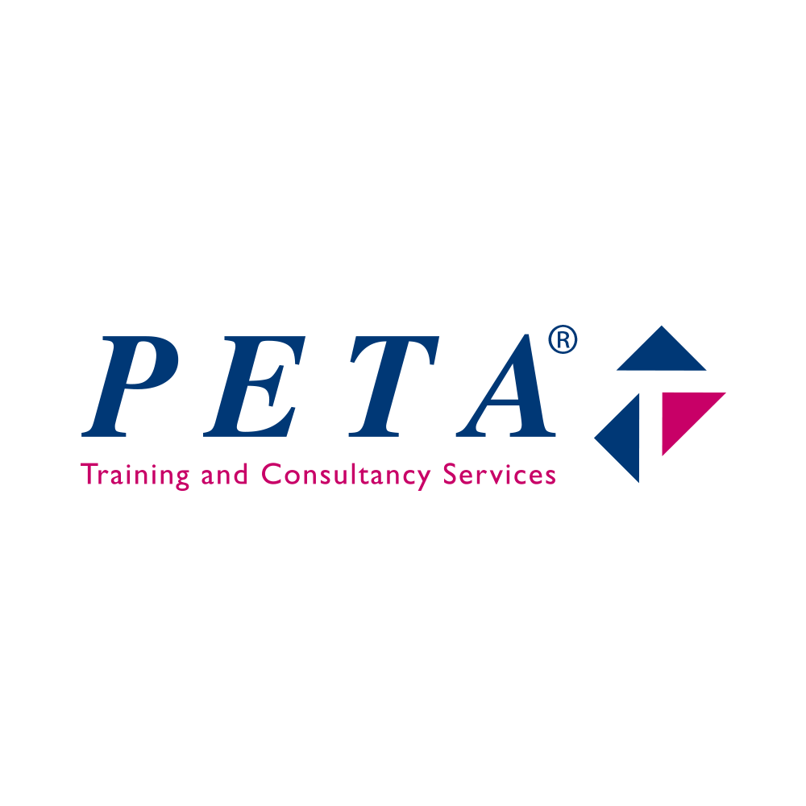](https://www.google.co.uk/url?sa=i&rct=j&q=&esrc=s&source=images&cd=&cad=rja&uact=8&ved=2ahUKEwiEwruvlaDaAhWBWhQKHZGiCF4QjRx6BAgAEAU&url=https://www.peta.co.uk/&psig=AOvVaw26XHcB4yLu37rhHBz4ZdqH&ust=1522915738124754)

**HAHA Training:**

### HAHA Training offer professional training to the Hair, Beauty and Barbering industry.  All our courses are City & Guilds accredited. They have links in Hampshire and surrounding areas.

### They offer a 2 year programme which includes functional skills level 2 if they have a D-C or level 1 if they already have a D or below.

### They are based in North End in Portsmouth however work closely with Fareham College so can offer placements that way.

## Contacts:

## Katrina Churcher: [katrina@hahatraining.co.uk](mailto:katrina@hahatraining.co.uk)

[](https://www.google.co.uk/url?sa=i&rct=j&q=&esrc=s&source=images&cd=&cad=rja&uact=8&ved=2ahUKEwjJvM-HnaDaAhVBNBQKHW2xA0MQjRx6BAgAEAU&url=https://www.goodsalonguide.com/community/news/haha-training-achieve-runner-up-position-in-the-news-hair-and-beauty-awards&psig=AOvVaw0t7PHU1tEtruYgKsWKrgo2&ust=1522917782140205)

Bicycle Recycling:

Bicycle recycling is owned by motiv8 who employ qualified mechanics who work alongside apprentices, trainee’s and volunteers. They provide work experience opportunities to young people who are NEET.

Bicycle recycling offer traineeships through Highbury college doing 1 ½ days in training workshop, ½ day classroom based including essential skills, 1 day industry experience, 1 day personal study.

They are able to gain Level 1 & 2 qualification in addition to option to gain industry recognised Velotech qualification.

[](http://www.bicyclerecycling.co.uk/index.html)Contact: 023 9260 1441 or contact@bicyclerecycling.co.uk

### HTP:

### HTP deliver training programmes in all areas including:

### Hospitality & Catering, Management, Retail, Customer Service, Business Administration, Health & Social Care, Childcare, Cleaning Services and Nail Technology.

### They are based over the South but the closest training centre is in Cosham. HTP offer traineeships, apprenticeships, full time courses, management programmes and training.

### HTP are currently running and Retail traineeship with young people going to Gunwharf Quays to complete this.

### Contact: 02392374752 (lakeside)

[](http://www.htp.ac.uk/)

### [Paragon SkillsParagon Skills](https://paragonskills.co.uk/)MPCT:

### The Military Preparation College (MPC) is a unique training college that helps 16-23 year olds develop their fitness, vocational qualifications, and employability skills to help prepare for employment, including rewarding careers in the British Armed Forces.

### At the college, students follow a weekly routine of activities and curriculum. This includes vocational and skills training, physical training, military training days and assessments. The college also help with gaining functional skills.

### MPCT also help 19-23 olds to develop their fitness, vocational qualifications and employability skills.

### Contact: garethames@mpct.co.uk



**GlobeUs**:

### GlobeUs are based all over Hampshire. They have an office e in Gosport and offer a full suite of Apprenticeships, Personal Licence Courses, Premises Licence Application Services, First Aid Courses and more.

### They specialise within:

### Childcare,

### Hospitality and food beverage apprenticeships

### Team leading and management

### **Contact:**

### 07706 872173 or [info@globeustraining.com](mailto:info@globeustraining.com)



**Fareham College:**

### Fareham College has been awarded the best FE College 2018, they offer full time and part time college courses alongside apprenticeships.

### They also have their own traineeship programme which offers 16-18 year olds the opportunity to progress onto an apprenticeship or employment.

### The college has two main parts the main campus and CEMAST which focuses on engineering qualifications, including apprenticeships.

### Contact: 01329 815 200



**Fareport:**

### Fareport are a training provider for apprenticeship in the following qualifications:

### Business Administration

### Customer Service

### Retail Skills

### Retail Team Leader

### Health & Social Care (all pathways, i.e. dementia, learning disability, adult, children)

### Management Level 3

### Operational/Department Manager Level 5

### They are based in Fareham and approximately 50% of their learners are based in the South - however, they have trainers all over UK.

### Contact: [johanna.jewell@fareport.co.uk](mailto:johanna.jewell@fareport.co.uk)



**St Vincent:**

### St Vincent’s is based in Gosport and they offer a range of College courses. These included Core skills maths & English for those who want to go onto to GCSE level courses. They also offer GCSE Maths and English retakes to various A Levels and BTEC’s.

### They also offer a preparation for work course for those with learning difficulties and disabilities.

### St Vincent’s also offer 19+ vocational qualifications which are City and guilds approved. (NVQS) These include:

### Health and social care

### Support teaching

### Childcare

### Business admin

### Advice and guidance

### Contact: 023 9258 8311



**Highbury College:**

### Highbury College is based in Portsmouth and has multiple campuses dotted around the city. They offer a range of different courses from A Levels, Apprenticeships, Diploma and Foundation courses for those who need extra support or left school early.

### Highbury offer a range of free training courses that support young people into work these include:

### From Advert to Interview - Job Skills Level 1

### **Cost:** FREE. This programme covers job search skills, creating a CV, application forms and a range of hints and tips in readiness for job interviews. This programme is 15 hours and can be studied at an IT Flexi Centre or online.

### OCN London Entry Level Preparation for Life & Work

### **Cost:** FREE. You can work towards this qualification at one of our [IT Flexi Centres](http://www.highbury.ac.uk/client/content.asp?Contentid=479) or as taught classes in the community. Contact: 023 9238 3131

### Image result for highbury college

### 

**HSDC:**

### Havant and South Downs College is based in Havant and is split across two campuses.

### They offer a range of different courses from GCSE re sits, A Levels and apprenticeships.

### They also do a Foundation Learning Courses which open doors to further study, employment or supported employment.

### Class sizes are generally smaller and a variety of specialist support is available.  You can choose vocational options to try out, such as catering, drama, sport, automotive, art, animal care, health and care, business and retail, IT and hair and beauty

### They also offer:

### [Clubs & societies](https://www.hsdc.ac.uk/life-at-hsdc/clubs-societies/)

### [Facilities](https://www.hsdc.ac.uk/life-at-hsdc/facilities/)

### [Student union](https://www.hsdc.ac.uk/life-at-hsdc/student-union/)

### [Trips & Experiences](https://www.hsdc.ac.uk/life-at-hsdc/learning-career-opportunities/trips/)

### Contact: 023 9387 9999



**Catch 22:**

### Catch 22 has been a charity for 200 years.

### They offer a range of different services which include:

### Children’s social care

### Deliver alternative education

### Get people into work through apprenticeships and employability programmes

### Build stronger communities through social action

### Deliver social justice and rehabilitation services (in prisons and in the community)

**Contact: 02392 861228**

**[](https://www.google.co.uk/url?sa=i&rct=j&q=&esrc=s&source=images&cd=&cad=rja&uact=8&ved=2ahUKEwjglJj0zunaAhXCXhQKHUnxCI8QjRx6BAgBEAU&url=https://twitter.com/catch22&psig=AOvVaw3LxpPpRoyQHu-c6PozkGE3&ust=1525439443348324)**

**Smart Training:**

### Smart training offer local traineeships within the local area:

### The programme lasts for up to six months and involves one study day a week plus two days of work experience - and throughout you will get lots of support.

### You get Maths and English tuition alongside CV and interview skills and will gain a Certificate in Workskills at the end.

### Some traineeship they provide includes:

### Childcare

### Hairdressing

### Sales

### Graphic design

### Business administration

## Contact: [Adam.Woollard@smarttar.co.uk](mailto:Adam.Woollard@smarttar.co.uk)



**Steve Claridge Football Foundation:**

### Steve Claridge football foundation offers NVQ’s, BTEC and apprenticeships within sport.

### They have a 2 academies one in Salisbury and Warsash.

### They also offer a free trials in front of pro and semi pro football clubs!

### Contact: [info.scffsalisbury@gmail.com](mailto:info.scffsalisbury@gmail.com) or 07540807270

[](https://www.google.co.uk/url?sa=i&rct=j&q=&esrc=s&source=images&cd=&cad=rja&uact=8&ved=2ahUKEwjj7JXC1-naAhVGuBQKHWckAX0QjRx6BAgBEAU&url=https://en-gb.facebook.com/claridgefoundation/&psig=AOvVaw0_YNN8OK_PUXSy_zXjgvX1&ust=1525441754781467)

**HIT:**

### HIT Training is the leading specialist training and apprenticeship provider for the UK’s hospitality and catering industry.

### The can find apprenticeships and training within:

### Hotel and accommodation

### Restaurant and causal dining

### Catering events and food service

### Pub, bar and licence trade

### Facilities and cleaning services

### Retail and café

### Image result for hit trainingContact: ****info@hittraining.co.uk****