Learner Plan (guidance for tutor)

If completed electronically the table can be expanded to accommodate additional learning objectives/goals.

This plan enables learners to initially self-assess against course objectives and to set individual learning goals and to measure progress.

The tutor is required to insert:
- course aim
- course learning objectives
- comments on learner’s progress and achievement.

The learner and/or tutor can insert:
- learner name
- one or more individual learning goal(s).

The learner must then score themselves at the beginning of the course (circle, tick or colour) based upon

I am not very good at this / need support
I am ok at this / need support
I am good at this / may need some support
I am very good at this and can do this by myself

The learner will:

- need to re-visit at end-point of the course to re-score themselves
- add in any comments on their progress and achievement.

The tutor can then use this information to update the Initial Assessment and Tutor’s Record as above.

Learner Plan Learner Name:

Tutor:_________________________ Date:__________ Course Title:_________________________________________________

Course Code:____________________________ Course Aim:______________________________________________________________

Course Objectives | How I feel at the START of the course | How I feel at the END of the course | Learner: Please comment on your progress and achievement | Tutor: Add comment on the progress you have seen
1. | 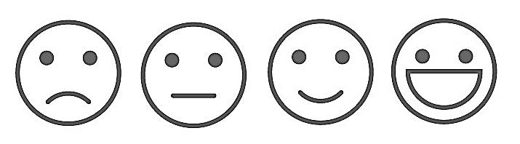
2.
3.
4.
The following are my agreed Individual Learning Goals for the course: |  | Achieved?  No/Yes | Learner Comments | Tutor Comments
1. |  | 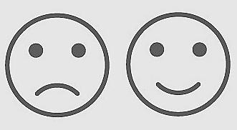
2.

Key: Ask the tutor if you need help
I am not very good at this / need support
I am ok at this / need support
I am good at this / may need some support
I am very good at this and can do this by myself

