How to join meetings as a guest in Teams
If you have been invited to a Microsoft Teams meeting, and do not have a Teams of Office 365 account. you can join easily as a guest. Here is how.
- Check your email for the Teams Meeting invite and click the Join Microsoft Teams Meeting link.
- Open Teams on the web or download the program
- Enter your name and choose your audio and video settings
- Click the Join Now button to be admitted into the meeting
1. Check your email for the Teams Meeting invite
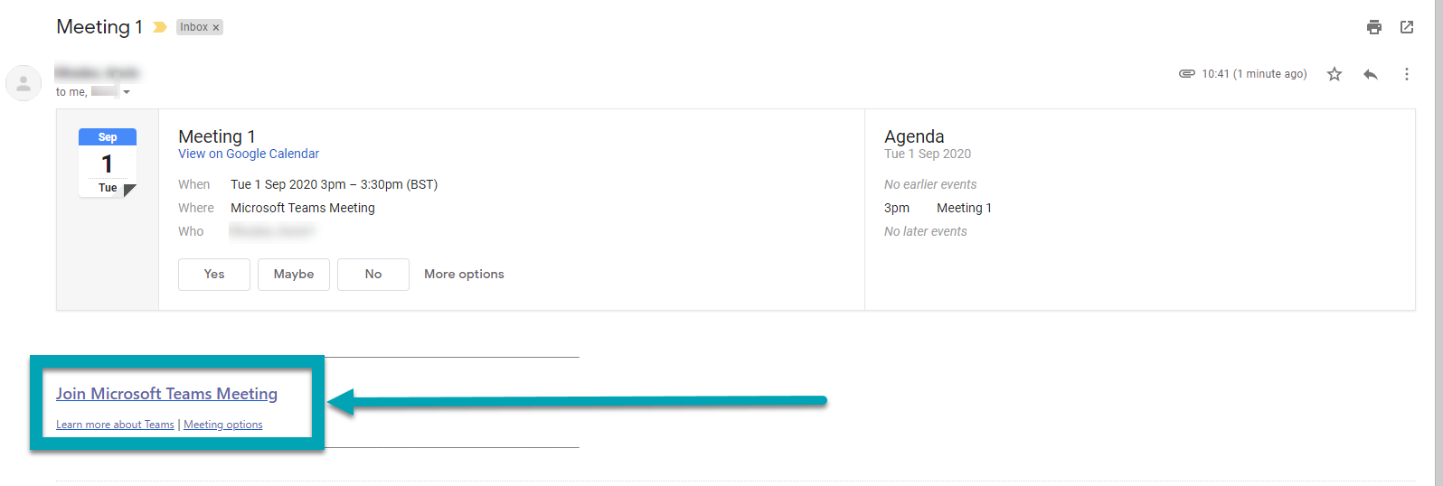
The first step in joining a Microsoft Teams meeting is simple. You will first want to check your email for the invite. You will then want to click the link on the bottom of the email that says Join Microsoft Teams Meeting. Once you click that, you also can Accept the invite to add it to your calendar in your email.
2. Open Teams on the web or download the program
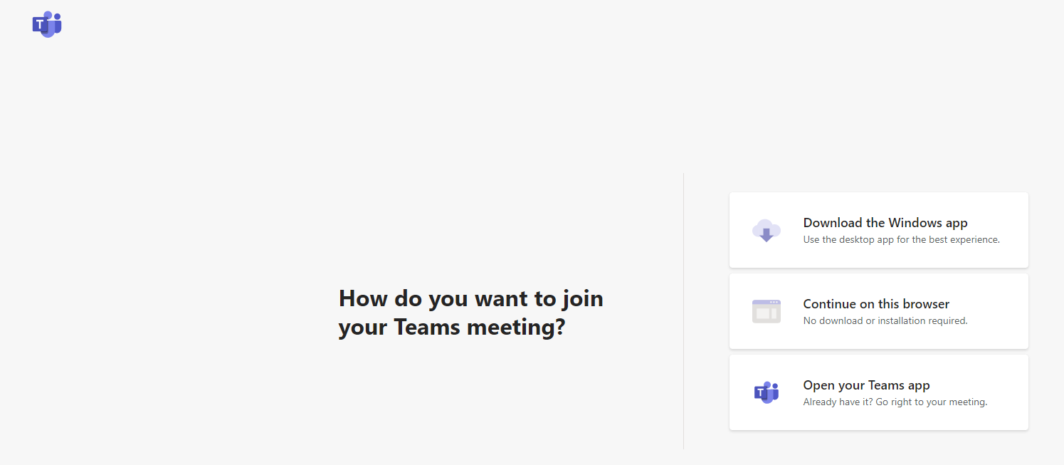
Next, you will see that after clicking the link, you will have the choice to Download the Windows app, or join on the web instead. If you choose to join the meeting on the web, you will have a web-based version of Microsoft Teams. Your browser will then ask you to use your webcam and microphone, so be sure to accept both. This ensures you will be seen and heard during the meeting.

3. Enter your name and choose your audio and video settings
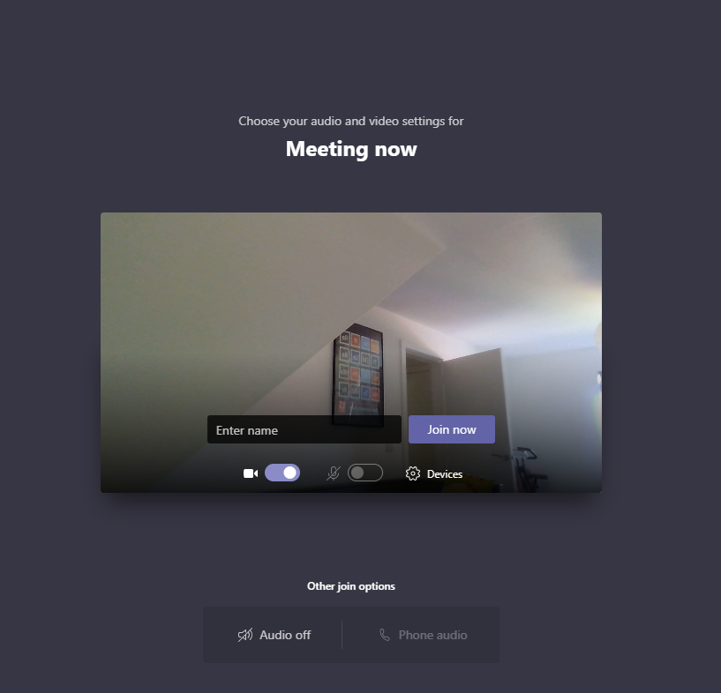
Once you have launched Microsoft Teams, you will have to enter your name and choose your audio and video settings. You can toggle off your microphone or webcam. You also can choose a different device for audio, if needed. Once you are ready, you can click the purple Join now button.

4. Join Now
Finally, you will be put into the meeting lobby. Once you are in the lobby, the meeting organiser will be notified that you are there, and you will be admitted in. If no one has admitted you to the meeting within 15 minutes of joining, you will be kicked out from the lobby, and you will need to join again. It is also worth noting that you will not have full access to some of the features in the Teams meeting.
