Hampshire Achieves ensuring Accessibility of online learning.

Ensuring equality, diversity and inclusion for online teaching, learning and
assessment
- Be aware of learners who may not be participating and explore why this may be the case.
- Consider reasonable adjustments for learners with restricted mobility, hearing or sight impairment etc.
- Consider how a blended approach can support learners for whom online learner is not totally suitable. This may include posting out paper-based resources.

Making Adjustments:
Generic:
- Discuss with learners as part of IA if there are any tools you were planning to use that they would find difficult to access and what adjustments you can make.
- With resources consider SCULPT (see below)
- Recommend tools/apps that might support their access.

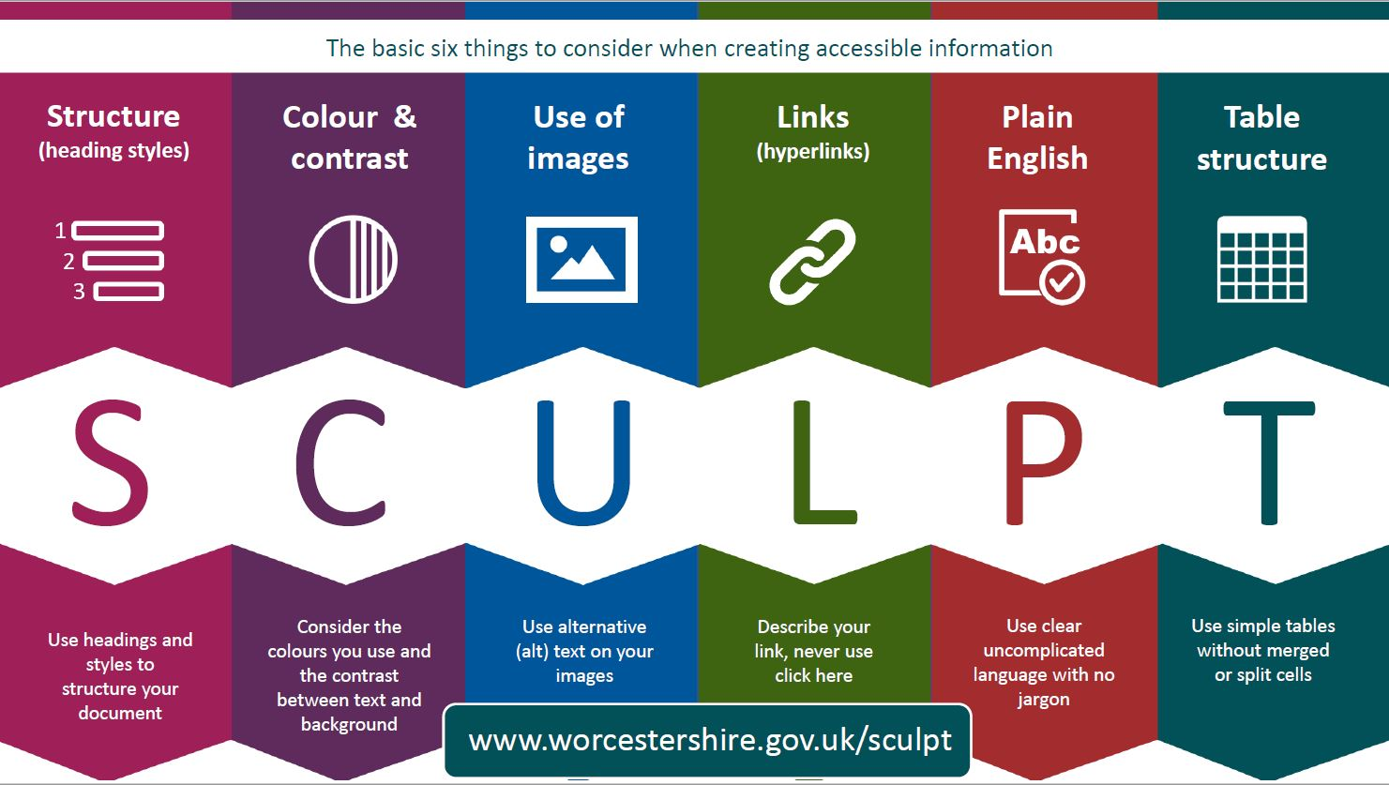

Making technology work for you: Making Technology Work for You - Interactive Poster | Excellence Gateway

Hearing impaired:
- Availability of subtitles
- Provision of resources before session
- Management of open mics to reduce noise
- Use of headset to reduce noise
- Knowledge of any software using with hearing aids
- Recording to listen back to later
- Position of mic – is it picking up laptop/PC processors sounds (whirring)
Deaf friendly remote learning: checklist for teachers | National Deaf Children's Society (ndcs.org.uk)

Visual impaired:
- Make sure learners are aware of when you are screen sharing and also slide transitioning (helps them adjust to change in brightness)
- Consider colours used, size of font etc (SCULPT)
- Be aware of supportive technologies you can recommend to learner

Additional information and CPD
ETF have a number of resources to help tutors and learners access learning:
Explore Accessibility Modules | Enhance Digital Teaching Platform (etfoundation.co.uk)
A wide range of short modules on ensure accessibility within the digital classroom, including;
- Creating inclusive content: principles
- Creating inclusive content: practice
- What is assistive technology?

Digital technologies | Special Educational Needs and Disability (excellencegateway.org.uk)
- Making technology work for you
- Making presentations accessible
- Assistive technology to support learners with SEND

My Computer My Way (abilitynet.org.uk)
Your step-by-step guide to individual adjustments you can make to your computer, laptop, tablet or smart phone to make it easier to use. It provides advice on four elements of accessibility;
- Hearing - How your computer, mobile or tablet can be made easier to use for people with a hearing impairment.
- Vision - The accessibility features that help you see websites and applications more clearly.
- Motor - Accessibility features designed to make your keyboard, mouse and mobile device easier to use.
- Cognitive - How to make reading, writing and using the internet easier on your computer, mobile or tablet

The link below puts a colour veil over the screen, so really helpful for those learners with dyslexia. You can change the intensity too so change how dark/light a shade it is. It is completely free.
https://www.aurelitec.com/colorveil/windows/download/.

Webinars to Support Remote Working
Available webinars are:
- Making the most of online learning.
- Delivering through a virtual classroom.
- Adapting content quickly to deliver online.
- Supporting learners in VLEs.
- Engaging learners in VLEs.
- Supporting learners with online reading skills.
- Making webinars more inclusive.
- Introduction to the Guide to EdTech and Essential Digital Skills Training to Support Remote Working.
- Supporting learners with writing skills.
- Enhance your powers of critical reflection.
- Supporting learners with low-level literacy skills remotely.
- Collaborative approaches to professional development: learning the lessons of lockdown.
- Releasing the genie – helping teachers and learners tap into the potential of students’ personal devices.
- Meeting the online accessibility needs of all our learners.
- Exploring, Adopting and Leading digital practices for hybrid teaching and learning.

