

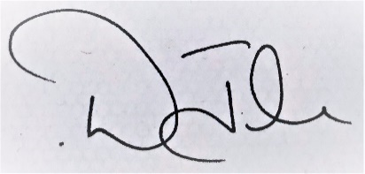

Dee John

Head of Service

(Hampshire Achieves)

Date:

www.hants.gov.uk

attended the following course

**<INSERT TITLE OF COURSE>**

and is hereby certified as completing:

* <INSERT COURSE OBJECTIVES>
* <INSERT COURSE OBJECTIVES>

**<insert learner’s name>**

**CERTIFICATE OF COMPLETION**