Learner Plan (guidance for tutor)

If completed electronically the table can be expanded to accommodate additional learning objectives/goals.
This plan enables learners to initially self-assess against course objectives and to set individual learning goals and to measure progress.
The tutor is required to insert course aim; course learning objectives; comments on learners’ progress and achievement.
The learner and/or tutor can insert learner names; one or more individual learning goal.

At the start of the course
The learner must then score themselves at the beginning of the course (circle, tick or colour) based upon

 | I am not very good at this / need support
 | I am ok at this / need support
 | I am good at this / may need some support
 | I am very good at this and can do this by myself

At the end of the course
The learner will need to re-visit at end-point of the course to re-score themselves and add in any comments on their progress and achievement.
At the end of the course the learner must identify one outcome code from the list below
1 Increased confidence
2 Improved skills for progressing to further learning
3 Improved skills for work
4 Improved essential skills (Courses that help you get English, numeracy or digital skills that are needed for work and everyday life)
5 Improved ability to support a child’s learning
6 Improved physical health
7 Improved mental health and well-being
8 Improved skills to participate in community life
9 Increased understanding of democratic values
10 Improved skills for independent living
11 No outcome area 1-10 achieved

The tutor can then use this information to update the Tutor’s Record of Progress and Achievement (HA16b)

Learner Plan Learner Name:

Tutor:_________________________ Date:__________ Course Title:_________________________________________________

Course Code:____________________________ Course Aim:______________________________________________________________

Course Objectives | How I feel at the START of the course | How I feel at the END of the course | Learner: Please comment on your progress and achievement | Tutor: Add comment on the progress you have seen
1. | 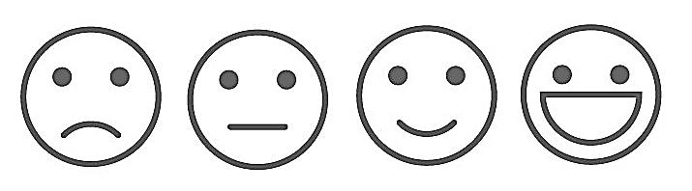 | 
2.
3.
4.
The following are my agreed Individual Learning Goals for the course: |  | Achieved?  No/Yes | Learner Comments | Tutor Comments
1. |  | 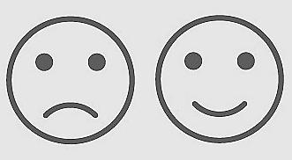
2. |  | 

Use this space if you have anything else that the tutor should know to support you or any other comment you would like to make about the course
My personal outcome from this course is (enter one code from the given list above) |  | Comment on this outcome (optional)

