**Create breakout rooms**

1. Join your meeting at its scheduled time and wait for your students to join. Your meeting will open in its own window.

**Important:** Make sure you join your meeting from the Teams desktop app (Windows or Mac) so you can create breakout rooms.

1. When your students have joined and you are ready, select **Breakout rooms** from your meeting controls.
2. Choose how many rooms you'd like to create from the dropdown.
3. Choose whether you'd like Teams to assign students to rooms **Automatically**or **Manually** if you'd prefer to assign students to rooms yourself.
4. Select **Create Rooms**.

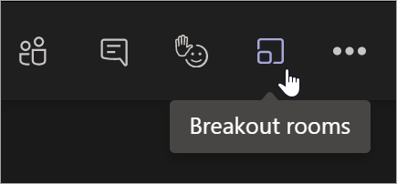

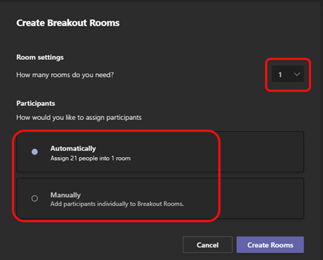

**Assign participants to rooms**

If you chose **Automatically**, participants will already be assigned to different breakout rooms.

To manually add participants to rooms:

1. Select **Assign participants**.
2. Choose the students who will share a breakout room by selecting the checkboxes next to their names.
3. Select **Assign** and then select a room for those students.
4. Repeat steps 2 and 3 until the whole class has been assigned to a room.

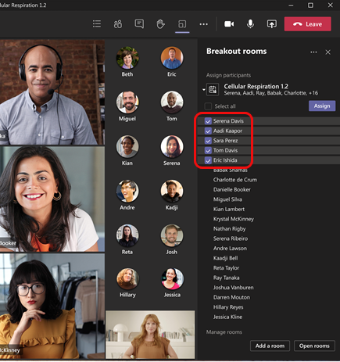

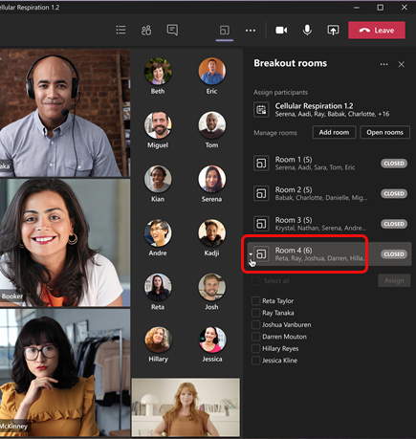

**Rename rooms**

Name your breakout rooms to reflect small student groups or projects.

1. Select **More options** More options button next to the room, then **Rename room**.
2. Type in the new name and select **Rename room**.

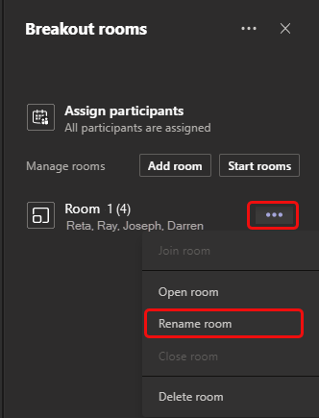

**Start breakout rooms**

To start rooms individually:

* Select **More options** More options button next to the room, then **Open room**.

To start rooms all at once:

* Select **Start rooms**.

You'll know rooms have successfully opened when their status changes to **Open**.

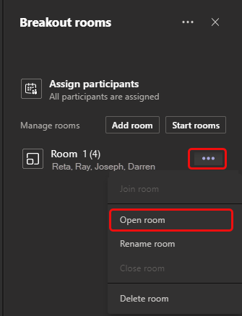

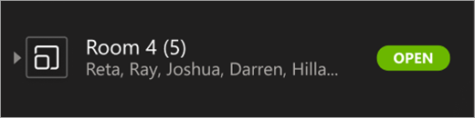

**Join a breakout room**

To join a room and check on its progress:

1. Select **More options** More options button next to the room, then **Join room**.
2. Select **Return** when you're ready to leave the breakout room and return to the main meeting.

**Send an announcement to breakout rooms**

Once breakout rooms have started, send announcements to give time updates or share prompts.

1. Select **More options**More options button **> Make an announcement**.
2. Type in your announcement and then select **Send**.
3. Students will receive a notification in their meeting chat to check for your announcement.

​

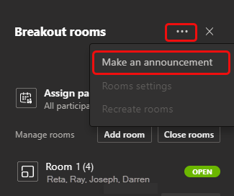

**Reassign participants**

Move participants to different breakout rooms individually.

**Note:** Currently, you can only move participants when breakout rooms are closed.

To move participants individually:

1. Expand the list of participants under a breakout room.
2. Hover over a student's name and select the checkbox that appears.
3. Select **More options** More options button and then the breakout room you'd like to move the student to.

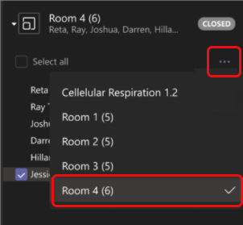

**How do I communicate with participants in their breakout rooms?**

As the meeting organiser, you can broadcast an announcement message via meeting chat to all breakout rooms so everyone in all rooms is informed of updates, changes, or timings during their breakout sessions. Click the ellipsis (…) in the breakout rooms panel and select **Make an announcement**. In the pop-up box, write your announcement then press Send. This message is labelled ‘important’ in the breakout room chat, so everyone in all the breakout rooms can see it and respond to it, including @mentioning the organizer to get his or her attention, if required.

**Chat with participants in a breakout room**

Each breakout room will have its own chat. You and students will be able to access it from your chats list and from **Chat** Open chat button  in the breakout room, just like regular meetings.

* Students will only be added to a breakout room chat when you start the room. They will be removed as soon as the room is closed.
* You will have access to all breakout room chats.
* Students can still see the chat history and any files shared after the breakout room is closed.

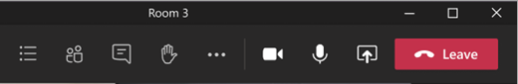

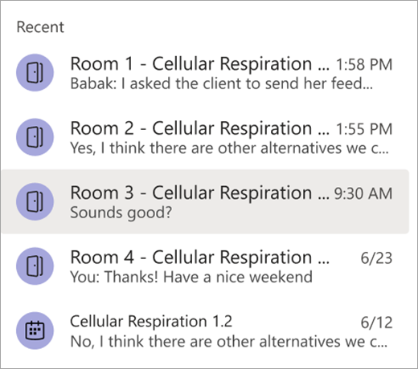

**Add or delete a breakout room**

To add an additional breakout room:

* Select **Add room**. Give your new room a name and confirm.
* Add participants to the room using the instructions above.

To delete a breakout room:

* Select **More options** More options button next to the room, then **Delete room**.

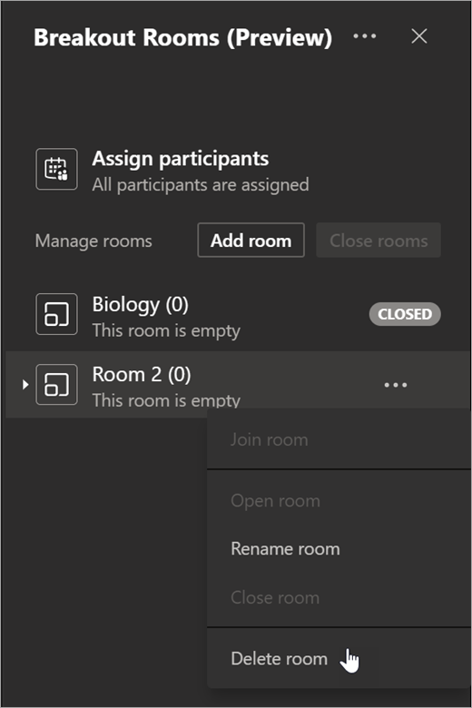

**Close breakout rooms**

To close rooms individually:

* Select **More options** More options button next to the room, then **Close room**.

To close rooms all at once:

* Select **Close rooms**.

You'll know rooms have successfully closed when their status changes to **Closed**.

* Select **Resume** when everyone is back from their breakout rooms and you're ready to meet as a larger group again.

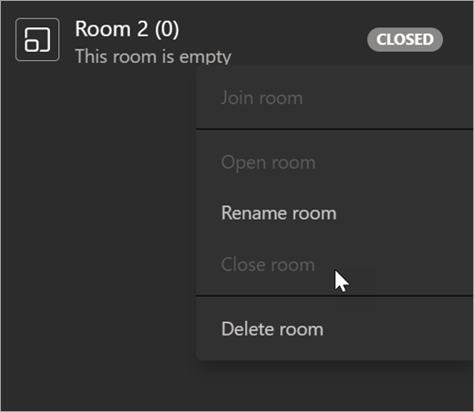

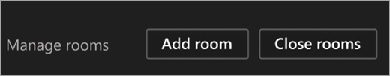

**Save files, recordings, and notes from breakout rooms**

Files, recordings, and notes from a breakout room can be accessed in its chat. You and your students will be able to access these materials after the room has closed, but students will not be able to chat or add additional materials.

**Edit breakout room settings**

To edit settings, select **More options** More options button > **Rooms settings**.

* **Automatic room setting**

By default, breakout rooms will be set to automatically move students into opened rooms. If you'd like to change this setting, switch the toggle for **Automatically move people into opened rooms**to off.

When the automatic setting is turned off, students will receive a message asking them to join a breakout room. They will need to select **Join room** before being moved.

* **Allow students to return to main meeting**

By default, this setting will be off. To turn it on, switch the toggle next to **Participants can return to the main meeting**to on.

This will allow students to leave their breakout rooms and return to the original meeting to rejoin the larger discussion.

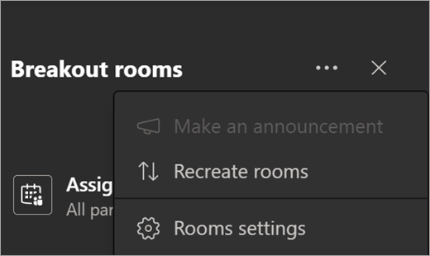

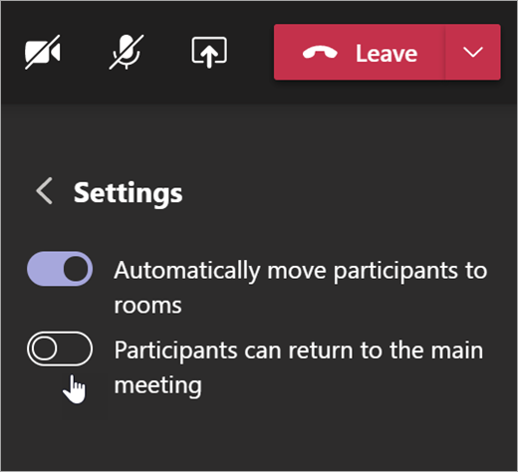

**Recreate rooms from scratch**

Return to the beginning of the breakout rooms process to start over and reconfigure your rooms and assignments.

1. Select **More options** More options button **> Recreate rooms**.
2. Follow the steps to create new breakout rooms and assign students.

