Hampshire Achieves Learner Plan (QD16c)
Using The Template

The template for the QD16c can be found at on the VLE
QD16c start of course
QD16c end of course

NB: to use the template you will need to have a Microsoft account. If you do not have one of these, you could use other similar software such as google forms

1) To create your own version, click on the Duplicate it button after opening the QD16c Forms link above

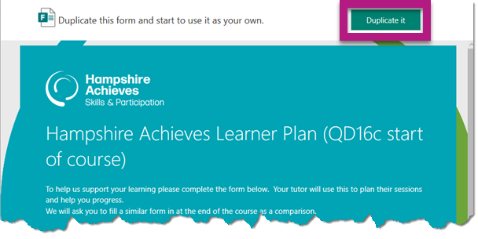

2) Once you have duplicated you can then add your course details and course objectives by clicking on the title of the Form.

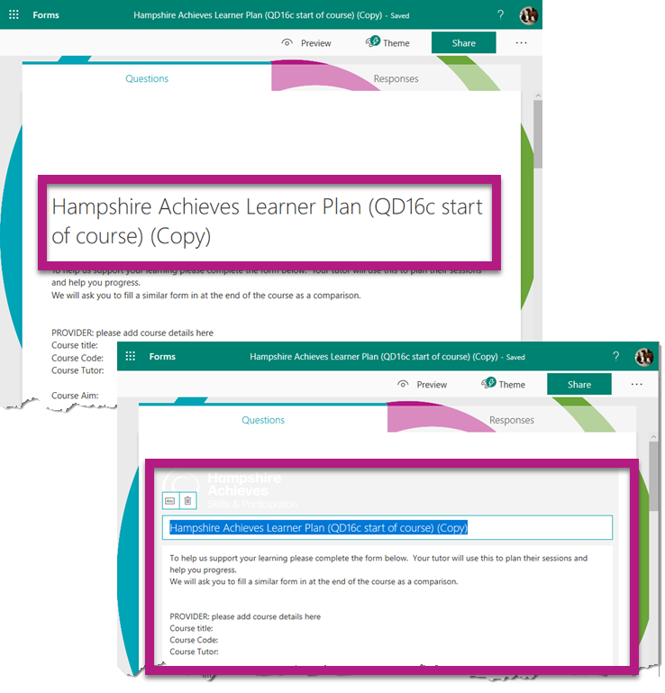

3) If you have multiple courses with the same objectives, you can copy the form for each class, and change the title section with course code and dates.
To do this just open Forms when in your Microsoft Office 365 account, select ‘My Forms’, Right click the Form to copy and select Copy.
You will also find any forms you have previously created by going to this same page

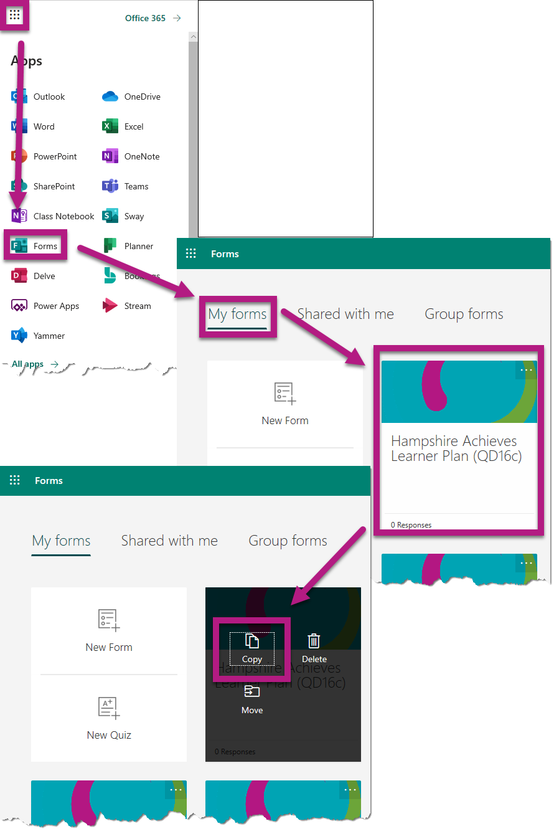

4) To send a link to your learners click on the Share/Send button and select Copy under ‘Send and Collect Reponses’. You can then send this copied link to everyone you want to complete the form.

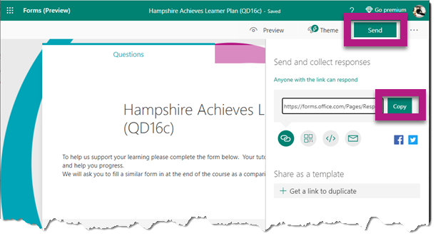Learners do not need to have a Microsoft account to complete

5) To see any responses, click on the Responses tab

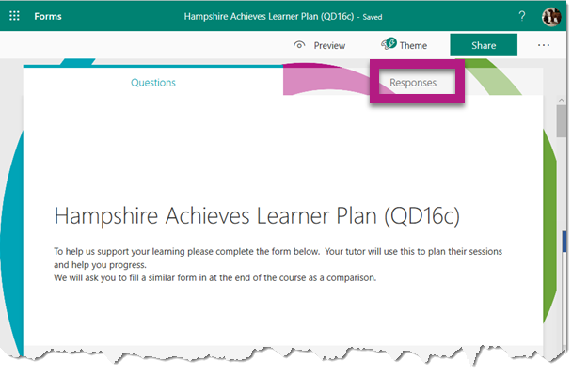

6) View Results will show you all of the current responses, Open in Excel will import these responses into an excel spreadsheet while clicking on the 3 Dots will allow you to either print out a PDF of the results, create a link to the results summary or let you delete all responses

