**Annex 1**

EBS – Adding a Course

**To be able to complete the data entry, any new delivery partners, venues and / or tutors will need to be added by MIS support.** Detailed Course Information should be provided by the delivery partner. The Course Information Sheet or CS25 spreadsheet (available on the VLE) should be used to collect the required information.

Curriculum Search:

UI – Unit Instance (top level course details)

UIO – Unit Instance Occurrence (each individual running of the course )

It is possible to have multiple UIOs linked to one UI (For example you may have a French for Beginners course that is run three times a year, once per term. You could create this as one UI with three UIOs one for each “occurrence” of the UI). However, the recommended approach is to keep to a simple model of having a different UI for each UIO .

**Course Code (UI Code)**

* For 2025-26 providers should allocate course codes themselves following three simple rules. Course codes must:
  + be no longer than 20 characters;
  + be unique;
  + start with your two-character provider prefix to ensure uniqueness across the county.

If you are uncertain of your provider prefix, please contact MIS Support (see Contacts).

* Each course (in MIS terms ‘Unit Instance’ or UI) requires a unique code.

**Add a new course (UI):**

Curriculum Search

* Check UI doesn’t already exist (if necessary) then click ‘Add UI’

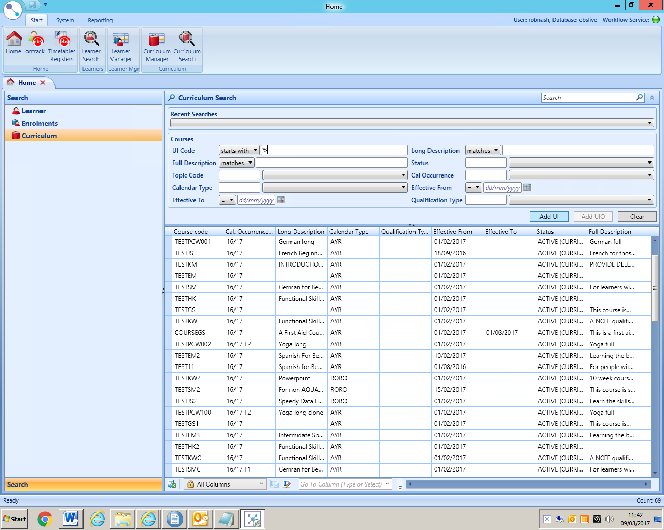

Click Here once a search has been performed. The button will be greyed out until you have completed a search.

Curriculum Search

The next page includes three tabs General / Course / Prospectus

**UI (Course) – General tab**

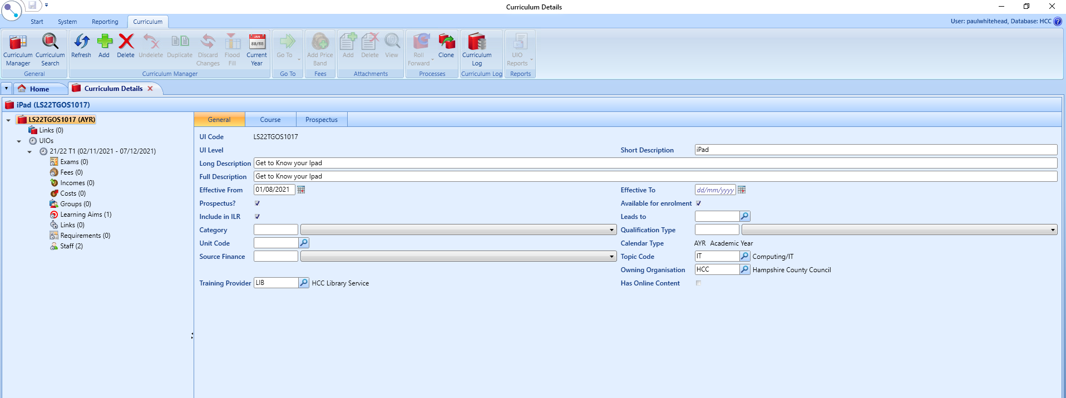

* UI Code = Course code
  + Should start with your provider prefix 2526 to indicate the academic year the course runs in followed by a ***unique*** alpha-numeric code.
* Complete all three description fields (Short, Long and Full) e.g. ‘Computing’ then ‘Learn the basics of IT’ then ‘Be confident in applying basic IT skills’. Short description is restricted to 13 characters, the long to 100 characters and the full 255 characters. The long and the full can be the same. Remember that this is just the course title. Do not include text describing the content of the course in the Full Description. Further information should be added to the Prospectus fields NOT put in any of the description fields.
* “Effective from” date is NOT the start of a particular course occurrence. Make it the start of the academic year.
* “Effective to” date should be left blank
* “Available for enrolment” Should be ticked or you will not be able to enrol leaners onto the course
* “Prospectus?” field should be ticked if course is to appear on Ontrack Prospect (ie visible to the public via the course search) or unticked if the course is not to be made visible. The majority of courses would be expected to appear in the Course Search, it’s only those courses that are restricted to a particular group of learners such as a course specifically put on for Service Users of a Day Care Centre, that would not be appropriate to advertise to the wider public and so would have the Prospectus? field unticked.
* “Include in ILR” will always be ticked for a funded course. No tick, no funding.
* ‘Calendar Type’ = “Academic year”
* ‘Topic code’ = Click on Magnifying glass, Search (Topic code=%) and select value from list (PREPE is Preparation for Employment).
* ‘Owning Organisation’ is always HCC.
* ‘Training Provider’ = is the provider for this course. If you are given a choice of two options for your centre, choose the option WITHOUT the suffix “UKPRN” here.
* All other fields can be ignored
* Then save – top left corner (white circle then save)

**UI (Course) – Course tab**

No changes required.

**UI (Course) – Prospectus tab**

**The information you enter on this screen is the information that is presented to a potential learner so you should give all the details a learner needs to help them decide whether the course meets their requirements and avoid the use of acronyms or jargon that a learner may be unaware of.**

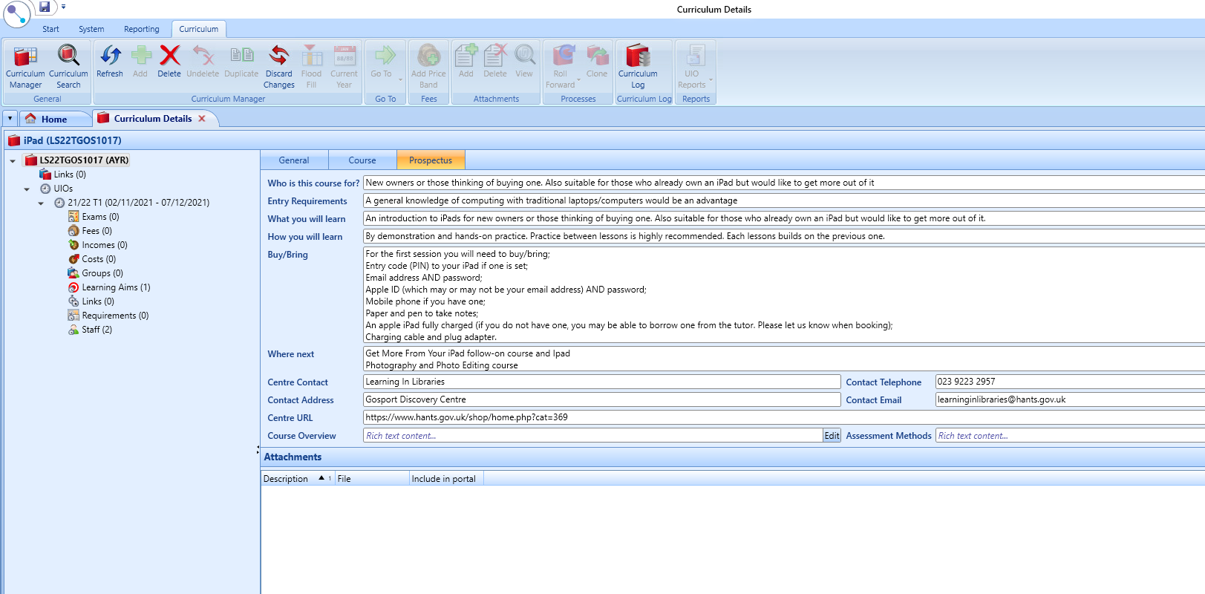

The information entered on this screen comes from the Course Information Leaflet that you are required to complete as part of the Quality Documentation (HA03). If you complete the HA03 form electronically then you will be able to cut and paste the information into here.

* “Who is this course for?” = HA03 section “Who is this course for”. Should be plain text, with no formatting, tabs or blank lines
* “Entry Requirements” = HA03 section “Previous knowledge/experience”. Again plain text, with no formatting, tabs or blank lines
* “What you will learn” = HA03 section “Learning Objectives (by the end of the course you will be able to)”. Again plain text, with no formatting, tabs or blank lines.
* “Where next” = HA03 section “Progression opportunities from this course are:” Again plain text, with no formatting, tabs or blank lines
* Course URL = this can be a link to your own web site that gives details of this course or, if you take online enrolments, a link to your enrolment form. If you have no suitable course page on your own website then this could just be a link to your home page or the page on which you give details of how to enrol. If you have no suitable website page you should copy and paste the OnTrack Prospect home page

<https://ebsontrackprospect-hcc.tribal-ebs.com/Page/findcourse>

This must be the full URL starting http:// or https://

* Course Overview should be completed by clicking on the EDIT button (see above). Enter your text in pop up window that appears and when you have finished, click on the cross (see below)

* Assessment methods = HA03 section “How you will be assessed”.

**Add a new UIO:**

* Curriculum search: search the course you need an UIO for, then click on Add UIO

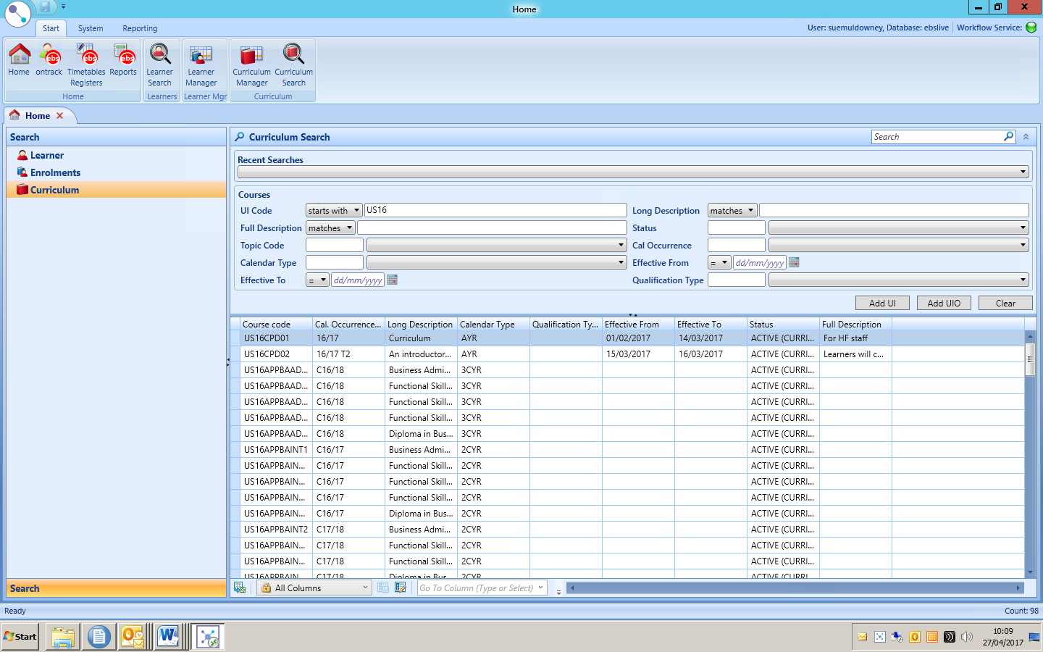

or, if following on from the UI stage above click on UIO then add

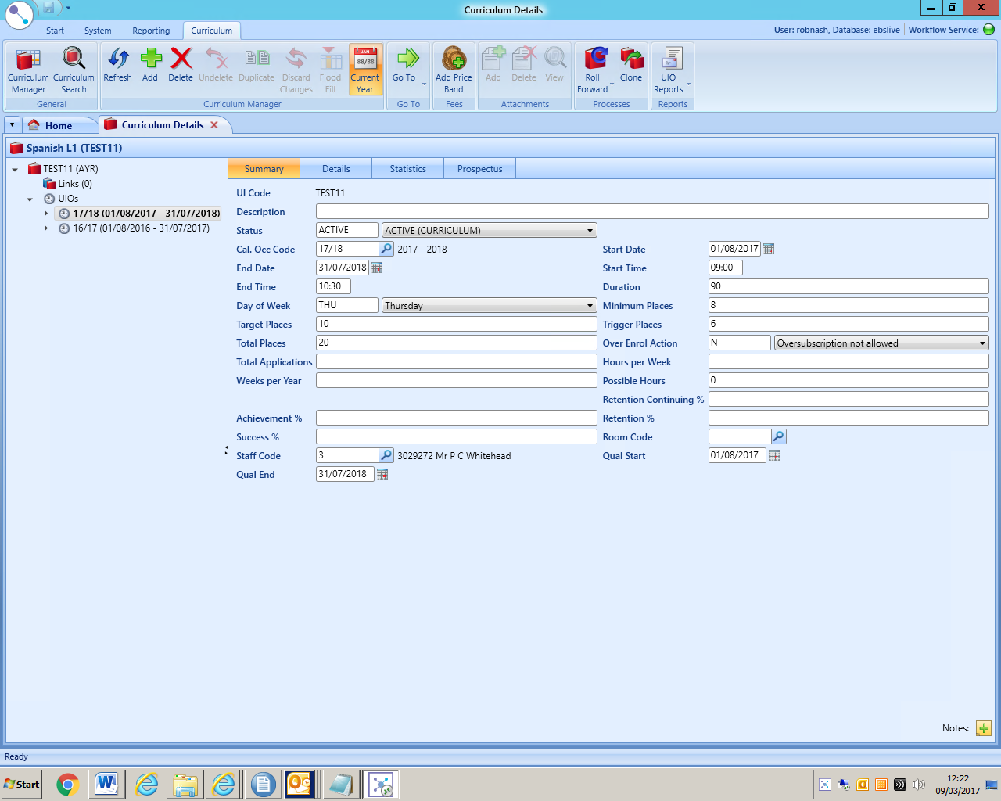

Click UIO then  
Click on the Add symbol

Add new instance occurrence pop up window will appear, choose **Yes**

**UIO (Course Occurrence) – Summary tab**

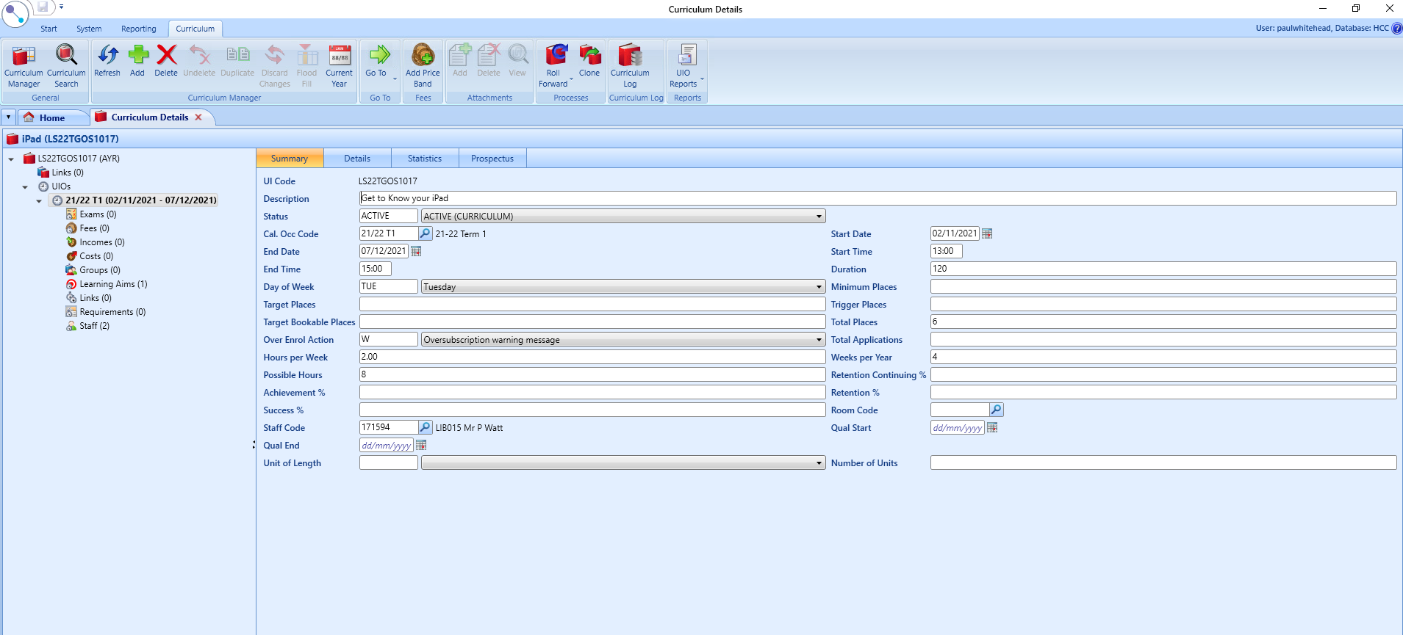

* ‘Description’ – Complete the description field with the course title. I suggest you cut and paste it from the Unit Instance.
* ‘Status’ = active
* ‘Cal occ code’ type 25 (for 2025/26) then select value from list
* ‘Start date’ & ‘end date’ = course dates
* ‘Start time’ & ‘end time’ = the time the course is running
* ‘Day of Week’ = choose day/days the course in running on
* Fill in ‘places’ if required:

Minimum places = minimum no. for course to still run

Total Application & Total Places = maximum no. on course

* Hours per week (If the course runs once per week for two hours then you just put 2. If the course runs more than once per week, put the total for the week)
* Weeks per year – how many weeks the course runs for

(Having entered the Hours per Week and Weeks per Year the Possible Hours are calculated. If this does not equal the course duration in hours, review the values given in Hours per Week and Weeks per Year. Is there more than one session a week? If so the Hours per Week needs to reflect that).

* Room Code – If your venue has more than one room available for ATL provision AND this information is recorded on EBS, add the room code.
* ‘Staff code’ = name of member of staff running the course. Click on the magnifying glass icon and search for the tutor name If the tutor taking the course has not been finalised, use tutor code 14 (Jill Speirs) to indicate the tutor is yet to be arranged. Remember to change this value once the tutor has been finalised.
* ‘Qual start/end’ = Always leave blank for Adult Tailored Learning. (This is one of the most common errors and causes problems when the ILR is verified as the Qual Start and End dates override the course start and end dates you enter when the enrolments are included in the ILR).
* Other fields can be ignored/left at their default values.

**UIO (Course Occurrence) – Details tab**

* ‘Owning (HCC) & Offering (H2050) organisation’ – Should default to the correct values IF you added them correctly to the UI. If not, you will need to add them.
* ‘Study Loc Code’ = Venue. Use the Search to find the correct value.
* Register mode- set to ‘Y’ generate register
* ‘Mode of attendance’ = Classroom/Online
* ‘Learner prospectus’ = tick (unless course is not to be advertised)
* ‘Learner Can Enquire = tick
* ‘Learner Can Apply’ = tick for it to appear on Tribal Course Finder
* ‘Learner Can Enrol’ = NO tick – We are not currently accepting online enrolments
* ‘Learner Can Drop = NO tick
* ‘Learner Can Apply, Then Enrol’ = NO tick
* ‘Can Enquire’ = tick
* ‘Can Apply’ = tick
* ‘Can Enrol’ = tick
* ‘Lot number’ – from funding agreement if applicable. If a Lot number is quoted on your funding agreement this MUST be entered here. Without this, the enrolments will not be counted towards your targets and so will not attract funding. If you do not know which lots the course relates to, contact your Contracts team. Please note that these lot numbers will be different each year.
* Accrediting body – Only if course is accredited.
* Application Process: 05 (Direct Delivery ATL) if course will appear on course finder
* Pre-course Quality checks – Leave blank if Pre-Course Quality checks have not been completed. Once the checks have been completed, you should enter the date on which the checks were done
* Post-Course Quality checks – Leave blank. Once the Post-Course checks have been completed, you should enter the date on which the checks were completed.
* All other fields should be ignored.

**UIO (Course Occurrence) – Statistics tab**

Not required

**UIO (Course Occurrence) – Prospectus tab**

Not required, all Prospectus information is currently entered at UI level, see **UI (Course) – Prospectus tab**

**UIO – Learning Aims LA1 - Aims**

* ‘Funding Year’ = 32 (2025 – 2026)
* Aim Type should be 4 (Aim that is not part of a programme)
* Aim – Use the search and search for an aim that starts with Z006 with a description containing Tailored Learning
* Learning Aim - Click the magnifying glass to get the learning aim search menu
* A screenshot of a match

  Description automatically generated

Or, search on

* Aim code starts with Z006
* Description contains ‘Tailored Learning’

And select the appropriate aim from the list.

Or you can enter a code from this list –

|  |  |
| --- | --- |
| **Code** | **Description** |
| Z0060047 | Non regulated Tailored Learning, Supported Learning and Independent Living |
| Z0060048 | Non regulated Tailored Learning, First step engagement in learning |
| Z0060049 | Non regulated Tailored Learning, Employability and transferable skills |
| Z0060050 | Non regulated Tailored Learning, Managing mental health and well-being |
| Z0060051 | Non regulated Tailored Learning, Vocational introduction - Health and Social Care |
| Z0060052 | Non-regulated Tailored Learning, Entry Level, Health and Social Care |
| Z0060053 | Non-regulated Tailored Learning, Level 1, Health and Social Care |
| Z0060054 | Non-regulated Tailored Learning, Level 2, Health and Social Care |
| Z0060055 | Non-regulated Tailored Learning, Entry Level, Construction |
| Z0060056 | Non-regulated Tailored Learning, Level 1, Construction |
| Z0060057 | Non-regulated Tailored Learning, Level 2, Construction |
| Z0060058 | Non-regulated Tailored Learning, Entry Level, Childcare, Teaching |
| Z0060059 | Non-regulated Tailored Learning, Level 1, Childcare, Teaching |
| Z0060060 | Non-regulated Tailored Learning, Level 2, Childcare, Teaching |
| Z0060061 | Non regulated Tailored Learning, Entry Level, Horticulture, Agriculture, Animal Care, Environmental Conservation |
| Z0060062 | Non reg ulated Tailored Learning, Level 1, Horticulture, Agriculture, Animal Care, Environmental Conservation |
| Z0060063 | Non regulated Tailored Learning, Level 2, Horticulture, Agriculture, Animal Care, Environmental Conservation |
| Z0060064 | Non regulated Tailored Learning, Entry Level, Manufacturing, Engineering |
| Z0060065 | Non regulated Tailored Learning, Level 1, Manufacturing, Engineering |
| Z0060066 | Non regulated Tailored Learning, Level 2, Manufacturing, Engineering |
| Z0060067 | Non regulated Tailored Learning, Entry Level, Retail, Marketing |
| Z0060068 | Non regulated Tailored Learning, Level 1, Retail, Marketing |
| Z0060069 | Non regulated Tailored Learning, Level 2, Retail, Marketing |
| Z0060070 | Non regulated Tailored Learning, Entry Level, Hospitality, Catering |
| Z0060071 | Non regulated Tailored Learning, Level 1, Hospitality, Catering |
| Z0060072 | Non regulated Tailored Learning, Level 2, Hospitality, Catering |
| Z0060073 | Non regulated Tailored Learning, Entry Level, Leisure Industries, Tourism |
| Z0060074 | Non regulated Tailored Learning, Level 1, Leisure Industries, Tourism |
| Z0060075 | Non regulated Tailored Learning, Level 2, Leisure Industries, Tourism |
| Z0060076 | Non regulated Tailored Learning, Entry Level, Creative Industries, Media |
| Z0060077 | Non regulated Tailored Learning, Level 1, Creative Industries, Media |
| Z0060078 | Non regulated Tailored Learning, Level 2, Creative Industries, Media |
| Z0060079 | Non regulated Tailored Learning, Entry Level, Digital Sector |
| Z0060080 | Non regulated Tailored Learning, Level 1, Digital Sector |
| Z0060081 | Non regulated Tailored Learning, Level 2, Digital Sector |
| Z0060082 | Non regulated Tailored Learning, Entry Level, Transport, Distribution |
| Z0060083 | Non regulated Tailored Learning, Level 1, Transport, Distribution |
| Z0060084 | Non regulated Tailored Learning, Level 2, Transport, Distribution |
| Z0060085 | Non regulated Tailored Learning, Entry Level, Business Administration, Legal, Finance, Marketing, Public Services and Enterprises |
| Z0060086 | Non regulated Tailored Learning, Level 1, Business Administration, Legal, Finance, Marketing, Public Services and Enterprises |
| Z0060087 | Non regulated Tailored Learning, Level 2, Business Administration, Legal, Finance, Marketing, Public Services and Enterprises |
| Z0060088 | Non regulated Tailored Learning, Entry Level, Science |
| Z0060089 | Non regulated Tailored Learning, Level 1, Science |
| Z0060090 | Non regulated Tailored Learning, Level 2, Science |
| Z0060091 | Non regulated Tailored Learning, Essential Skills, Pre-Entry Level, ESOL |
| Z0060092 | Non regulated Tailored Learning, Essential Skills, Entry Level, ESOL (Entry 1) |
| Z0060093 | Non regulated Tailored Learning, Essential Skills, Entry Level, ESOL (Entry 2) |
| Z0060094 | Non regulated Tailored Learning, Essential Skills, Entry Level, ESOL (Entry 3) |
| Z0060095 | Non regulated Tailored Learning, Essential Skills, Level 1, ESOL |
| Z0060096 | Non regulated Tailored Learning, Essential Skills, Level 2, ESOL |
| Z0060097 | Non regulated Tailored Learning, Essential Skills, Pre-Entry Level, English |
| Z0060098 | Non regulated Tailored Learning, Essential Skills, Entry Level, English (Entry 1) |
| Z0060099 | Non regulated Tailored Learning, Essential Skills, Entry Level, English (Entry 2) |
| Z0060100 | Non regulated Tailored Learning, Essential Skills, Entry Level, English (Entry 3) |
| Z0060101 | Non regulated Tailored Learning, Essential Skills, Level 1, English |
| Z0060102 | Non regulated Tailored Learning, Essential Skills, Level 2, English |
| Z0060103 | Non regulated Tailored Learning, Essential Skills, Pre-Entry Level, Maths |
| Z0060104 | Non regulated Tailored Learning, Essential Skills, Entry Level, Maths (Entry 1) |
| Z0060105 | Non regulated Tailored Learning, Essential Skills, Entry Level, Maths (Entry 2) |
| Z0060106 | Non regulated Tailored Learning, Essential Skills, Entry Level, Maths (Entry 3) |
| Z0060107 | Non regulated Tailored Learning, Essential Skills, Level 1, Maths |
| Z0060108 | Non regulated Tailored Learning, Essential Skills, Level 2, Maths |
| Z0060109 | Non regulated Tailored Learning, Essential Skills, Pre-Entry Level, Essential Digital Skills |
| Z0060110 | Non regulated Tailored Learning, Essential Skills, Entry Level, Essential Digital Skills |
| Z0060111 | Non regulated Tailored Learning, Essential Skills, Level 1, Essential Digital Skills |
| Z0060112 | Non regulated Tailored Learning, Life skills: healthy eating/cooking |
| Z0060113 | Non regulated Tailored Learning, Life skills: first aid |
| Z0060114 | Non regulated Tailored Learning, Life skills: household budgeting, financial literacy |
| Z0060115 | Non regulated Tailored Learning, Life skills: lipreading |
| Z0060116 | Non regulated Tailored Learning, Life skills: British Sign Language |
| Z0060117 | Non regulated Tailored Learning, Life skills: parenting skills |
| Z0060118 | Non regulated Tailored Learning, Life skills: environmental sustainability |
| Z0060119 | Non regulated Tailored Learning, Life skills: volunteering, active citizenship |
| Z0060120 | Non regulated Tailored Learning, Life skills: managing life transitions |
| Z0060121 | Non regulated Tailored Learning, Preparation for Access to Higher Education |
| Z0060122 | Non regulated Tailored Learning, Humanities and social sciences |
| Z0060123 | Non regulated Tailored Learning, Languages |
| Z0060124 | Non regulated Tailored Learning, Creative Arts |
| Z0060125 | Non regulated Tailored Learning, Performing Arts |
| Z0060126 | Non regulated Tailored Learning, Physical activity |

**Note that many of these learning aims include the Level, and care should be taken to select the appropriate aim**.

* ‘Funding Model’ = 11
* ‘Funding Source’ = 105 (ESFA – Adult)
* Programme Type – leave blank
* Partner UKPRN = Select from drop down. Leave blank if you are part of HCC. For H2050 External Partners, if you have notified MIS support of which organisations have been awarded contracts, they should be included in this list. If you can’t find them, they will need to be added by MIS Support.
* Default Learning Aim should be ticked.
* Planned Hours field here should be left blank.
* Other fields should be left at their default values.

**UIO – Learning Aims LA2 – Aims**



* ATL Purpose – Set this to the appropriate value that you anticipate will be the purpose for the majority of learners who enrol on this course. You will be able to override this on the enrolment of any learner who has a different purpose. Available values are:
  + Engaging and/or building confidence
  + Preparation for further learning
  + Preparation for employment
  + Improving essential skills including English, ESOL, maths and digital
  + Equipping parents/carers to support children’s learning
  + Health and well-being
  + Developing stronger communities
* AFL Prov Type – Set this to 1 if the course is a Family Learning course, otherwise leave blank.
* All other fields should be ignored.

**UIO – Learning Aims LA3 – HE**

Not required

**UIO (Course Occurrence) – Learning Aims LA4 – Funding**

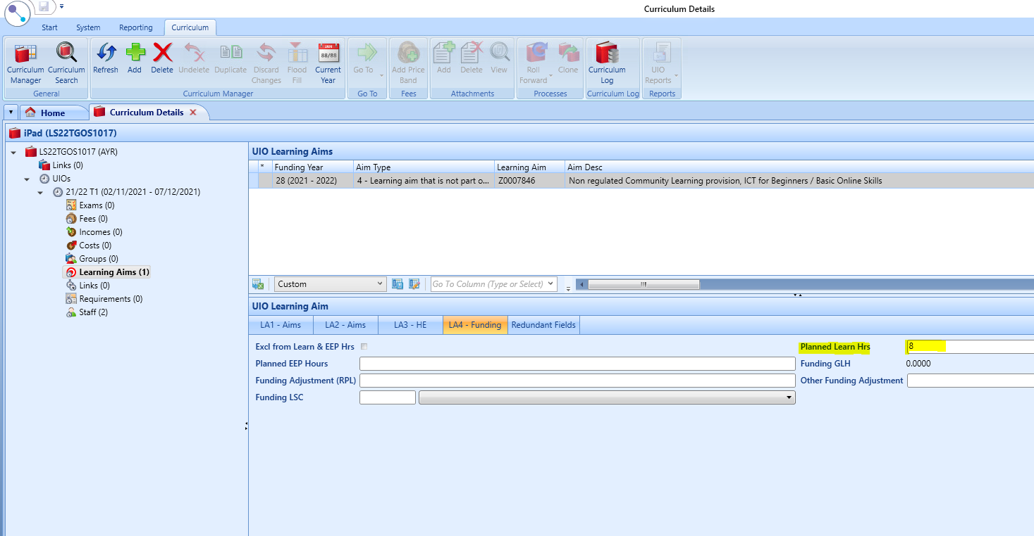

* ‘Planned Learn Hrs’= Total GLH of the course
* Leave other fields blank
* Save.

**Your course is now created** and available to take enrolments. Sometimes though, circumstances arise which mean details need to be changed. See below.

**Informing Hampshire Achieves about any Course Changes**

Providers with access to the MIS system may inform us of changes by changing the details on the system.

To cancel a course, change the course status to

INACTIVE – if the course started but has then had to be cancelled part way through  
WITHDRAWN – if the course did not start.

If the course did not start, any learner enrolments on the course need to be removed. Contact MI Support to arrange this.

If the course started but was then cancelled, any enrolments should have their Progress status changed to the appropriate “Withdrawn” option that best describes the reason for withdrawal. If you don’t know the reason, use “other reason” rather than ‘not known’. The progress date must then be set to the date of the last session that took place. (See Adding a Learner and Enrolment Guidance).

If you have already created the Register Event on Shape, you will either need to delete the event (if the course never started) or de-activate the cancelled sessions (if the course started but was then cancelled before the planned end date) to ensure that the register sessions are not counted as “unmarked” against the tutor. Contact MI Support if you are unsure how to do this.

**EBS Shape (Register Module)**

**To access EBS Shape, either:**

**Select Shape from Login options**



Or, from EBS Central, select timetables / registers to open up EBS Shape



**Once your course(s) is/are created, you will need to generate the register(s). Select Register and Event Generation,**

You can generate the registers individually or in a batch – so long as they all start with the same prefix. Use Course Code ‘starts with’ or ‘matches’ as appropriate. Click on ‘Generate’ when valid records are confirmed in the search results. An event number will be generated for the register, which is what the tutor will see as their reference on Ontrack and is also another criteria to search on when updating or checking registers etc.



**Finding the Register**

You can search for a register in EBS Shape either by the event code (1), course reference number(2), staff reference(3) or learner reference number(4). Click on the appropriate icon to open up the search box

4

3

2

1

Use the information you have to search for the relevant register. The search results will be shown in the box on the right.

**During the Course – EBS Shape (Register Module)**

Attendance for all courses must be recorded after each session by the tutor. If they have access tutors should mark the registers using the On-track system. (A paper register for each session may still be required for health and safety purposes etc). If the On-track system is not used, then a paper register should be used and you then will need to plan for the attendance information to be collected and entered promptly onto the MIS within 48 hours of the session finishing. A blank register proforma is available on the VLE for use when a paper register is necessary.

Available register marks are:

Punctuality is monitored and lateness recorded. On a manual register/ Ontrack the tutor should record how many minutes late, but if you are entering the data on EBS Shape, the minutes attended is recorded. On EBS:

* click in the cell where lateness is to be recorded.
* Right click to open up the menu
* Select ‘Display’ to open up the sub-menu and select ‘Both’.

* An additional set of columns will be displayed, enter the minutes ATTENDED in the right hand column, having marked ‘L’ in the left-hand column.



**Adding Learners to the Register**

**As learners are enrolled on the course, their names and reference numbers are automatically added to the register.** It is possible that there may be a few learners that have not yet been entered onto the MIS in time for the first session. In this case the tutor should record their attendance on the Ontrack register by using the ‘Add’ button and keying in the name manually. The marks can then be merged when the enrolment is processed. Contact MI Support for information on how to do this. Learners entered manually by the tutor will not be funded until the enrolment form has been processed and the marks merged.

**Changes to Course Details**

Sometimes it is necessary to cancel or change the course details, e.g. change of tutor. Once you have generated the register, any amendments to the course information will NOT be updated on the register, (this does NOT apply to enrolments, these are automatically added / updated).

If a course has had to be cancelled without starting, the register event will need to be deleted. On the EBS intro page search for the course either by register event or the course reference. Click on the delete icon.



For other changes; if the course has not started, you can delete the register event (as above) and regenerate the register once the Course Details have been amended on EBS Central. If the course has already started, updates need to be made manually, contact MIS support for assistance with this.