# Learner Search

**Adding a New Learner**

* Before adding a new learner, you should ensure you have done a thorough search to ensure that there is no existing record for the learner. Bear in mind when searching that the learner could have moved address, changed name or given different information on previous enrolments. For example, a learner may have previously enrolled as Robert but has written his name as Bob on subsequent enrolments.
* The recommended procedure for ensuring the learner is not already on the MI system before adding them as a new learner is as follows:
* Before starting the search, click on the “Clear” button to ensure all previous search criteria are removed



* Enter the learner’s date of birth and press Return
* Check that none of the learners found are the learner you are looking for
* Assuming no match is found, again click on Clear to remove the date of birth and then search on Postcode.
* Assuming no matching learner is found, click on Clear again and then enter the learner surname – either partially or fully as appropriate. You can search for partial surnames by changing the “matches” in the search criteria to “starts with” or “contains” or whichever is most suitable. You change that by clicking on the dropdown next to “matches”. If it’s a name like McDonald you could search for “CONTAINS” Donald in case they were previously entered as Macdonald. To do that change ‘Matches’ to ‘ Contains’.
* If there are a lot of matches, without first clicking on Clear, add the learner’s forename (either partially or fully as above) to focus the search and again check none of the returned records are the learner you are looking for.
* Having searched on date of birth, postcode and name we can be reasonably certain there is no matching learner and so we can carry on and **Add** a new learner

Please note that you should search by one criterion at a time and so it is important to click on Clear between searches otherwise you will be searching for matches with ALL the criteria which may mean you miss near matches.

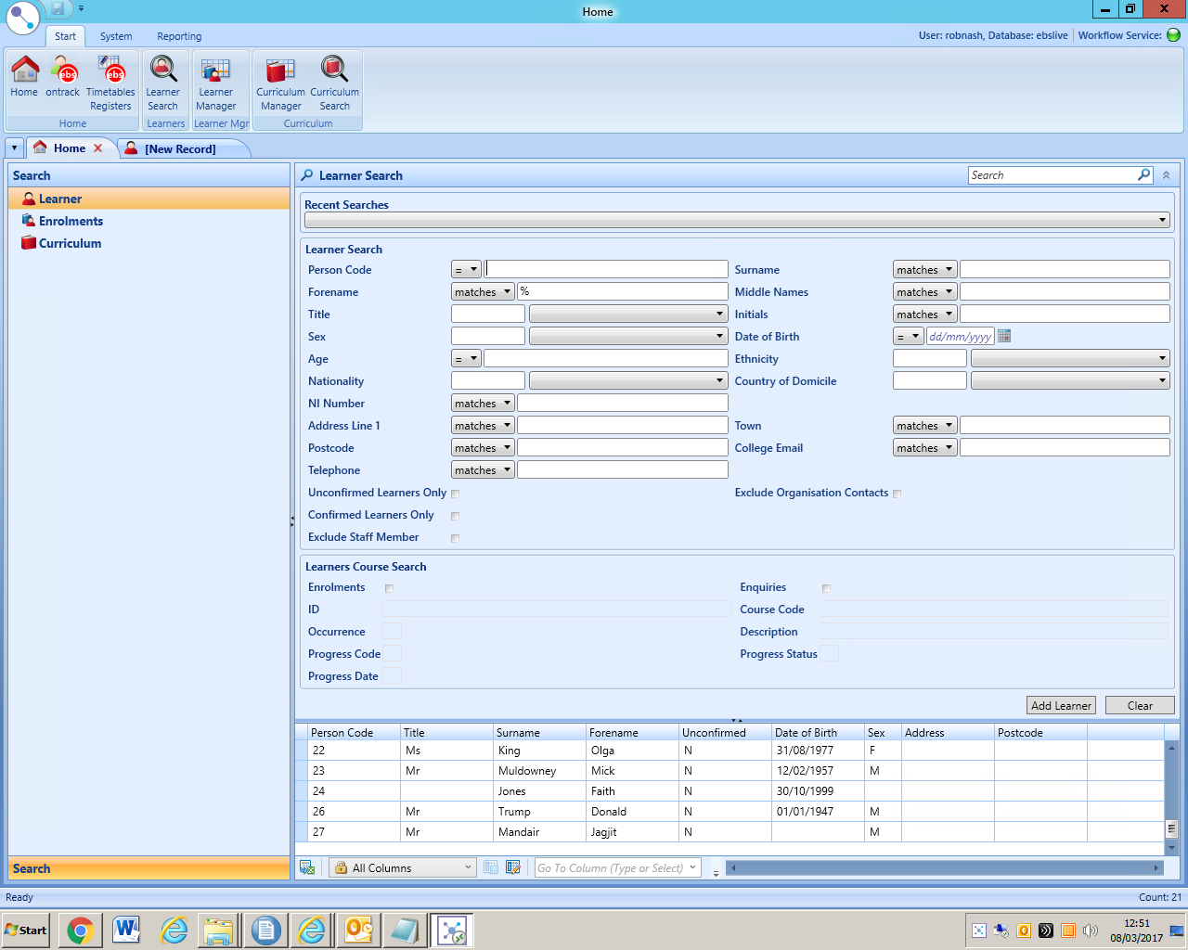

Clear search

Search for learner by Name or even Code (%=default)

If no search result use   
Add Learner

* If you do find an existing learner record please check the details are correct and update or add as required. If the address has changed please ADD A NEW ADDRESS (Add Address button top left of screen), please do not change the current address unless you are correcting a mistake. You need to draw a distinction between *correcting* a learner’s address and recording a *change of address* because the learner has moved house. In the first case, where there is an error in the learner’s address or postcode then these should be corrected by changing the recorded address. In the second instance, where a learner has moved, do NOT change the address. Instead, you should add an address to the existing learner record using the Add Address button.



**Learner tab:** Complete learner details

Complete the mandatory fields name, title, address, and DOB. (The gender field will be set automatically from the information in the title field).

Also add mobile phone number &/or landline number and email address.

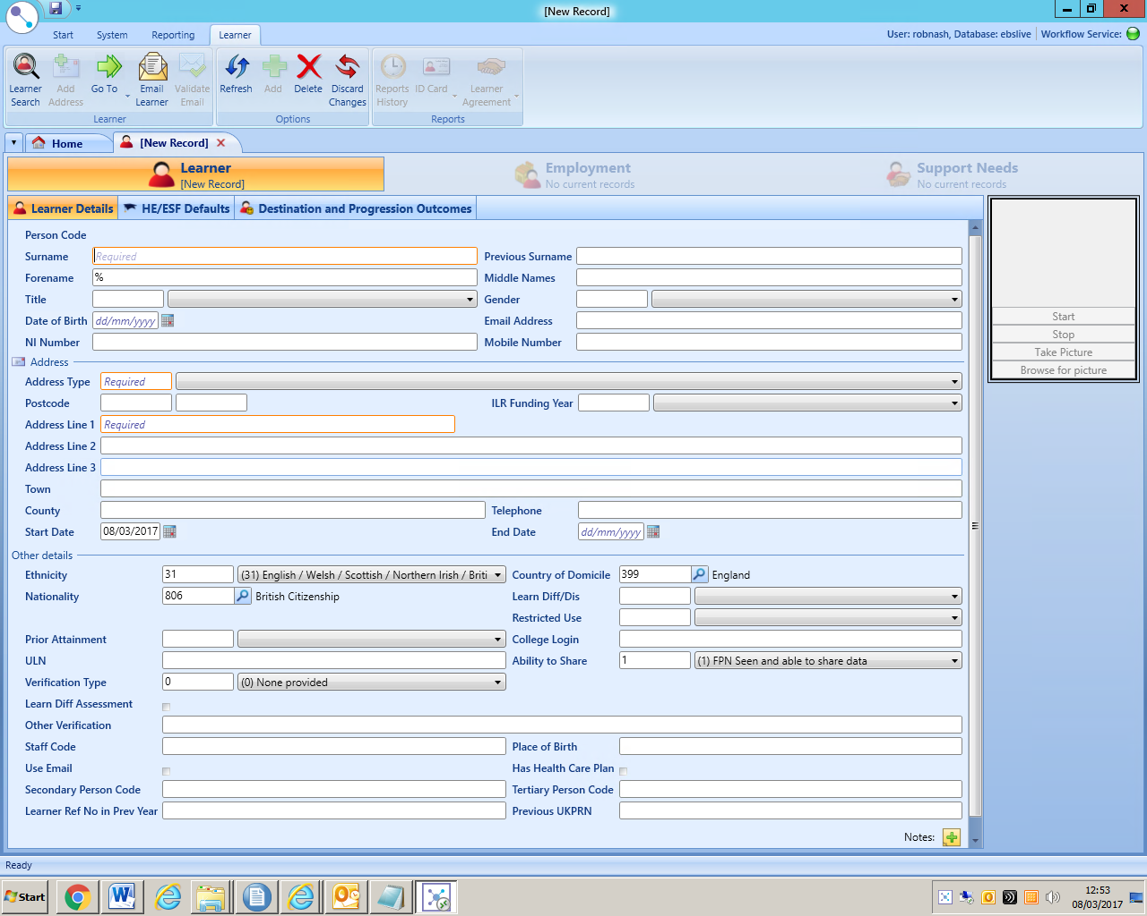



Note for the Address:

* Use Address type HOME (the default) not Permanent. Address Type should always be Home. Work addresses should not be used; we require the learner’s **home** address because the eligibility rules are based on where they live.
* ALWAYS enter the postcode and look up the address. Click on the magnifying glass to the right of the Postcode field and you will see a list of matching addresses to choose from.  This means you don’t have to manually enter the address, just select the correct house name / number.
* If the address you are looking for is not on the list then THE POSTCODE YOU ENTERED IS INCORRECT.
* Please check the postcode before manually entering an address.  The simplest way to do this is just to google the address you are looking for or use the Royal Mail Postcode Finder at https://www.royalmail.com/find-a-postcode.

Postcode lookup is far more reliable and accurate than the postcode on the form so if the address you want is not found on the postcode you entered then either the learner has written the wrong postcode or you  have mis-read it so check the address on Google/ Royal Mail and only after you have verified the postcode is correct should you manually add the address on ebs.

* DO NOT add ILR Funding Year to the address details.
* The “Start Date” in the Address panel of the Learner details refers to the date from which this address is valid. It must be on or before the date of the first enrolment for the learner. When adding a new learner, it is recommended to use either the start of the academic year (1-Aug-2025 for academic year 2025-26) or the start of the term to avoid using a date after the start date of the course the learner has enrolled on. Do not use the date of data entry unless you are sure the enrolment is being added before the course starts.

Under ‘other details’ sections please enter

* Ethnicity,
* Nationality – if the learner has indicated they have entered the country through one of the Afghan, Ukraine or Hong Kong resettlement schemes please enter the relevant code
* Afghanistan = 602
* Hong Kong = 669
* Ukraine = 845

Otherwise there is no need to update this field.

* Learn Diff/Dis
* ‘Verification type: none provided

Once completed don’t forget to Save

Once saved, Additional Sections need to be completed, use the menu at the left-hand side.

**Support Needs**

You only need to complete this section IF the Learner has responded ‘YES’ to the Learning Difficulty / Disability question, then click on **Support Needs** (left hand side of screen) to open up the in-put screen.

Click **Add** and enter the learning difficulties or disabilities declared one at a time.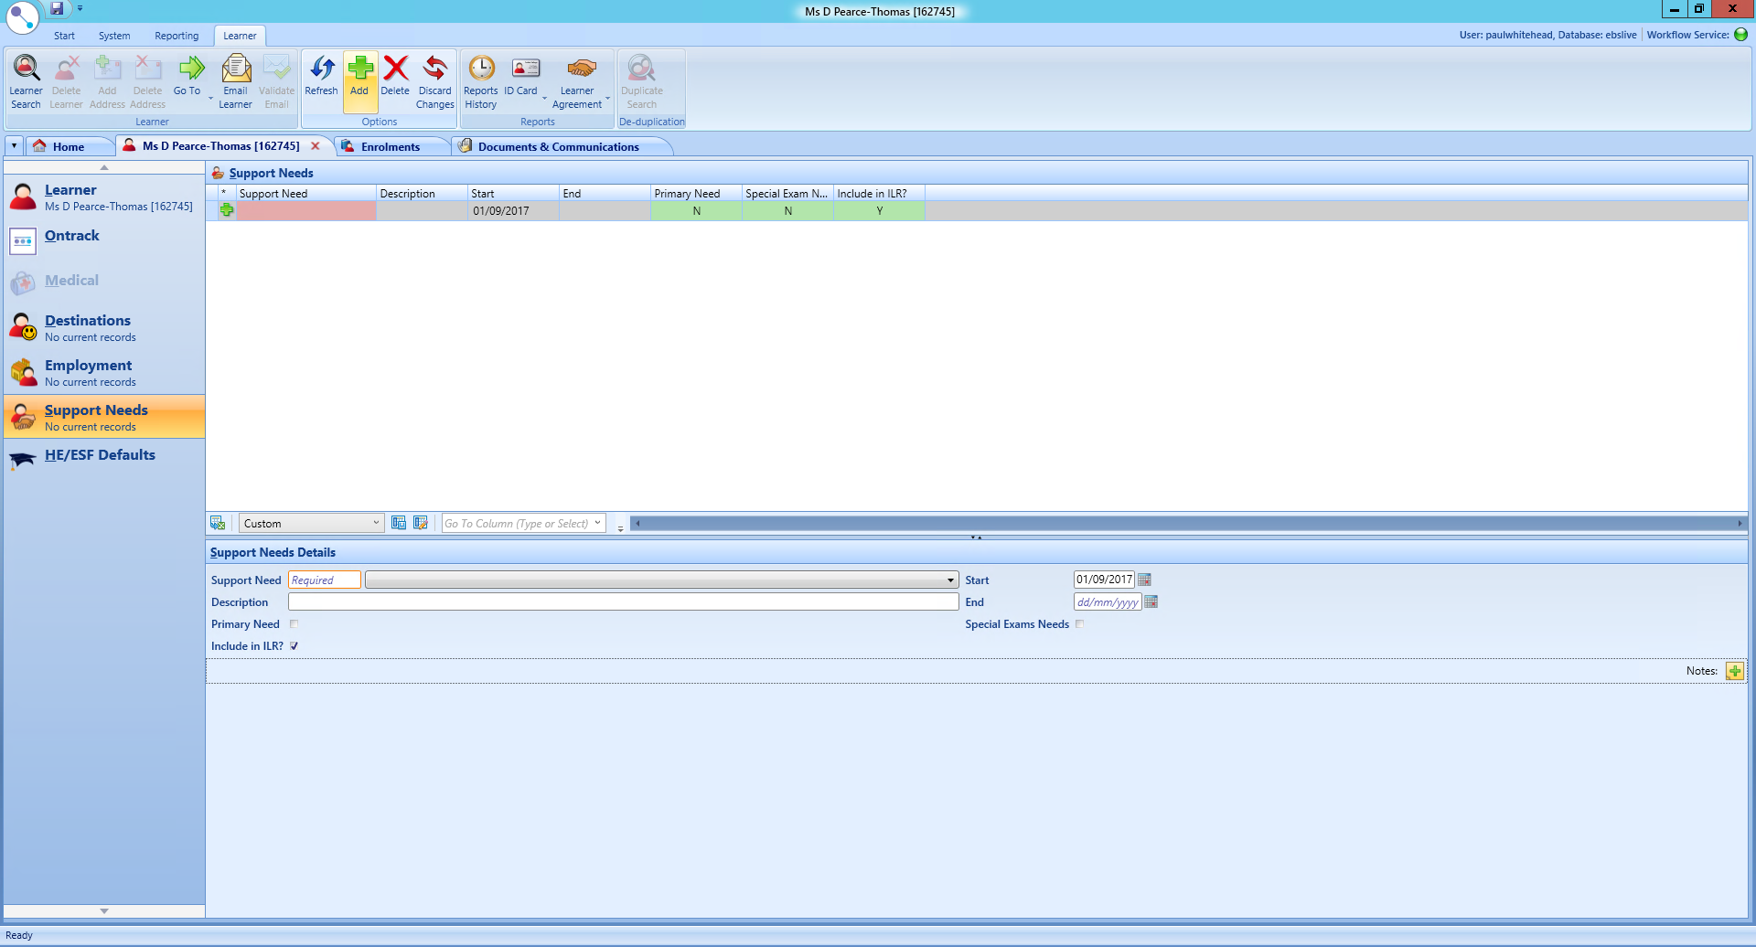

You’ll need to ensure that one row is identified as the primary aim **even if there is only one row.** Start date = start of course / academic year.

You can also add notes in the description box if relevant.

**Employment Status**

This section must be completed for ALL learners. To do this, in the left-hand menu click on Employment & Placements.

Add a new record to the lower table, Learner Employment, by clicking on “Add Employment”. If you mistakenly click on Add and find the record you are creating is in the top section, discard your changes and try again.



Fill in the fields as required / appropriate.

* Employment status – select value from the list
* Date Status Applies – this should be a date BEFORE the learner’s first enrolment in the academic year, e.g. the date they signed their enrolment form.
* Self Employed? - If applicable, click in the box to set to ‘Yes’.
* If the learner is employed, you also need to enter the Employment Intensity and Length of Employment.
* If the learner is not employed, you need to complete the length of Unemployment field.
* In either case, enter the benefit Status field as required using one of the following values:

1 – In receipt of Job Seekers Allowance

4 – In receipt of Universal Credit

5 – In receipt of Employment and Support Allowance (all categories)

6 – In receipt of other state benefits

Leave the field blank if the learner is not in receipt of any state benefits.

Be careful not to complete the wrong field – length of Employment instead of Length of Unemployment when Unemployed or vice versa. These would be errors in the ILR and need to be fixed before the enrolment can be funded.

Having saved all your learner’s personal information, you are now ready to enrol them on their chosen course.

**Enrolling Learners**

Find the learner to be enrolled and click on the Enrolments tab

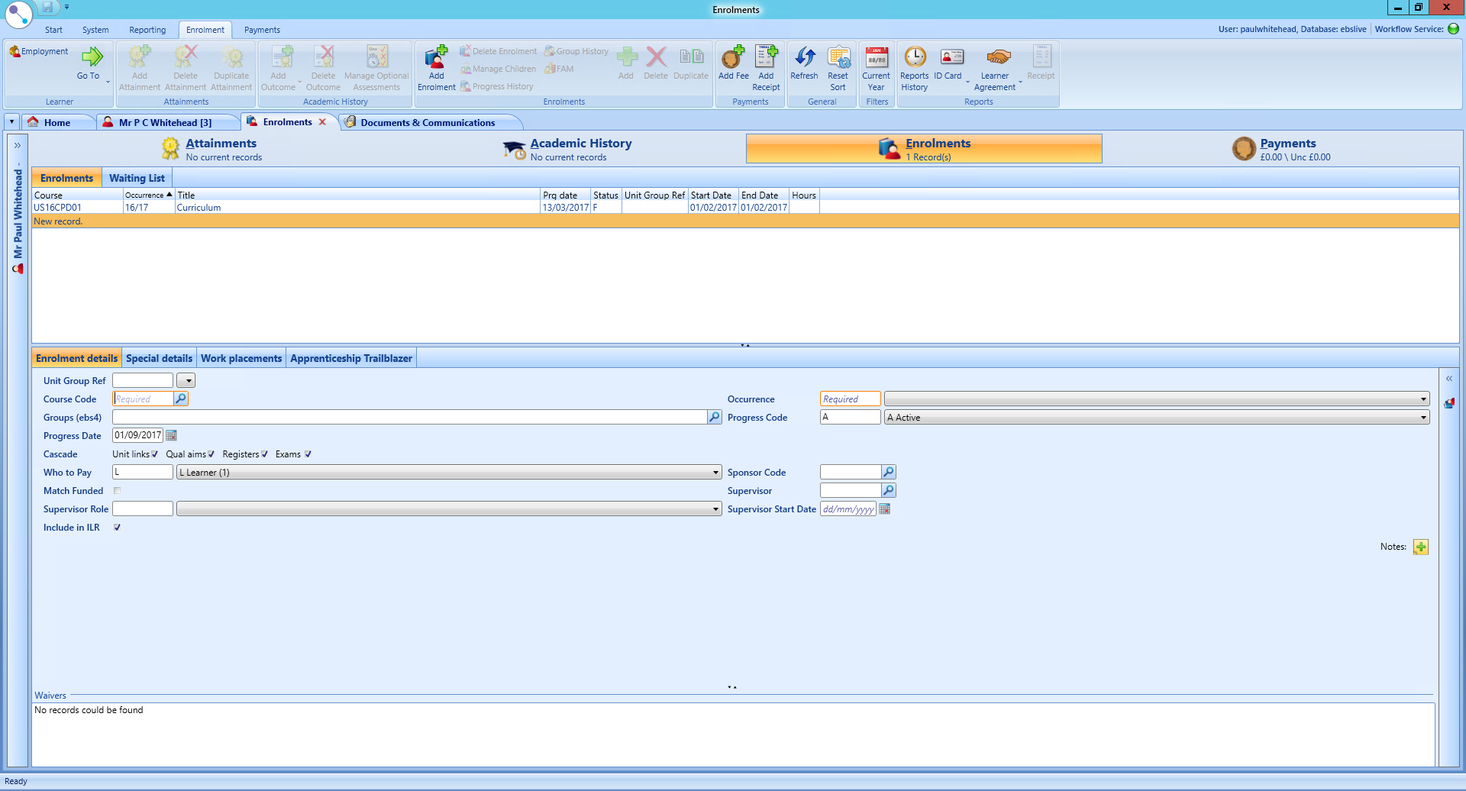



If the New record line is highlighted (as in above example) move onto the Enrolment details, otherwise click on the Add Enrolment button

**Enrolments tab:**

**Enrolment details**

* Course code: course learner is enrolling on (will need to search for correct course or type first few characters of code and select from the list of matches)
* Occurrence code will fill in automatically if there is only one. If you have several occurrences against one course code, select the correct occurrence.
* Progress code - the default ‘Active’ should be set – if not select ‘Active’ from the options available.
* Progress date – The date on which the Progress code first applies so for a progress code of “Active, this will be the start date of the course, or for a learner starting late, the actual date they start. Note, this defaults to today’s date but should be overwritten.
* Include in ILR – Should be ticked for all funded enrolments to ensure they are included in the ILR. If unticked, enrolment will not be treated as a funded enrolment. If unticked by default, check the Course Details.

**Special Details Tab**

* There are only two reasons to use this tab at the enrolment stage, to amend start dates for learners joining a course late, or to override the default Enrolment Purpose. To open up the fields to be able to report information, click in the ‘Use Special Details’ box at the top of the screen.

1. For a learner joining a course late, the start date is not the standard start date for the course. Change the Register Start Date AND ‘ILR Aims Special Start Date’ to the learner’s personal start date.



1. For a learner who has indicated on their enrolment form that the purpose of their enrolment is something which differs from the default purpose you added to the course, enter the personal ACL Enrolment Purpose.

**Updating Enrolment Information at the End of the Course**

All enrolments need to be updated at the end of the course with the learner completion and achievement information.

Using the Menu at the Right hand side of the home screen, select Enrolment, clear the search screen and search for your learner(s) by name / course code.

Select the learner by clicking on the correct record to open up the details.



Referring to the HA16B completed by the tutor to confirm the achievement status of each learner, change the Progress Code as appropriate.

Learners that are recorded on the HA16b as having completed the course and achieved their learning objectives should have a final Progress Code of CA = Completed and Achieved.

Those that are recorded on the HA16b as having completed the course but not having achieved should have the Progress code set to CC = Completed Course without Achievement.

Learners who withdraw from the course should be recorded with one of the W progress codes with the precise value determined by the reason for withdrawal. Avoid the use of ‘Withdrawn – Not Known’.





A learner who enrols but then does not attend any sessions is considered a “non-starter” rather than to have withdrawn and the enrolment should be removed from the MIS. You will need to email MIS Support (see contacts) to have the enrolment removed. Such enrolments do not affect your achievement rate and are not eligible for funding.

The Tailored Learning Outcome is held in the Special Details on EBS. You will need to activate the Special Details by ticking the box “Use Special Details” before the fields will accept data, (see ‘Special Details Tab’ above).

The Tailored Learning Outcome for each learner should be entered by the tutor in the Outcome column on the HA16b using one of the codes on the form. These values are also available in the Dropdown box for the “Tailored Learner Outcome” field in the Special Details of the enrolment on EBS.

**Please note that an outcome is required for learners that withdraw.**



Select the appropriate value from the drop down for “Tailored Learning Outcome”

**Recording Learner Destination and Progression (NOT REQUIRED FOR ATL)**

Open up the Learner Record and select ‘Destination’ from the menu at the left hand side of the screen. To add the destination, click on the ‘Add’ button, and using the drop down menus select the appropriate funding year (2025/26 = 32), and Outcome Type, and enter the start date. A screenshot of a computer

