Please use this form to tell us what you think of the course and what else you would like to do

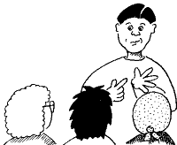
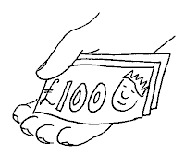

My course was

And it finished on

It was … | Very good | OK | Not very good
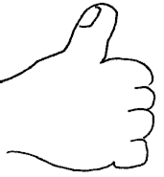
What I really liked was …

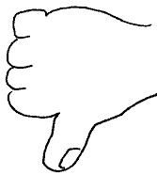
I did not like …

I have learned to …

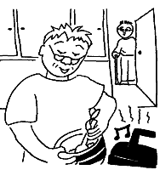
Now I can …

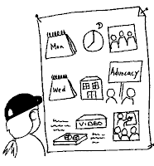
What I want to learn next is …
?
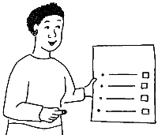

My name is

