**Please use this form to tell us what you think**

**of the course and what else you would like to do**

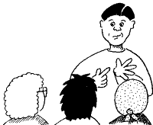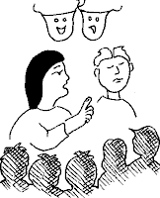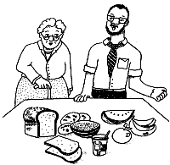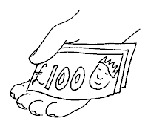

# My course was

**And it finished on**

|  |  |  |  |
| --- | --- | --- | --- |
| **It was …** | **Very good** | **OK** | **Not very good** |
| **What I really liked was …** | | | |
| **I did not like …** | | | |
| **I have learned to …** | | | |
| **Now I can …** | | | |
| **What I want to learn next is …**  **?** | | | |

**My name is**