Moodle Forums – Quick Start Guide

Table of Contents
Moodle Forums – Quick Start Guide 1
Introduction 1
Creating a Forum 2
Starting a Discussion 3
Tips for using Forums in Teaching (Staff) 4
Setting Expectations 4
Icebreaker Activity 4
Creating Effective Discussions 4
Moderating Online Participation 5
Netiquette for Forums (Staff & Students) 5
Do … 5
Don’t … 5

Introduction
Forums are a tool for producing structured discussions, and they are also a valuable means of supporting a sense of community and belonging when opportunities for social interaction are limited to the classroom or virtual learning environment (VLE).
This guide outlines how to set-up a forum activity within Moodle and how to construct and moderate impactful discussions.

Creating a Forum
- Go to Hampshire Skills and Participation VLE, login and go to the relevant course/page.
- Select Turn Editing On.

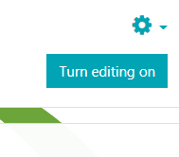
- In the appropriate section click Add an activity or resource

- In the list select Forum and click the Add button (below).

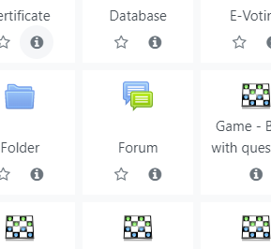

- Type a Forum Name & Description for the Forum.
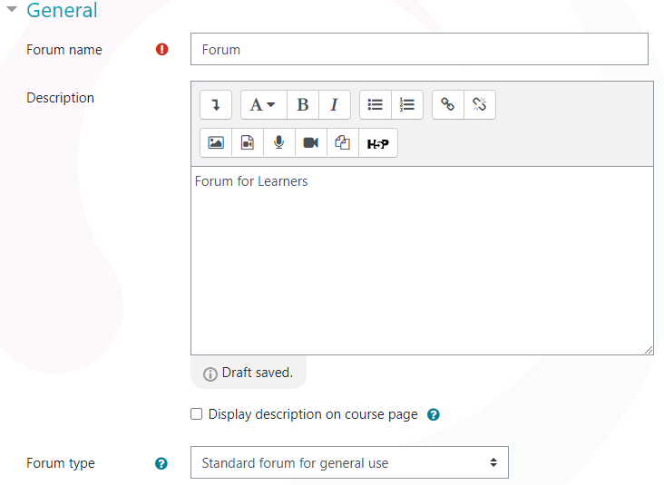

A single Forum might be used for one discrete learning activity (e.g. ‘Project Discussion Activity’) or for a series of discussions (e.g. ‘Assessment Support Q&A’).

- Click the Save & Display button at the bottom of the page.

Starting a Discussion
- Go to the Forum & click the Add a new discussion topic button.

- Type a Subject and a Message and click Post to Forum.

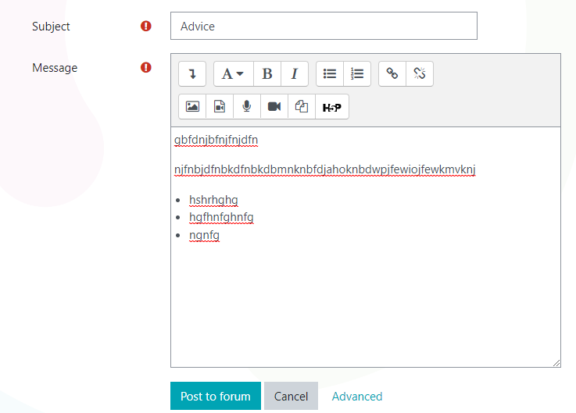
The content of the message will depend on the nature of the discussion and the purpose of the Forum. It’s important to include clear instructions & expectations in the initial message for any learning activity.

After posting the message you will see a confirmation message:
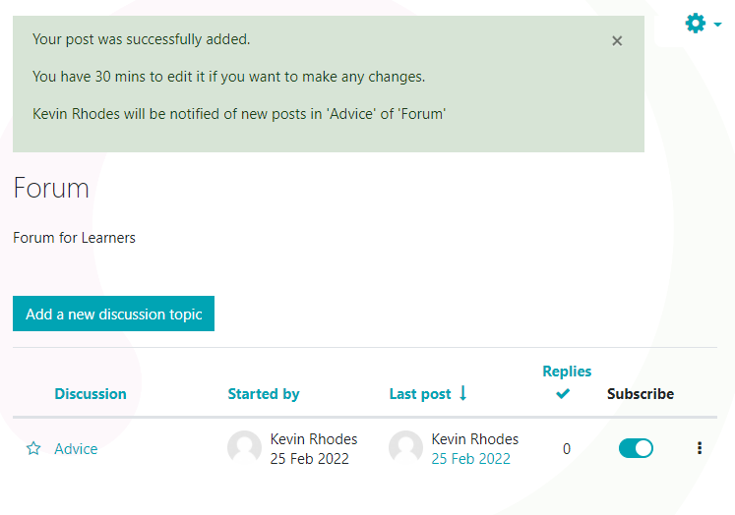

Tips for using Forums in Teaching (Staff)

Setting Expectations
It is important to establish clear social and academic expectations around forum participation. Here are some areas that may require clarification:

Your Role | How will you be moderating discussions? What form will feedback take? We suggest using a summary post to close a discussion and highlight interesting ideas.
Style | What voice should students write in? Is formal or informal language appropriate?
Length | What is the minimum length of a forum post? A reply?
Content | Consider how you want students to ‘add value’ to discussions. Should they contribute original ideas or is it alright to ask new questions? Do they need to justify or support their arguments with references and examples? Is it enough to write ‘I agree’ or ‘disagree’ when replying to others? Should posts include a works cited?
Frequency | Is it acceptable to publish one’s posts all at once or do they need to be spread out over the term, for example, on a week-to-week basis?
Etiquette | How can students challenge and engage each other in respectful and positive ways?

Icebreaker Activity
For your first forum activity, ask your students to introduce themselves and describe their hopes, fears, and expectations around online learning and forum participation before responding to a peer. This should help establish expectations and get students accustomed to forum activities.

Creating Effective Discussions
An effective forum discussion
- Clearly outlines its purpose and what is expected
- Asks a provocative, open-ended question that requires supporting a position
- Is tied directly to other course events, for example, sessions, readings, projects, or assessments
- Encourages students to draw on personal experience and relatable examples
- Fosters relationships by encouraging students to reference each other’s ideas in a positive and constructive way
- Asks students to reply to at least one other post
- Gives students some agency over the questions and topics they focus on

Moderating Online Participation
Here are some suggestions for moderating forum discussions
- Set the tone for forum participation with your own posts.
- Model the kind of participation you want to see.
- Use personal storytelling to help students relate to the content and yourself. Providing some insight into your values and personal experience can help students feel more comfortable about sharing and participating online.
- Start your course by sending a brief private message to each student introducing yourself and welcoming them to the unit. This is particularly effective after students complete an icebreaker forum activity.
- Close all forum discussions with a summary post recognizing the interesting ideas students have shared and providing positive reinforcement.
- Ensure students understand why they are participating in forums and how it might feed into assessment, for example, in the form of a portfolio submission.
- Provide regular opportunities for learners to participate in non-threatening forum discussions to help them feel comfortable.
- Alternate online activities by including blogs, wikis. Try not rely solely on forums.
- Don’t jump into a discussion too early. This may stifle discussion and bias student perspectives against alternative viewpoints.

Netiquette for Forums (Staff & Students)

Do …
- Keep your posts clear, concise and constructive
- Stick to the subject
- Be respectful and civil
- Clearly distinguish fact from opinion
- Reference other people’s ideas and content
- Read a person’s full post before posting a reply
- Use emojis sparingly, but particularly if you are concerned the meaning or humour of your message might get lost

Don’t …
  - Resort to personal attacks
  - Use language that may cause offence to others
  - Type your messages in CAPITAL LETTERS. This is considered shouting.
  - confuse fact with opinion
  - Begin a new thread if your post relates to an existing one
  - Include the body of the original message in your reply. Highlight only the relevant quotations you wish to discuss

