How to transfer your PowerPoint presentation to the new Branding.

- Find & download the new PowerPoint branding at Participation & Lifelong Learning Business Support - _Templates - All Documents (sharepoint.com) and save into your personal file manager / file browser

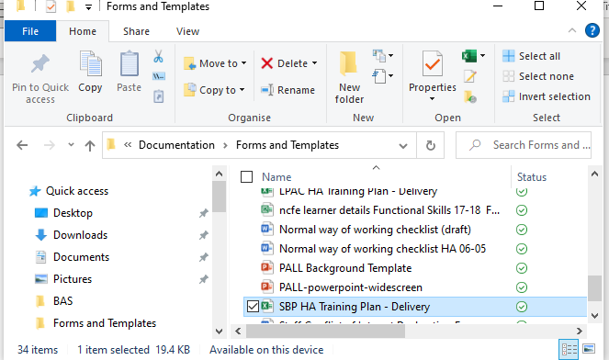

- You will need to delete the text boxes and then save the blank slide on your desktop. You can overwrite the original download if you want.

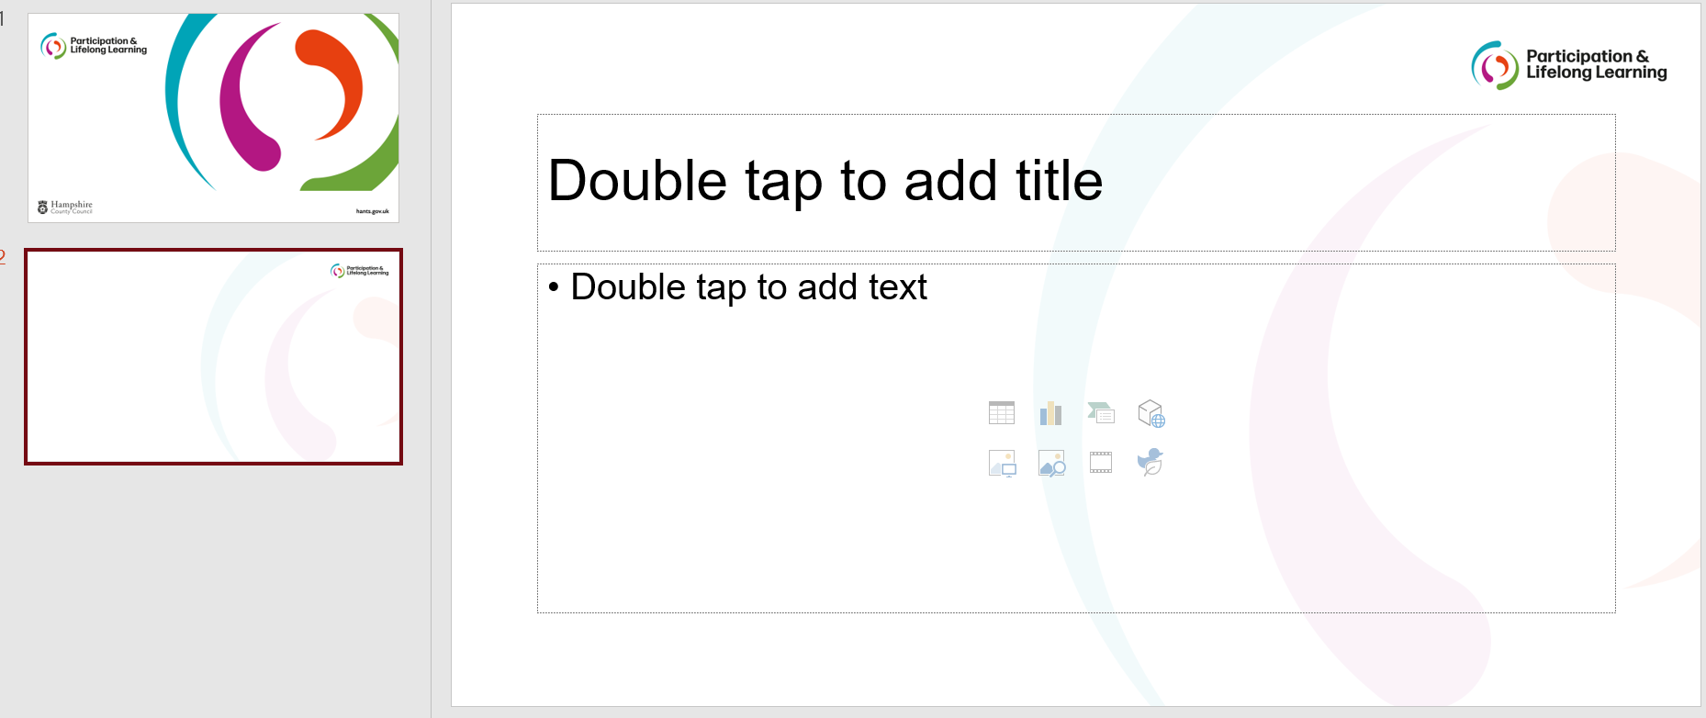
- Open your PowerPoint presentation, click on the Design tab…

…and select the drop-down arrow.

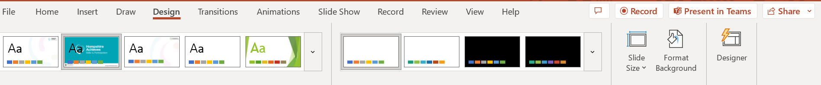

- Click browse for themes…
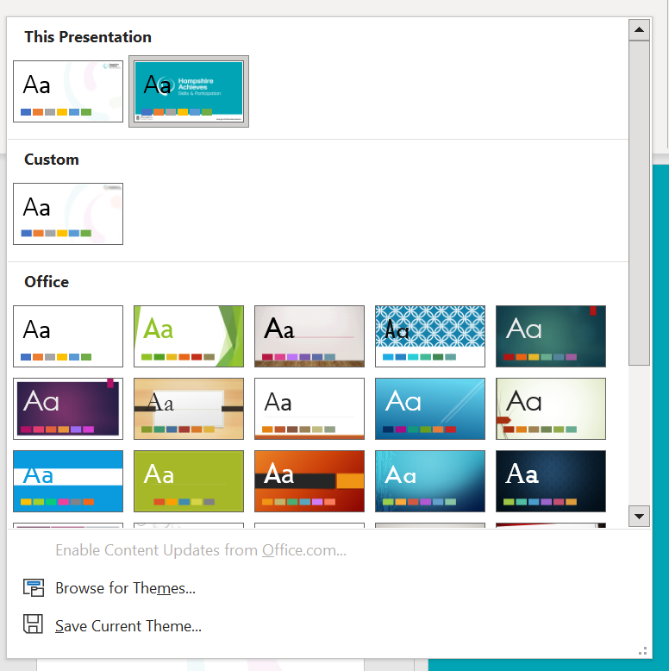

…and double click your saved background template from the file manager.

This will apply your new background to the PowerPoint presentation.

- You may find that you need to insert the “Front Page” separately by cutting and pasting from the original file.

