

Vocational Profiling (Pre 16)
Information & Guidance
for Leaders & Administrators



Vocational Profiling Guidance

This document provides leaders and administrators with guidance on planning, administering, and resourcing the delivery of Vocational Profiling (VP)
This pack contains recommended resources and adaptive strategies to support in the delivery of VP to Young People (YP) with Special Educational Needs and/or Disabilities (SEND). An adapted symbol-supported version of the VP, for pupils with complex communication and interaction needs is also available on the Hampshire VLE, available via: Course: Hampshire Futures Careers Information Service
In accordance with GDPR requirements, schools and colleges must ensure that clear processes are in place for the secure storage, access, and handling of the Vocational Profile (VP). As the VP contains personal data, it is subject to the same confidentiality, data protection, and consent requirements as any other record holding identifiable information. Please refer to your provider’s GDPR policy for guidance on lawful processing, data retention, and access controls. -protection, and consent requirements as any other record holding identifiable information. Please refer to your provider’s GDPR policy for guidance on lawful processing, data retention, and access controls.

An Evidence Based tool that aligns with statutory and regulatory frameworks.
Vocational Profiling is an evidence-based tool used within the Preparing for Adulthood (PfA) pathway (See Appendix 1 p.19).
It has been designed to align with statutory requirements in the SEND Code of Practice, including expectations relating Education, Health and Care Plans (EHCP), with HCC requiring VP to be used and embedded within EHCP reviews from Year 9 onward (See Appendix 2 p.20).
VP also supports delivery of the Gatsby Benchmarks, following National Careers Guidance, as well as providing evidence related to best practice for inclusive provision, as outlined in the Ofsted Framework (Appendix 3 pp. 20-23).

Vocational Profiling: Person Centred- Strengths based - Aspirational
Vocational Profiling uses a person-centred, strengths-based approach, focusing on aspirations, interests, and needs, with an aim to improve independence, employability, community inclusion and overall health and wellbeing. It aims to:
- Capture the YPs voice: How do they feel they are achieving, do they feel a sense of belonging and how do they define/ see themselves as thriving?
- Support pathways to improved outcomes for Vulnerable Groups
- Evidencing progress and achievement (beyond academics)
- Support Wellbeing by highlighting strengths and skills
- Build aspiration, improve life chances and social mobility.
- Explore possibilities: identify goals, agreeing actions & planning steps to success
- Support early, pre-emptive identification of barriers to maximise successful outcomes.
It allows exploration of routes to employment or further education; shining a light on strengths and skills and supporting self-advocacy. It will be particularly helpful for initial discussions with Careers Advisers and as a starting point for creating CVs and applications for work experience.
Administering Vocational Profiling
The Vocational Profile belongs to the Young Person- made by them, for them, about them!
Whilst Vocational Profiling (VP) can be flexibly adapted to meet the needs of different cohorts and individual pupils, with administration planned according to the context of your school, please note the key considerations and recommendations below, which have been shown to support successful outcomes.
- Vocational Profile should be completed in co-production with the young person, ideally by someone who knows them well, who is trusted by the YP and attuned to their needs.

- Wherever possible, VP is best administered on a 1:1 basis – particularly for pupils with EHCP and identified complex needs. However, we recognise that capacity and resources may mean your school adjusts this to ensure that VP can be accommodated within the context of your school and the individual needs of each cohort.

- Whilst certain activities within the VP can be carried out by YP independently, an essential aspect of building a VP requires adult interaction and discussion, with guidance, conversation and prompting required to ensure sufficient detail is collected and information clarified.
It is essential that the YP’s voice and perspective remain at the forefront. However, coproduction with key adults, including parent/carers, is strongly encouraged to ensure a broad and balanced overview. This is particularly important when the YP is at an age or developmental stage where limited self-awareness or real-life experience may mean they do not yet have the full information or understanding needed to make fully informed decisions. A more holistic picture helps ensure that actions and targets accurately reflect their needs and abilities, enabling effective planning of next steps to support successful outcomes.-production with key adults, including parent-awareness or real-life experience may mean they do not yet have the full information or understanding needed to make fully informed decisions. A more holistic picture helps ensure that actions and targets accurately reflect their needs and abilities, enabling effective planning of next steps to support successful outcomes.
Initial Vocational Profiling can be administered in a 6–8-week block, with pre and post administration questionnaires recommended to measure impact.
Please see Appendix 4 p.23 for current questionnaires used.
Schools are recommended to create their own questionnaires, to gather baseline and impact data.
Below is a suggested ‘order of administration’ to clarify steps:

Reviewing and Updating the Vocational Profile
A YPs aspirations and needs will naturally shift and change over time. The VP is a working document or ‘passport’, so can be reviewed and updated as experiences or skills occur that are relevant to work (such as work experience or choosing a higher education provider).
We would recommend a review annually as a minimum. It is important to capture likes/dislikes/capacity to do certain tasks from any work experience placement, to best tailor careers advice for the young person moving forward. A review can be a simple check through, focusing on relevant sections. Alternatively, when a significant event e.g. work experience has happened, the one-page review can be used to quickly capture the information.
This document was created for a Pilot Project around Vocational Profiling for Year 9, 10 and 11 pupils on the SEND register. As you may be seeing this outside of the pilot timeline (end July 2026), please email careers.service@hants.gov.uk for further information, advice or support.
Section 1: Thinking About Me
Before completing this section, it would be great if the student has had the opportunity to give out questionnaires to their ‘Very Important People’ (see Appendix 4 p.24). This will help them identify their strengths and barriers. They can give this questionnaire to parent/carers, important family members, staff or friends.
Encourage open conversation about healthy habits.
Remember: this is just for self-reflection rather than ‘blame and shame’.
An example of small change (you could use as yours to model the process)
My goal | Benefits of making this change |  | My worries about making this change
I want to make healthier choices about….  Screen Time.  I want to change…  How much I go on my phone at nighttime. | How will you feel when you’ve made this change?  What difference will it make?  I hope it will help me have better sleep (and get to sleep when I go to bed rather than hours later) and have more actual conversations with my family. |  | That I will be missing out on things. That I might find it hard to go to sleep without my phone as I have always done this.
My Action Plan
Small, realistic, steps to success |  | I would be more successful if…
Think about the steps you will take to help you make that change- one small change at a time.  Buying an old school alarm clock so I don’t need my phone on my bedside table.  Give myself ‘doom scroll’ time before bed so that I don’t feel like I am missing out. |  | Who would be able to help you achieve these goals  Everyone in my house has their phones away after dinner so I’m not jealous / tempted!

Adaptive strategies: Supporting SEND pupils to explore and communicate their strengths & skills.
Asking - What do you love doing? What do you believe in? What do you want to do in the future? What are your strengths? can often be met with a shrug.

The resources below are less intrusive than direct questions, allowing the YP to use visuals to guide and communicate their thoughts as well as more interactive online activities/ quizzes for those that find verbal communication a challenging or uncomfortable experience.

Recommended introductory Card sorting activity:
Packs are available for general exploration of ‘my skills’ as well as packs that focus on highlighting strengths and skills associated with neurodivergence or skills built as a result of having a medical/ health condition.
Perfect for work experience and future job applications!
Available to purchase via: Shop – What's Your Strength?

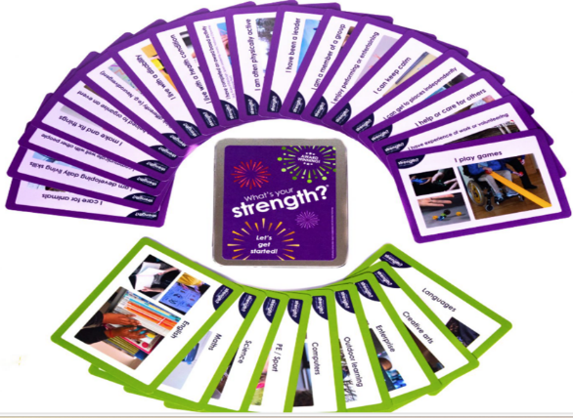
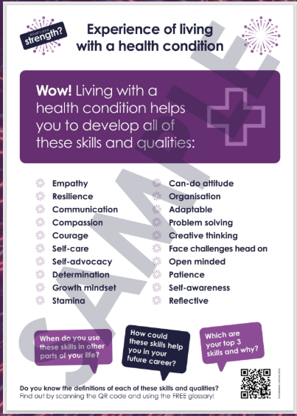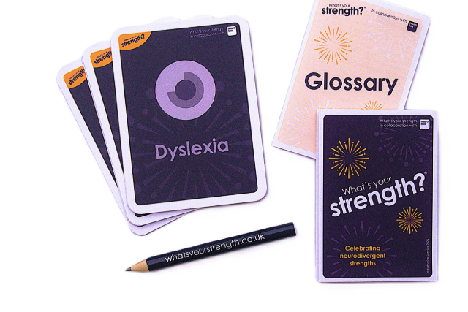

My Skills and Qualities

Name……………………………………………………………………………… Date…………………………..

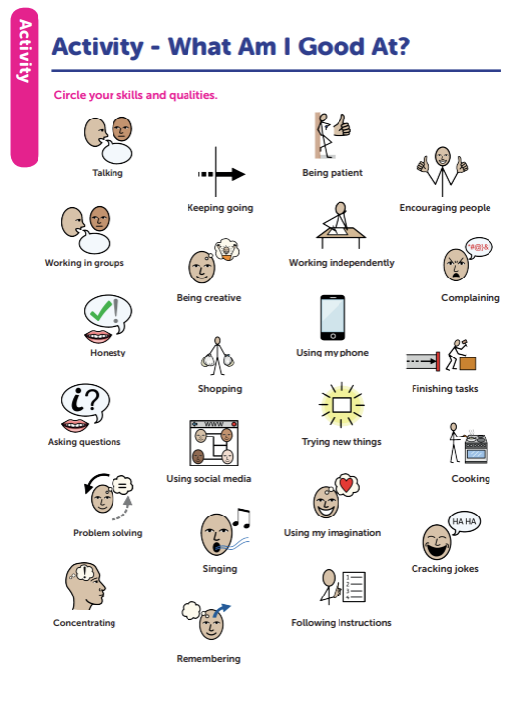

Supporting wellbeing & self-esteem - Applying a strength-based lens
We all know how challenging it can be to identify our strengths- even more so when carrying a negative self-image. This can often be one of the most significant barriers for YP with identified SEND.
This activity can be used to support you in flipping the narrative. Changing what is usually talked about as a barrier or difficulty into an identifiable strength.
The activity is based on the work of Paula Moraine drawing on differences in executive functioning which are key foundational skills for any workplace environment.
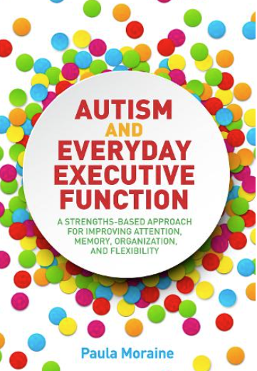
..
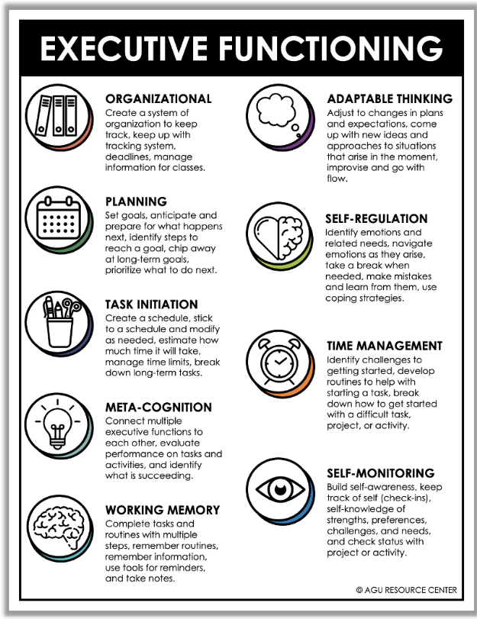
Recommended Background information on Executive Functioning for Profilers:
Autism Executive Functioning: an Overview
Executive Function | Autistic Learners
NB- This research focused on YP with Autism, but executive functioning is also a core feature of neurodevelopmental conditions such as ADHD and Specific Learning Difficulties - dyslexia, and dyspraxia.

Strengths based executive functioning profile for……………………………….
For each section, circle where you feel your strengths lie on the scale provided.

Attention
10 | 9 | 8 | 7 | 6 | 5 | 4 | 3 | 2 | 1 | 0 | 1 | 2 | 3 | 4 | 5 | 6 | 7 | 8 | 9 | 10
🐿️ Quick switching Single focused 

Notes/ comments and observations:

Memory
10 | 9 | 8 | 7 | 6 | 5 | 4 | 3 | 2 | 1 | 0 | 1 | 2 | 3 | 4 | 5 | 6 | 7 | 8 | 9 | 10
🐘 Remembering from the past. Using information in the here and now 🐬

Notes/ comments and observations:

Listening & Following Instructions
10 | 9 | 8 | 7 | 6 | 5 | 4 | 3 | 2 | 1 | 0 | 1 | 2 | 3 | 4 | 5 | 6 | 7 | 8 | 9 | 10
🐎 Quick Slow and steady 🐢
Notes/ comments and observations:

Organisation
10 | 9 | 8 | 7 | 6 | 5 | 4 | 3 | 2 | 1 | 0 | 1 | 2 | 3 | 4 | 5 | 6 | 7 | 8 | 9 | 10
🦉 Highly structured Creative & flexible
Notes/ comments and observations:

Emotion & Energy Regulation
10 | 9 | 8 | 7 | 6 | 5 | 4 | 3 | 2 | 1 | 0 | 1 | 2 | 3 | 4 | 5 | 6 | 7 | 8 | 9 | 10
🦢 Cool and calm Passionate and changeable 🐒

Notes/ comments and observations:

Initiative
10 | 9 | 8 | 7 | 6 | 5 | 4 | 3 | 2 | 1 | 0 | 1 | 2 | 3 | 4 | 5 | 6 | 7 | 8 | 9 | 10
🦅 Highly proactive Prefer guidance 🐕

Notes/ comments and observations:

Goal Setting
10 | 9 | 8 | 7 | 6 | 5 | 4 | 3 | 2 | 1 | 0 | 1 | 2 | 3 | 4 | 5 | 6 | 7 | 8 | 9 | 10
🐎 Long-term planner Spontaneous goal setter 🦜

Notes/ comments and observations:

Flexibility
10 | 9 | 8 | 7 | 6 | 5 | 4 | 3 | 2 | 1 | 0 | 1 | 2 | 3 | 4 | 5 | 6 | 7 | 8 | 9 | 10
Adaptable to changes Prefer routine 
Notes/ comments and observations:

Question Prompts:
‘Communities’
When thinking about ‘Communities you belong to?’ This can range from sports, hobbies, clubs to communities that a YP may identify with.
*Please keep in mind PREVENT training here especially if these communities change and a young person is identifying with potential radicalised ideals/ political movements here*
Question about clothing is to start thinking about access arrangements a young person may need for a job with regards to clothing/uniforms. A particular consideration for any YP with sensory processing needs.
Thinking about school. It can be difficult when…
Some prompts could include:
- Is there a time of day that is tricky? (I hate mornings for example!)
- Particular lessons?
- Transitions (i.e. getting to school / swapping rooms and lessons / going home again?)
- Friendships or relationships with staff?
- If there is a lot of reading / listening in a lesson?
- Noise?
- Certain places around the school? (such as certain classrooms / cafeteria / outside spaces)?
Forms of ID – this can just prompt a conversation on if they know physically where this is, as they will need this to access further pathways.
For YP approaching 16 awareness of the importance of keeping a record of their National Insurance Number will be helpful.

If you are using the symbol supported VP, this section is outlined in dark blue.

Further Prompts:
Behaviours can include:
- Running away
- ‘shutting down’ - explore what this looks like for YP (i.e. hiding face / non-verbal / under desk etc)
- Shouting / swearing
- Aggressive behaviours
- Destruction of property
- Hurting others around them (kicking, throwing, biting?)
- Communication / speech especially those that change when heightened (such as stuttering)
- Anxiety, panic attacks
Helpful strategies/ adaptations could include:
- Allocated quiet space
- Visual prompts / clear instructions
- Visual timetable
- Sensory aids (including fidgets / ear defenders etc)
- Trusted adults and peers
- Breathing / mindfulness
- Diet changes
- Use (or limit) of electronic devices
- Clothing adaptations
- Music / headphones
- Movement break

If you are using the symbol supported VP, this section is outlined in green
Section 2 – Things you might get support with, in school

Just a reminder to the adviser that this is the young person’s document. You can prompt with questions and share the views of others where appropriate for that individual, but ultimately, they should only put what they feel comfortable with.
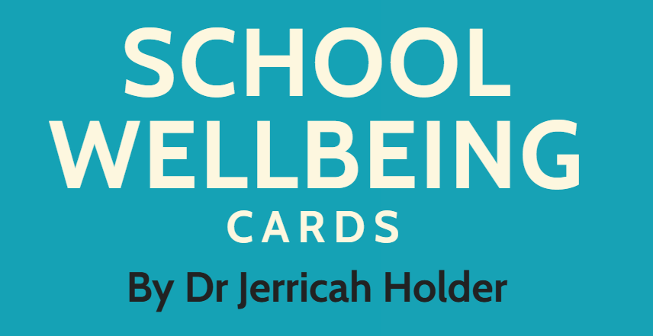
Recommended Introductory Activity for pupils with identified SEMH needs, any pupil with an EHCP, those at risk of EBSA or those with low attendance.
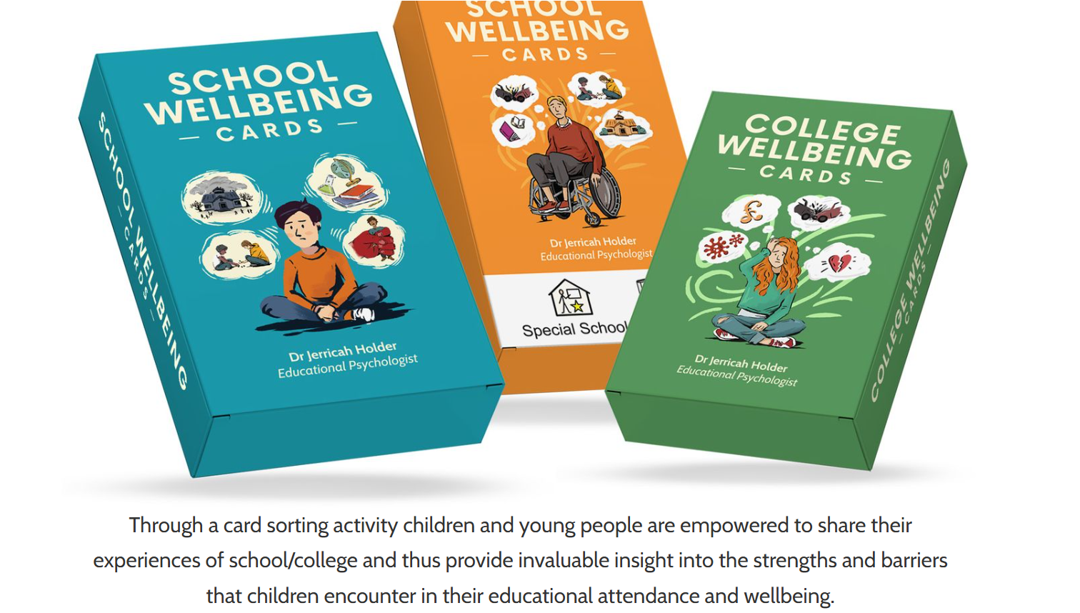
Accessible Card Sorting Activity for identifying Pupil Perspective on Risk factors & Protective Factors
The card sorting activity helps identify, from the YP’s perspective, the factors they perceive to be supportive of success (pull factors) versus factors which represent challenges or difficulties (push factors). associated with anxiety and unhappiness as well as the strength and protective factors which aid wellbeing and resilience.
The YP simply sorts the cards into groups identifying what they feel is:
Like Me  Not Like Me
The supporting adult or YP themselves can then simply capture this as a photo/ image and upload to the VP- see example below
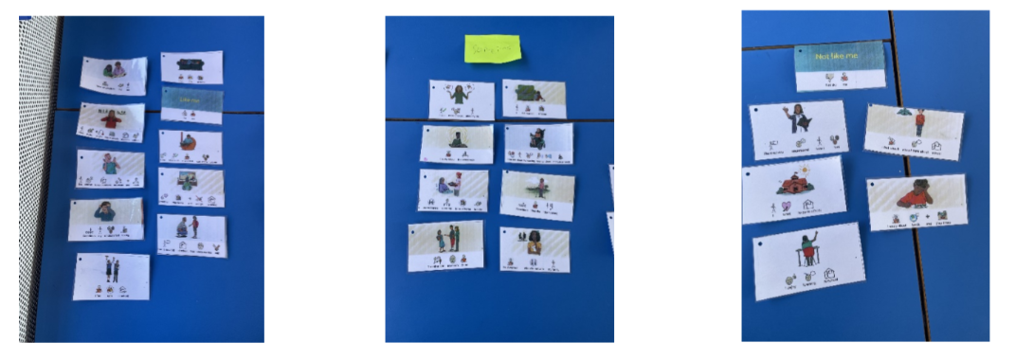
Packs can be purchase via: https://www.schoolwellbeingcards.co.uk/
Section 3: Health
Explain to the YP the reason for asking this information is that it is important to be aware of their own health needs, and to advocate this for themselves.
Questions about lifting / balance etc will help identify what jobs / careers may be suitable for them and to consider whether an employer may need to make reasonable adjustments.
The Health section helps the YP begin to understand:
- how their health affects daily life
- what support they may need
- how to communicate this confidently to adults, employers, and colleges
This ensures:
- young people are not placed in roles that may cause harm
- guidance can be given in making realistic choices

Section 4: Communication
Again, it is important to emphasise that reasonable adjustments will be expected in the workplace in the same way as at school.
Note anything that they currently use to support their communication e.g. signing / symbols / Assistive Technology or perhaps awareness from others about the need for additional processing time. This means that forward planning and preparation can be made for any work placement opportunities, helping to make the experience successful.
Discussion can explore needs associated with executive functioning, transitions, and wellbeing. It is important to identify how communication difficulties may impact:
- task completion
- following instructions
- managing social interactions
- expressing needs or managing emotions
Communication can change when a young person is heightened or stressed. The YP may benefit from thinking through triggers and strategies they could use to help them return to a regulated state.
Pre-emptive discussion about communication worries, alongside reassurance that support plans can be put in place, is an important first step in preventing barriers from developing and ensuring the young person feels confident and understood.
Gathering this information will also help match the young person with roles, environments, and expectations that will enable them to be successful.

Section 5: Travel
Noting any concerns, worries or barriers for transport can help with planning and preparation.
For pupils in Year 11 who have had transport support or DLA, planning for ongoing support e.g. Personal Independence Payment (PIP) may need consideration for transition.
Section 6: Money
Money management is one of the four statutory PfA pathways that Vocational Profiling feeds into. It supports outcomes related to Independent Living and Community Inclusion, both of which rely on the young person’s ability to make safe, informed financial decisions.
Colleges, training providers, and employers expect a basic level of financial literacy — such as being able to manage lunch money, travel costs, equipment fees, or apprenticeship wages. The VP’s financial section helps advisers and parents recognise where extra support or intervention may be needed before a young person transitions.
Discuss what the student spends money on. Do they pay for these things or does someone else? This helps identify how independently the young person currently manages everyday financial tasks such as buying items, budgeting or making personal purchases.
Section 7: Time
Good time skills support a young person’s ability to navigate daily routines, education, and future employment confidently.
Time management directly relates to how independently a young person can organise themselves, which is central to their independence and employability.

With both money and time, make sure to feedback to relevant tutors/maths/SEND department if you feel this is something the YP could benefit from extra support/intervention.

If you are using the symbol supported VP, these sections (3 to 7) are outlined in orange.

Section 8: Thinking about getting a job
It is OK if a YP doesn’t have answers for these yet (i.e. what might want to do in college or with an apprenticeship) Please keep in mind possible scheduling a careers appointment through the school’s careers department to explore options in more detail.
Doorways Activity
A visual sorting activity to Identifying ‘what I care most about’.
A nice introductory activity when at the early stages of exploring next steps on their pathway to PfA. This introduces YP to potential Doorways, through which to explore what they care about most. There’s even a mystery door just in case.
Example doors: earn money (work), understand more (learn), have fun (play), or contribute (give) to an area you are interested in.
Getting to the heart of what matters
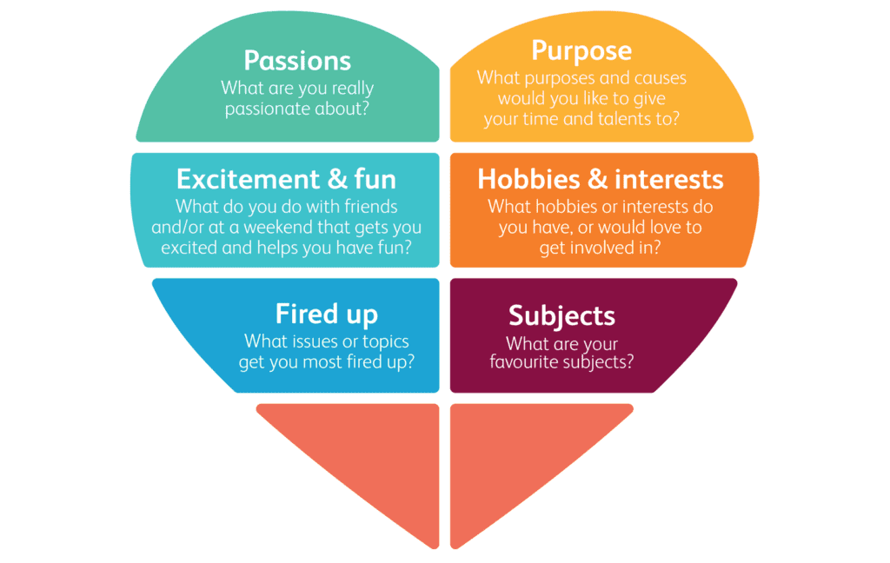
Feel it | Windmills Foundation - Windmills Foundation
Doorways.pdf
Click these links for further info and to access the resources
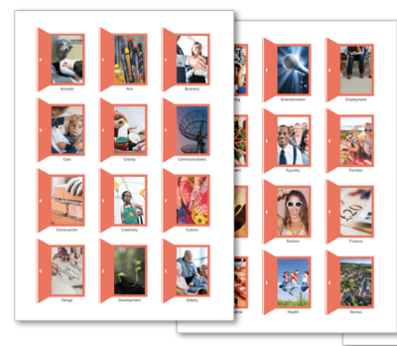
Section 9: Work Experience
When discussing hours prefer to work – think about needs / accessibility.
If a YP says they haven’t had a 1:1 careers appointment, please follow this up to book one in through your school (especially if Year 9 and above with EHCP or Year 10 and above). They may have already had one, but useful to book following completing this VP anyway to give more focus to careers appointment. Check YP is happy for this to be shared with careers advisor.

Work Experience Questions

When collating information about things that went well, first ask the YP if they got any verbal or written employer / customer feedback.
Ask specific questions rather than broad queries e.g. ‘How did it go?’
Be guided by the YP but start with positives e.g. Tell me about the best thing about your experience.
You could also check/ ask questions related to things that you know to have been likely challenges.
- How did you feel before, during, after each day?
- How did you get on with your colleagues/ customers / members of the public?
- Were there any issues with the space itself (environment)?

Next steps could include thinking about other work experience opportunities, following up with the same company, looking at pathways for that job.
Where difficulties arose, this may help identify the line of work as something they would not wish to pursue- crossing that job off their list!
It may also highlight skills that need targeted support e.g. practise getting up on time / practise interactions / work on feedback from an employer.

If you are using the symbol supported VP, this section is outlined in purple.
Section 10: Review
This page can be copied as many times as the document is reviewed (at least annually but recommended after any particular event such as work experience).
We recommend that reviews are dated and added to the original VP to provide a working update as the YP progresses along the PfA pathway.
If you are using the symbol supported VP, this section is outlined in light blue.

Abbreviations used in this document:
VP | Vocational Profile
YP | Young Person
SEND | Special Educational Needs and Disabilities
EHCP | Education Health and Care Plan
GDPR | General Data Protection Regulation

Appendices
Appendix 1
Vocational Profiling (VP) – An Evidence Based Person Centred Approach.

How can VP be integrated into our current systems?
Vocational profiling is underpinned by research and considered part of an evidence-based approach, particularly within the Supported Employment (SE) model, such as Individual Placement and Support (IPS). The effectiveness of the overall SE model, which uses vocational profiling as a key component, is supported by a large body of international evidence, including numerous randomised controlled trials.
Evidence Base for Vocational Profiling
- Integral to Evidence Based Models: Vocational profiling is a core principle and initial step in the Supported Employment model, specifically the IPS approach. IPS has been shown in at least 25 randomised controlled trials to be significantly more effective at helping people, to find and keep jobs compared to traditional methods.
- Mechanism for Success: Research has identified vocational profiling as one of the key mechanisms leading to positive outcomes, such as job entry. The process of a specialist working closely with an individual to deeply understand their experiences, skills, aspirations, and job preferences helps ensure the best possible job match, which is crucial for sustained employment.
- Improved Outcomes: Studies have shown that following vocational profiling and input from a vocational specialist within an evidence-based framework, there are significant increases in the proportion of clients engaged in work or educational activity.
- Person-Centred Approach: The process is a person-centred "discovery document" which aims to understand the individual in depth. This tailored, individualised approach to careers advice is recommended by governmental bodies and committees as an effective way to identify the needs and aspirations of disadvantaged individuals, such as young disabled people.
Key Documents/ Further Information:
National Development Team for Inclusion (NDTI): https://youtu.be/Z5sUx9XetGo
Gatsby: Vocational Profile to Gatsby Standards May 2025
DfE Gov.UK- Research Report: Identifying and supporting the needs of children with SEND in mainstream settings - GOV.UK

Appendix 2:
HCC Guidance: expectations for integrating Vocational Profiling into annual EHCP reviews from Year 9: Year 9 Annual review checklist.pdf

Appendix 3:
Using Vocational Profiling (VP) to support delivery of Gatsby Standards and fulfil statutory expectations for IEPs & EHCPs

VP supports you in gaining Pupil Voice/ My Views, helping to build and maintain motivation and engagement for vulnerable groups.
Build on the young person's aspirations, guiding goals for work, life skills, and social participation
Vocational Profiling feeds directly into EHCPs (KS3+) linking with the 4 key 'Preparing for Adulthood' (PfA) pathways:
Employment Independent Living Community Inclusion Health
Directly linking and feeding into sections related to:
transport, money management, relationships, future education/training, and managing health needs.

Gatsby Benchmark Standards | Benefits for the YP | Linking with IEPs & EHCPs
1. Stable careers programme – Use Vocational Profiles (VP) to gather pupil-led feedback and evaluate your careers plan; embed VP reflections into annual CEIAG review. | Builds self-awareness and records achievements; pupils reflect on opportunities they’ve had and identify next steps. | Section 1 VP- ‘Thinking About Me’ links directly to Section A “All About Me” in EHCP- Info can be copied and pasted directly into this section or highlighted as ‘See attached VP doc”  Ensures fulfilling expectations from HCC annual review checklist form Y9  Captures ‘My View/ YP voice’  Skills gaps identified through VP can be linked to IEP/SEN Support Plan targets.
2. Learning from Career & Labour Market Information (LMI) – Plan activities that compare pupils’ VP self-knowledge with LMI | YP are given the opportunity to build self-knowledge, focusing on identifying strengths and are supported in developing ways to communicate and advocate for any adjustments/ adaptations needed.  YP can test their ideas against real LMI and refine choices in light of ‘real life’ experiences. | Record the LMI activity and outcomes in Annual Review
3. Addressing the needs of each pupil Use VP sections on preferences and support needs to personalise careers provision and remove barriers. | Clarifies support needs to communicate/advocate for work experience or job options. | Year 9+: integrate VP into Section A (“All About Me”), PfA outcomes, and transition planning via the EHC Hub.  IEP / SEN Support Plan – use APDR cycle to turn VP insights into short-term, measurable targets.  Copy & Paste or refer to VP to highlight strengths/interests  Links- developing_outcomes_in_ehc_plans.pdf  Year-9-Annual-Review-Guide-updated-2025.pdf
4. Linking curriculum learning to careers – Use VP ideas to map | Connect likes/dislikes at school to pathways; builds relevance and motivation. | Reference these links in Annual Review and IEP targets (e.g., subject-specific adaptations supporting career goals).
5. Encounters with employers – Plan targeted employer encounters chosen from VP interests | Pre/post reflection sharpens relevance; records impact in VP. Supports more targeted discussion with Careers Advisor. | Log encounters (and support needs) in Annual Review; add to Section A and progress notes; update IEP where adjustments are required.
6. Experiences of workplaces – Use VP practical support details to make work experience accessible | At pre-planning stage use VP to consider adaptations and support required to make experience successful.  Reflect on workplace experiences to build confidence and decision-making. | Plan Work Experience in Annual Review; capture transport/support in EHCP; record outcomes and next steps in IEP.
7. Encounters with FE/HE – Share VP at key transitions | Communicates support needs to providers; improves fit and preparation for transition. | Use Annual Review to explore post-16 options; add One-Page Profile to transition pack; record consultation with providers via EHCP Hub.
8. Personal guidance – Give careers advisers VP in advance to tailor sessions | Prepares for 1:1 guidance; clarifies questions and supports communication | Summarise guidance actions in Annual Review; update Section A and IEP/SEN Support Plan targets accordingly.

Appendix 4
Questionnaires - Links for pre and post VP Questionnaires

The links can be copied and forwarded to the relevant people via email or used within a co-production meeting to gather views and perspectives.

Schools and Colleges are recommended to use these as a template to gather baseline and post intervention data, to measuring impact.

Baseline Questionnaire Young Person (Pre Vocational Profiling) | Vocational Profiling Pre-Intervention Questionnaire
Young Persons perspective | Vocational Profiling Post-Intervention Questionnaire
Parent Carer: Post VP perspective | Vocational Profiling Parent/Carer Perspective
School Staff: Post VP perspective | Vocational Profiling School Staff Perspective

VIP Questionnaire
You have been chosen to answer questions about……………………………as someone who knows them well!
Name of person completing form:…………………………………………………………………
I am a: Parent Friend Teacher Learning Support Assistant Other (please specify) …………………………………………………………………………………………………….
Things I like or admire about them:
Personality
Skills
Hobbies
Things that are important to them:
People
Hobbies/clubs
Anything else?
Things they need help with
At school
At home
In a new place (like work):
Any other comments you would like to make?

This or that
They reply to messages (when they do) with
 | Voice notes |  | Text
They Prefer to be
 | Indoors |  | Outdoors
They are an
 | Early Bird |  | Night Owl
They really like
 | Quiet Conversations |  | Loud parties

My Wishlist
I would love for them in the future to:
I think they are their best self when:
One change I would make to school to make them even more successful is:

