Hampshire Achieves ensuring Accessibility of online learning.

Ensuring equality, diversity and inclusion for online teaching, learning and
assessment
Be aware of learners who may not be participating and explore why this may be the case.
Consider reasonable adjustments for learners with restricted mobility, hearing or sight impairment etc.
Consider how a blended approach can support learners for whom online learner is not totally suitable. This may include posting out paper-based resources.

Making Adjustments:
Generic:
Discuss with learners as part of IA if there are any tools you were planning to use that they would find difficult to access and what adjustments you can make.
With resources consider SCULPT (see below)
Recommend tools/apps that might support their access.

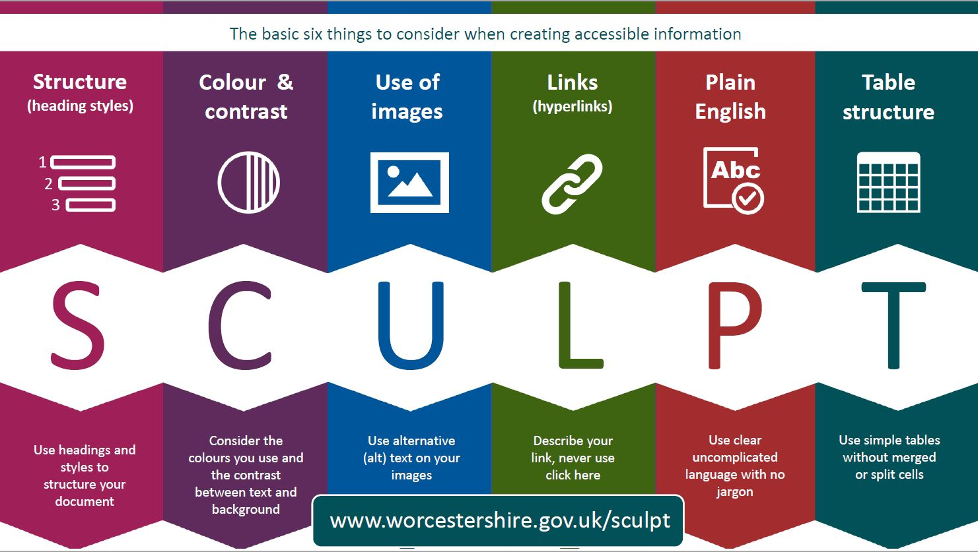

Hearing impaired:
Availability of subtitles
Provision of resources before session
Management of open mics to reduce noise
Use of headset to reduce noise
Knowledge of any software using with hearing aids
Recording to listen back to later
Position of mic – is it picking up laptop/PC processors sounds (whirring)

Visual impaired:
Make sure learners are aware of when you are screen sharing and also slide transitioning (helps them adjust to change in brightness)
Consider colours used, size of font etc (SCULPT)
Be aware of supportive technologies you can recommend to learner

Additional information and CPD
ETF have a number of resources to help tutors and learners access learning:
Accessibility in EdTech | Learning | Education and Training Foundation
What Can Technology Offer Learners With SEND? • Government Events

My Computer My Way (abilitynet.org.uk)
Your step-by-step guide to individual adjustments you can make to your computer, laptop, tablet or smart phone to make it easier to use. It provides advice on four elements of accessibility;
Hearing - How your computer, mobile or tablet can be made easier to use for people with a hearing impairment.
Vision - The accessibility features that help you see websites and applications more clearly.
Motor - Accessibility features designed to make your keyboard, mouse and mobile device easier to use.
Cognitive - How to make reading, writing and using the internet easier on your computer, mobile or tablet

The link below puts a colour veil over the screen, so really helpful for those learners with dyslexia. You can change the intensity too so change how dark/light a shade it is. It is completely free.
https://www.aurelitec.com/colorveil/windows/download/.

