
Anxiety Managment
self-help

CONTENTS

INTRODUCTION Pg 2

WEEK 1 – THE CAVE-MAN IN YOUR BRAIN Pg 4

WEEK 2 – COMMUNICATING WITH THE CAVE-MAN Pg 11

WEEK 3 - CALMING THE MIND Pg 18

WEEK 4 – BECOMING A THOUGHT DETECTIVE Pg 22

WEEK 5 - DEALING WITH TRICKY SITUATIONS Pg 29

WEEK 6 – HEALTHY BODY – HEALTHY MIND Pg 36

INTRODUCTION

WHAT IS ANXIETY?

Everyone has times in their life when they feel nervous or worried. In fact a study has shown almost 2 in every 5 people worry about something at least every day. For some people though, they worry and feel anxious a lot more and it can seem to take over their lives. There are many different ways to feel anxiety, as well as reasons for anxiety, so not everyone has the same experience. You might find that there are lots of anxious people in your family and this is because anxiety can be partly genetic. Even so, most of the aspects of anxiety are habits and it is possible to change these habits and learn new ones. Anxiety becomes a real problem when it begins to interfere with how we feel about ourselves and how we live our lives. 1 in 5 young people struggle with how anxiety affects their lives. If this describes you, remember you are not alone- and this book is here to help.

HOW DO I USE THIS BOOKLET?

In this book you will find a lot of useful information about why we experience anxiety as well as several different types of techniques to help you manage and lessen your anxiety. It is split into 6 sections and it will be most effective if you complete the sections over 6 weeks; 1 section a week. Set aside 20 minutes at the beginning of each week to read the week’s section and complete the activities included in the section. This time should be set aside to be exclusively for this book so turn your phone off and choose a quiet place where you will not be disturbed. This book is to be used as a therapeutic tool and it is important that you engage with it as if you would when visiting a clinician. Start at the beginning in Week 1, and work through each section week by week. Each section will also have weekly tasks and exercises to practice throughout the week so set aside 5 minutes each day for the other days of the week to complete these. Of course, no one is going to check if you have completed these activities or not, but we really encourage you to use them. If you think of these exercise as tools, by the end of the 6 weeks you will have a toolbox full of useful ways to help you manage your anxiety. When your anxiety rises, these tools will help you the most if you already know how to use them. The best way to make sure you know how to use them is to practice them regularly and when you are feeling fine (not anxious). Don’t worry; this practice will only take up a few minutes of your day!

WHY SHOULD I USE THIS BOOKLET?

The booklet is based on Cognitive Behavioural Therapy (CBT). Although it sounds quite complex, CBT simply looks at how our thoughts, feelings and actions are all closely linked and can affect each other. The CBT model says that it is not the actual events that bother us but the way that we interpret them. This booklet will help you understand the way you interpret situations and whether your interpretations are helpful or not. Unhelpful interpretations can cause us to feel anxious and then respond in negative ways. Helpful interpretations can cause us to feel relaxed and respond in positive ways. The more you use either helpful or unhelpful interpretations, the more of a habit you will create. Over the next few weeks you will learn new ways of thinking about situations and how to make the best decisions in these situations to have a positive outcome. Everyone can struggle from time to time to make the best choice in a situation, but if you are an anxious person, taking the time to learn and practice these techniques will create new, helpful habits. Although these habits seem so small, they can have a significant impact on every area of your life.

WEEK 1

THE CAVE-MAN IN YOUR BRAIN

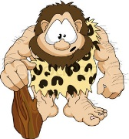

Our body is made up of different organs and systems which keep us alive and functioning well. You may have already heard of these systems in your biology or science classes. Our Circulatory System keeps our heart pumping; our Respiratory System keeps us breathing; our Digestive System helps us digest the food we eat and breaks it down into what is useful and what is waste. These systems are all linked to each other and work together as a team. The system that is the captain of the team is called the Central Nervous System – your brain and all your nerves.

The Central Nervous System helps many functions work without you having to think about it – you don’t need to remind yourself to make sure your heart beats, to blink, breath while you sleep, or to digest your food. These are all involuntary functions because they happen automatically. However there are a lot of functions that you can decide to use. You can decide to chew your food, walk around the house, smile, hold your breath, or stretch. These are all voluntary functions, because you can choose, or volunteer, to do them. The brain controls all these functions by sending messages to the body part that needs to do something. These messages are sent through millions of nerves that run throughout your body.

Our brain, the captain of the team, is always working and watching what is happening both inside us, and in our environment. This is so that it can help us to respond to any situation as quickly and effectively as possible. When we are happy and relaxed everything works fine, but when our brain detects danger it changes the messages to put our body into alert, as if flicking a danger switch on. As we assess the situation, we have to decide whether we stay and deal with it or run away. This is called fight or flight.

This switch between ‘All Fine’ and ‘Flight/Fight/Freeze’ is looked after by The Cave-Man! The Cave-Man has one job – to keep you safe. Back in prehistoric times, humans used to live in caves and the jungle and their world had a lot of dangers. If they saw a tiger or other predator, they needed a way to quickly prepare their bodies to either fight for their life, run for their life, or freeze so as not to be noticed.

Activity 1
Below is a diagram of a person. When you feel anxious, what changes do you notice in your body when you become anxious? Label these changes on the person. Remember there are no right or wrong answers as everyone experiences anxiety differently.

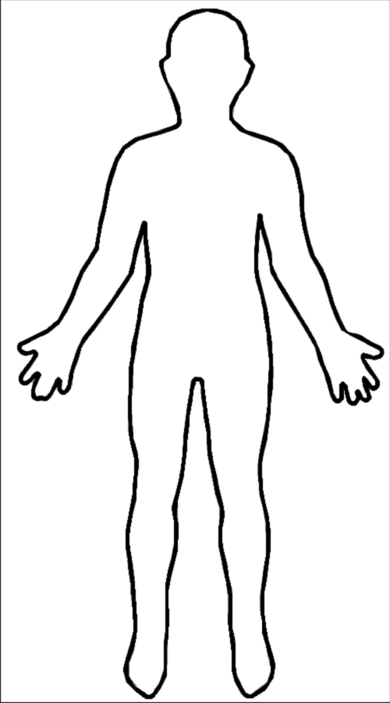

In dangerous situations, the Cave-Man is very useful because when he flicks his switch, a jolt of adrenaline is sent throughout your body to prepare you to respond to the danger. When The Cave-Man flicks his switch to Fight/Flight/Freeze, the following change happen in our bodies.
Your mouth becomes dry. This is because your digestive system is switched off to make sure all your energy is used for fighting or running. Your mouth and the saliva it makes are part of the digestive system, so when this system is switched off, so are the salivary glands.

You can’t think properly and feel lightheaded or dizzy. This is because there is less blood flow running to your head as you don’t need to think in order to run or fight; you just need to react quickly.

You feel like you will choke or can’t breathe. This is because as all your muscles tighten, so do the muscles in your neck.

Your heart beats very fast. This is because your body needs to pump your blood to your muscles as quick as possible to feed them the extra oxygen they need to work at their highest capacity.

Your breathing becomes very fast and shallow. This is because your body is trying to get as much oxygen as possible to make sure your muscles can work at their highest capacity.

Your hands become tingly or cold. This is because the blood flow is quickly diverted towards your large muscles so that they are ready for a large spurt of energy.

You become very sweaty. This is because when you use a lot of energy at once, by fighting or running, you are at risk of overheating so your body needs to increase its sweating to keep you cool.
You suddenly need the toilet. This is because as stomach muscles tighten they press on bowel and bladder.

Your muscles become very tight. This is because they are preparing to use quick , strong movements to either run from the predator or fight the predator.

You feel like you have butterflies or will be sick. This is because your digestive system is quickly switched off to make sure all your energy is used for fighting or running. The blood flow is then diverted away from your stomach and towards your larger muscles.

The Cave-Man is very good at keeping you safe in dangerous situations and he can make all these different changes in your body happen very quickly. Unfortunately though, as time has gone on, we no longer live in such a dangerous world. We don’t hunt for our food and we don’t really have any predators. As our lifestyle has changed, The Cave-Man has stayed the same. His number one priority is still to keep us safe, but while switching from All Fine to Flight/Fight/Freeze was once very useful to us, it can now be very inconvenient and uncomfortable as we rarely need to fight for our lives or run from a predator. These days a perceived threat can be a noise in the night, seeing a group of people looking at us and laughing, or worrying about something. In these situations The Cave-Man’s ‘help’ is actually very unhelpful and an out of proportion response to the type of threat present. It’s sometimes helpful to think of this as an over-reactive fire-alarm that goes off even when there is no smoke.

If the Cave-Man in your brain likes to switch on Fight/Flight/Freeze at even the smallest threat, it can be very troubling and embarrassing. You might even find yourself dreading his help. It can also be very easy to misinterpret these changes in your body as changes that will harm you rather than changes that are there to protect you. Sometimes people think that there is something very wrong with them, or that maybe they are having a heart attack. Understanding what is happening in your body and why can be very helpful in taking away the fear or dread of anxiety. Next time you feel your anxiety rising and The Cave-Man flicking his switch to help you, try to remain focussed and be aware of the changes that are happening in your body. Reminding yourself with each change why that change has happened and how it is really supposed to be helping you. The more often you can do this, the easier it will become and, more importantly, your anxiety levels will get lower and therefore be quick to come down again.

In the figure below you can see the shape of a hill. Let’s call this The Worry Hill. The Worry Hill charts how anxiety rise over time, peaks, and then comes down again. There is also a line which shows the expectations some people have when their anxiety rises. This line continues to go up and doesn’t come down. With all the uncomfortable physical sensations that can take place when your anxiety rises, it is very easy to think that things are only going to get worse. You may even think that you will throw up, choke, faint, or have a heart attack!
The Worry Hill
W
O
R
R
Y
T I M E
This is where we think our worry will go… up and up and up and up…
If we avoid something we are worried about then our worry goes down quicker but we won’t challenge our worried thinking and the worry will be stronger next time
If we can manage to stay in a worrying situation our worry will go down by itself. This will help us challenge our worried thinking. Each time you can stay in a worrying situation the worry hill will get smaller

Activity 2

The Worry Hill

This is an activity to practice while you are worrying about something. Take a moment to notice all the new sensations that are taking place in your body. For every change you notice, remind yourself of The Cave-Man, what he is doing to that part of your body, and how it is supposed to be keeping you safe. If you can, notice the time it takes for your anxiety to peak, and then come down. Once your anxiety has come down again, plot the experience on the blank graph. How many minutes did it take your anxiety to peak? Out of 10 (with 10 being the highest) what number did your anxiety reach? How many minutes did it take for your anxiety to come down again? What happened as a result of the anxiety – did you choke, faint, throw up, have a heart attack? It is most likely that although it felt like something might happen, nothing bad will happen to you as a result of all the bodily sensations during heightened anxiety.

My Worry Hill

 | 10
 | 9
 | 8
W | 7
O | 6
R | 5
R | 4
Y | 3
 | 2
 | 1
 | 0
 |  | 5 | 10 | 15 | 20 | 25 | 30 | 35 | 40 | 45 | 50 | 55 | 60 | 65 | 70 | 75 | 80 | 85 | 90
 |  |  |  |  |  | T | I | M | E

Weekly Task

The Worry Hill Exercise

This week, whenever you experience your anxiety levels rising, practice The Worry Hill exercise. Notice all the bodily sensations that are happening in your body. Try and remember what is happening in your body to cause that sensation and why The Cave-Man thinks it will keep you safe. It may help to write these down as they are happening along with their explanations.

As you feel yourself becoming more anxious, plot the experience on the graphs provided until you feel back to normal. Make a note of the time (in minutes) of each experience. If you can, try and note why your anxiety levels began to rise in the first place – this will be useful information for later exercises. It can be hard to stay with your anxiety, but remember, your anxiety will come down!

My Worry Hill – date:

 | 10
 | 9
 | 8
W | 7
O | 6
R | 5
R | 4
Y | 3
 | 2
 | 1
 | 0
 |  | 5 | 10 | 15 | 20 | 25 | 30 | 35 | 40 | 45 | 50 | 55 | 60 | 65 | 70 | 75 | 80 | 85 | 90
 |  |  |  |  |  | T | I | M | E

What changes happened in my body?
What caused my anxiety?

My Worry Hill – date:

 | 10
 | 9
 | 8
W | 7
O | 6
R | 5
R | 4
Y | 3
 | 2
 | 1
 | 0
 |  | 5 | 10 | 15 | 20 | 25 | 30 | 35 | 40 | 45 | 50 | 55 | 60 | 65 | 70 | 75 | 80 | 85 | 90
 |  |  |  |  |  | T | I | M | E

What changes happened in my body?
What caused my anxiety?

My Worry Hill – date:

 | 10
 | 9
 | 8
W | 7
O | 6
R | 5
R | 4
Y | 3
 | 2
 | 1
 | 0
 |  | 5 | 10 | 15 | 20 | 25 | 30 | 35 | 40 | 45 | 50 | 55 | 60 | 65 | 70 | 75 | 80 | 85 | 90
 |  |  |  |  |  | T | I | M | E

What changes happened in my body?
What caused my anxiety?

My Worry Hill – date:

 | 10
 | 9
 | 8
W | 7
O | 6
R | 5
R | 4
Y | 3
 | 2
 | 1
 | 0
 |  | 5 | 10 | 15 | 20 | 25 | 30 | 35 | 40 | 45 | 50 | 55 | 60 | 65 | 70 | 75 | 80 | 85 | 90
 |  |  |  |  |  | T | I | M | E

What changes happened in my body?
What caused my anxiety?

WEEK 2

COMMUNICATING WITH THE CAVE-MAN

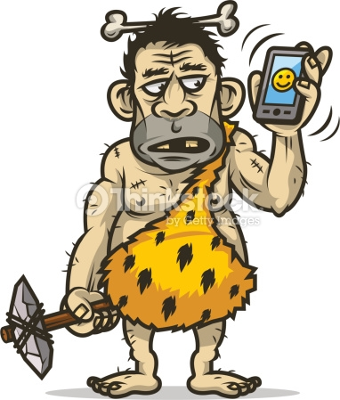

BREATHING

As we learned in Week 1, when The Cave-Man perceives a threat, he switches our bodies into Fight/Flight/Freeze mode which can be very uncomfortable. While we don’t have direct access to The Cave-Man’s switch, we can send him a message in his own language to let him know that we are safe and sound and do not need his help. Once he receives this message he can then flick the switch back to All Fine mode.

One of the best ways to send The Cave-Man a message in his own language is by altering the way we breathe. If you remember from last week, one of the bodily functions that changes when the Fight/Flight/Freeze mode is switched on is our breathing – we take short shallow breaths into our chest in order to get as much oxygen into our system as quickly as possible. However, this type of breathing can actually make us feel worse. It can lead to headaches or feeling faint or dizzy, and this in turn makes us feel more anxious. Fortunately, we can choose to change this breathing style without permission from The Cave-Man.

The best way to change your breathing when anxiety starts to rise is to choose the complete opposite type of breathing to Fight/Flight/Freeze breathing. What better type of breathing to mimic than the breathing you use while you are asleep – this is probably the time in the day when you are most relaxed! This type of breathing is very slow and deep, into our belly rather than into our chests. Let’s call this Relaxed Breathing. When The Cave-Man notices that your breathing is very relaxed, he realises that you are not in any current danger and flicks his switch back to All Fine.

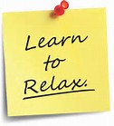

Activity 1

Relaxed Breathing

Relaxed breathing can be a skill that needs a little bit of practice to master if we are already in the habit of shallow breathing. The two biggest things to remember when practicing Relaxed Breathing are:
- Slow Breathing
- Deep Breathing

Before you start, make sure you are in a comfortable position either lying down or sitting in a comfortable chair. Try and be aware of how your chest area feels – you need to be as loose and floppy as possible. Put your hands on your belly, just below your ribs with your fingers loosely interlocked by about a centimetre. Image that there is a balloon in your belly that you need to blow up. Take a slow breath in through your nose and direct your breath down into your belly in order to fill up the balloon. Imagine the balloon is getting bigger as you breathe the air into it. Breathe out again slowly through your mouth. Try this for a few breaths, really focussing on breathing in slowly while filling up the balloon in your belly.

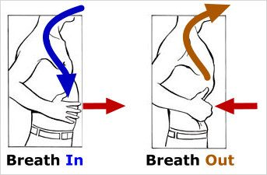

Continue to breathe in and out slowly, filling up the balloon, but now notice what is happening to your fingers. As you breathe in, your belly should expand and get bigger and you will notice that your fingers on each hand move sideways away from the fingers on the other hand. As you breathe out again, your fingers should come back together and loosely interlock again. Your belly expanding and your fingers moving apart while you breathe in are good signs that you are doing this right!

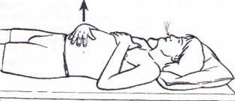

If you are new to Relaxed Breathing it can be hard to switch from breathing with your chest to breathing with your belly. While you are completing this exercise, try and pay attention to what your chest is doing. This area should be relaxed and not taking in much air until the end of the breath. A good way to tell if you are breathing into your chest is to notice if your shoulders are moving upwards while your breathe in and downwards while you breath out. If you are sitting in a chair while trying this exercise and you notice your shoulders are moving throughout the breath, try this exercise lying down instead. Another way to tell whether you are breathing into your belly or chest is by placing a book onto your belly. As you breathe in, the book should go up, and as you breathe out, the book should go down.

If you are finding it hard to get your breathing quite right, a great way to start is by blowing bubbles. The aim is to blow a really big bubble - this can only be done if you take a big breath and then blow it out slowly; if you blow too fast or too hard the bubble will burst. It’s really important to remember to breathe into your belly when you try this.

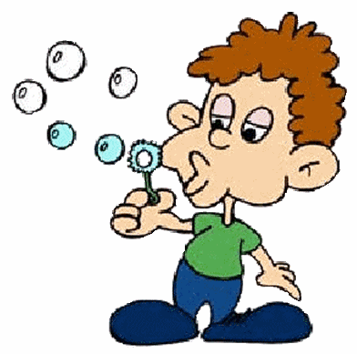

Activity 2

Square Breathing

Once you have gotten the hang of Relaxed Breathing, you are ready to apply your new skill to an activity.

Make sure you are in a comfortable position, either lying down or sitting in a comfortable chair. Choose a time when you will not have any distractions. A good time is in bed before your go to sleep. Take a few minutes to do several rounds of Relaxed Breathing to get into the pattern of breathing deeply and slowly. Now look at the diagram of a square below. Start at the arrow and breathe in for 4 slow beats following the arrow along the top side of the square. Now hold your breath for another 4 slow beats following the arrow down the right side of the square. Now breathe out slowly for 4 slow beats, following the arrow along the bottom side of the square and then hold your breath again for another 4 slow beats following the arrow back up the left side of the square. Practice this for several rounds while referring to the diagram. Once you have gotten the hang of this, you can close your eyes and practice this Square Breathing exercise for several minutes visualising the square in your mind’s eye.

Breathe in for 4 counts
Start

Hold for 4 counts
Hold for 4 counts

Breathe out for 4 counts

MUSCLES

Now we are going to focus on another way to send The Cave-Man the message that we are All Fine. If you can remember from Week 1, when our anxiety rises, The Cave-Man tells our major muscles to tense up in order to be ready to either fight for our lives, run for our lives, or freeze so as not to be noticed. Similarly to our breathing, we can adjust our muscles to either be tense or relaxed.

This week we are going to learn to notice when our muscles are getting tense and how to adjust them so that they are relaxed. Doing this can prevent anxiety rising, and can also help reduce anxiety once it has started to go up. When The Cave-Man notices that your muscles are very relaxed, he realises that you are not in any current danger and flicks his switch back to All Fine.

Activity 3

Progressive Muscle Relaxation

During this exercise, you will be asked to tense your muscles, and then relax your muscles one at a time. While your muscles are tense, pay attention to how they feel. While they are relaxed, pay attention to how they feel and notice the difference to when they are tense. The aim of this activity is to learn how your body feels when you are anxious and how to adjust your muscles to be relaxed.

Before you start, make sure you are in a comfortable position either lying down or sitting in a comfortable chair. Close your eyes and take a few minutes practising the Relaxation Breathing from the last exercise to prepare yourself for this new exercise.

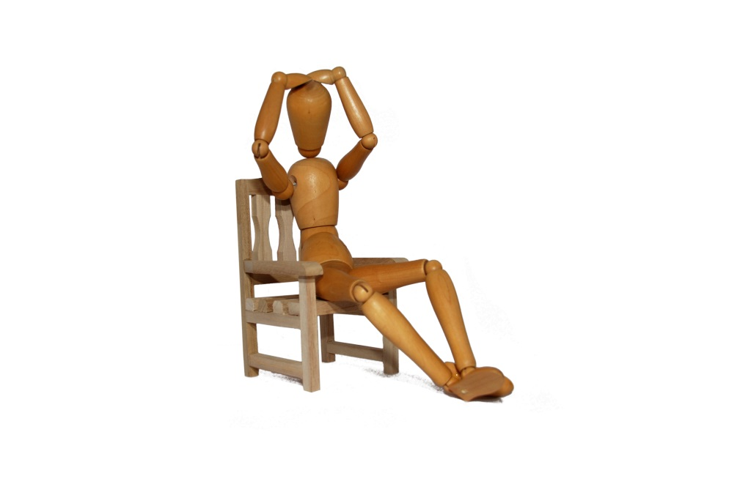

Tense your foot muscles as tight as possible. Make sure your toes are curled. Try and get these muscles as tight and tense as possible. Hold for a moment and notice how your feet feel whilst they are tense. Notice your own reaction to having tense muscles. Now relax your feet and let the tension melt away. Notice how your feet feel now that they are relaxed. What are the differences between how they feel when tense and when relaxed? Slowly repeat this step twice to get acquainted with how different your feet feel when they are relaxed to when they are tense.

Tense your lower leg muscles as tight as possible. Make sure your calves and knees are tightly squeezed. Try and get these muscles as tight and tense as possible. Hold for a moment and notice how your lower legs feel whilst they are tense. Notice your own reaction to having tense muscles. Now relax your lower legs and let the tension melt away. Notice how your lower legs feel now that they are relaxed. What are the differences between how they feel when tense and when relaxed? Slowly repeat this step twice to get acquainted with how different your lower legs feel when they are relaxed to when they are tense.
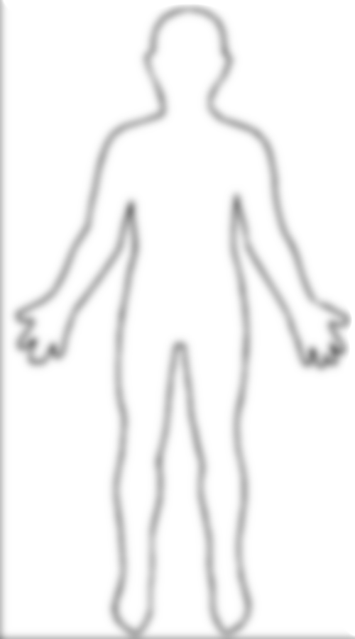
Tense your upper leg and bottom muscles as tight as possible. Make sure your muscles are squeezed. Try and get these muscles as tight and tense as possible. Hold for a moment and notice how your upper legs and bottom feel whilst they are tense. Notice your own reaction to having tense muscles. Now relax your upper legs and bottom and let the tension melt away. Notice how your upper legs and bottom feel now that they are relaxed. What are the differences between how they feel when tense and when relaxed? Slowly repeat this step twice to get acquainted with how different your upper legs and bottom feels when they are relaxed to when they are tense.

Tense your stomach muscles as tight as possible. Try and get these muscles as tight and tense as possible. Hold for a moment and notice how your stomach feels whilst it is tense. Notice your own reaction to having tense muscles. Now relax your stomach and let the tension melt away. Notice how your stomach feels now that it is relaxed. What are the differences between how it feels when tense and when relaxed? Slowly repeat this step twice to get acquainted with how different your stomach feels when it is relaxed to when it is tense.

Tense your chest and shoulder muscles as tight as possible. Make sure your shoulders are curled up to your neck. Try and get these muscles as tight and tense as possible. Hold for a moment and notice how your chest and shoulders feel whilst they are tense. Notice your own reaction to having tense muscles. Now relax your chest and shoulders and let the tension melt away. Notice how your chest and shoulders feel now that they are relaxed. What are the differences between how they feel when tense and when relaxed? Slowly repeat this step twice to get acquainted with how different your chest and shoulders feel when they are relaxed to when they are tense.

Tense your arm and hand muscles as tight as possible. Make sure your arms are curled and hands clenched. Try and get these muscles as tight and tense as possible. Hold for a moment and notice how your arms and hands feel whilst they are tense. Notice your own reaction to having tense muscles. Now relax your arms and hands and let the tension melt away. Notice how your arms and hands feel now that they are relaxed. What are the differences between how they feel when tense and when relaxed? Slowly repeat this step twice to get acquainted with how different your arms and hands feel when they are relaxed to when they are tense.

Tense your face muscles as tight as possible. Make sure your nose, eyes, and forehead, are wrinkled. Try and get these muscles as tight and tense as possible. Hold for a moment and notice how your face feels whilst it is tense. Notice your own reaction to having tense muscles. Now relax your face and let the tension melt away. Notice how your face feels now that it is relaxed. What are the differences between how it feels when tense and when relaxed? Slowly repeat this step twice to get acquainted with how different your face feels when it is relaxed to when it is tense.

Weekly Task

This week, take some time out each day to practice the Relaxed Breathing Exercise, the Square Breathing Exercise and the Progressive Muscle Relaxation exercise. We recommend practising for at least 15 minutes. A good time to practice these is first thing in the morning and/or before you go to sleep at night. Once you are familiar with the exercises you probably won’t need to refer to this booklet. This means that you can practice these exercises wherever you are without anyone even knowing you are doing them!

These exercises are also useful when you feel your anxiety rising. When this happens you can try to notice whether your breathing is speeding up (Fight/Flight/Freeze mode) and adjust it back to the Relaxed Breathing learnt this week. You may also notice that your muscles are tightening (Fight/Flight/Freeze mode) and can adjust them back to the relaxed state you learnt this week. You may notice it is only one particular area of your body that tightens. This can be an area to practice on throughout the day. What affect does this have on your anxiety? The more you practice these exercises, the easier they become and then the quicker you are able to adjust your breathing and muscles during heightened anxiety.

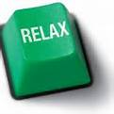

WEEK 3

CALMING THE MIND


For the last couple of weeks we have focussed on what happens in our body when we experience anxiety, and how to send a message to The Cave-Man, using our body, to reduce our anxiety. This week we are going to focus on how anxiety affects our mind. When we are feeling anxious, sometimes we have racing thoughts, often worrying thoughts, in our minds that can make it hard for us to focus on anything. This can interfere with our lives, by making it hard for us to complete schoolwork, have a conversation with friends, and even just relax and watch a movie! Racing thoughts at night can also interfere with our sleeping which then have even more effects on our lives.

Although learning to catch and change our thoughts is effective long-term, sometimes it can very helpful to have a few immediate techniques to use to calm your mind in the moment. This week we will focus on ways to experience short term relief from a racing mind. We will tackle some more complex approaches that have long term benefits later in this booklet.

When we find our minds racing and we can’t focus on what we need to, a good way to calm our minds is by distraction ourselves from our thoughts. This can help you to focus on something completely different as well as to keep control over your racing mind. Another way that we can control our thoughts and calm our mind is by using grounding techniques. These exercises can bring your thoughts back to where you are and the environment you are in. Taking our focus away from stressful thoughts to neutral thoughts can reduce anxiety.

While distraction and grounding techniques can be very effective at calming our minds, sometimes taking some time to leave the moment you are in and create a mental safe space for you to go to is just as helpful. When your thoughts start racing and you feel out of control, imagine a safe, calm place to escape to from your current anxiety.

The following activities are exercises that you can use when you find your mind racing and you can’t control your thoughts.

Activity 1

Distraction- The 321 Exercise

Take a minute to take some deep breaths. Look around you and notice 3 things you can see, 3 things you can hear, and 3 things you can touch. Now take a few more deep breaths and notice 2 things you can see, 2 things you can hear, and 2 things you can touch. Take a few more deep breaths and notice 1 thing you can see, 1 thing you can hear, and 1 thing you can touch. For each step, try to notice different things that you can see, hear and touch. How do you feel now? If you need to try this exercise again, you could start at 5 things that you can see, hear and touch and then work down to 1 from there.

Activity 2

Distraction- The A-Z Exercise

Take a minute to take some deep breaths. In your mind, go through the alphabet (A through to Z) and think of a word, object, or activity for each letter. You can vary this by choosing different categories, e.g.
- types of animals
- things you like to eat
- activities
- places
- names
- celebrities
How do you feel now? If you need more time to calm your mind, you could repeat this exercise several times with different themes.

Activity 3

Grounding- The Pencil Case

Take a minute to take some deep breaths. Take something out of your pencil case. Imagine that you are an alien and you are not familiar with the object. Using all 5 senses, try to describe the object you are holding in as much detail as possible. What does it feel like? Does it make a sound? What does it sound like? Does it smell? What does it remind you of? What does it look like? What colours and textures does it have? How do you feel now? Repeat this exercise with different objects for as long as you need.

Activity 4

Grounding- The Here and Now Exercise

When we get anxious, we often think about things that have happened in the past or worry about things that might happen in the future. Try to ground yourself in the moment, in the here and now. Look around you. Remind yourself that you are ok, you are safe and that nothing bad is happening. Focus on the present moment. When your mind wonders off and you begin to worry, notice this and try to bring your mind back to the present moment. Do not feel bad if your mind wonders, just notice that it has wondered and bring your attention back to what you are trying to do.

Activity 5

Safe Space Visualisation

Sometimes when your mind is racing, taking yourself away from the current moment can be very calming. It is helpful to create an imaginary safe space that you find to be calming, and return to this same safe space when you need to. Before you begin, take a few minutes to do some deep breathing. Close your eyes and imagine a relaxing place. This can be the beach, a forest, a field, a snowy mountain; wherever you feel that you would be most happy and calm. What do you notice is in this space? Are there any buildings? Are there any animals? What is the lighting like? Can you hear any background noise? Take some time to really create all the dimensions of this safe space. Now think about what you would be doing in this safe space? Would you be lying down? Choose the most relaxing position you can think of in this safe space and take some time to soak up the calmness. Now we need a way to deal with intrusive thoughts. As this is a safe place away from your racing mind, it is not appropriate to allow your thoughts to come here. When a thought comes into your mind, try not to react to it but notice that the thought has entered your safe space. Now turn this thought into something that fits into your safe space. This might be a feather, a seed off a dandelion, a cloud, or a snowflake. Choose something that suits you and suits your environment. Once you have transformed your thought, notice as a calm breeze blows it away. Watch as it slowly drifts away into the distance. Soon it is gone and all is quiet and still again in your safe space. Stay here for as long as you need to let your mind calm down. You can return to this safe space whenever your feel overwhelmed by your thoughts.


Weekly Task

This week, take some time each day to practice these exercises. Choose a quiet time and place where you will not be distracted or disturbed. Take up a relaxed position, lying down is best. Before you begin, spend a few minutes using the Relaxed Breathing from last week. Scan your body to see if your muscles are relaxed and if you find any tension, adjust the muscle so you are nice and relaxed. Choose one of the exercises provided each day to practise. If there is one exercise that you particularly enjoy, you can add this to the end of your practice session.

This week, whenever you feel your mind racing, choose the activity that you feel will be most beneficial in the moment you are in and use it to help calm your mind.

WEEK 4

BECOMING A THOUGHT DETECTIVE

Research suggests that only 40% of our thoughts are about what we are doing right now. This means the other 60% of the time our mind has wondered to things that have happened in the past or things that may happen in the future. The focus of our thoughts has a lot to do with what we believe about ourselves and what we believe about life.

Not only do thoughts affect how we behave, thoughts also impact how we feel.

Harry’s core belief is that he is boring, and because of this he assumes no one will like him. When Harry is in a social situation, he feels nervous as he thinks he will be standing alone the whole time. When the rude person speaks to him and he sees it as evidence that he is boring, he might feel depressed that he doesn’t have friends. When the nice person speaks to him and he dismisses it as a once off he might feel embarrassed that the person was being polite. As you can see in the diagram about Harry’s core belief below, negative core beliefs can be a big problem as they have affect the way we feel and live our lives.

Harry’s Thought : I am boring
Situation

At a party and a person was rude

At a party and a person was nice
Feelings
Sad and embarrassed

Behaviour
I may as well go home from the party early because no one here will like me

Thoughts
See! This person doesn’t like me because I am boring.

Feelings
Awkward, anxious and sad

Behaviour
I’m not going to make too much of an effort with this person because they don’t really like me

Thoughts
They were only nice to me because they were being polite

Automatic Negative Thoughts
Throughout the day we have thoughts that pop into our head automatically. They can be meaningless, like what you are going to do when you get home, or what you feel like for dinner. They can also have meaning and be related to core belief. These meaningful automatic thoughts are either positive or negative. Positive automatic thoughts are helpful as they encourage you. If you have finished a game of sport, you may think “wow I played really well today!” This positive automatic thought will then encourage you to practice during the week and turn up at the next game. On the other hand, negative automatic thoughts can discourage and stop you from doing things. Imagine you just gave a speech in front of your class, you may think “how embarrassing! My voice sounded so strange and I’m sure I kept mixing up my words”. This negative automatic thought may lead to you skipping school next time you have to give a speech, or even talk less in a group in case you sound strange or mix up your words.

Negative automatic thoughts have several things in common. They are automatic and pop into your mind without warning or effort. They are distorted (not accurate) as they don’t give the full or accurate picture. Their only purpose is to make your negative thought stronger. They are continuous so it is hard to stop them from happening. And they seem true as they can become evidence to support your beliefs.

The more we hear these negative automatic thoughts, the more we start to believe them, especially if we don’t stop to challenge them. As they are automatic, we have no say in how regularly we experience the thought and it can seem like they are playing on repeat in your head. The more we listen to a negative thought, the worse we feel. When we feel bad, we are more likely to listen to the negative thoughts and this then effects our behaviour, making us less likely to do things we want to do and reinforcing the negative thought.

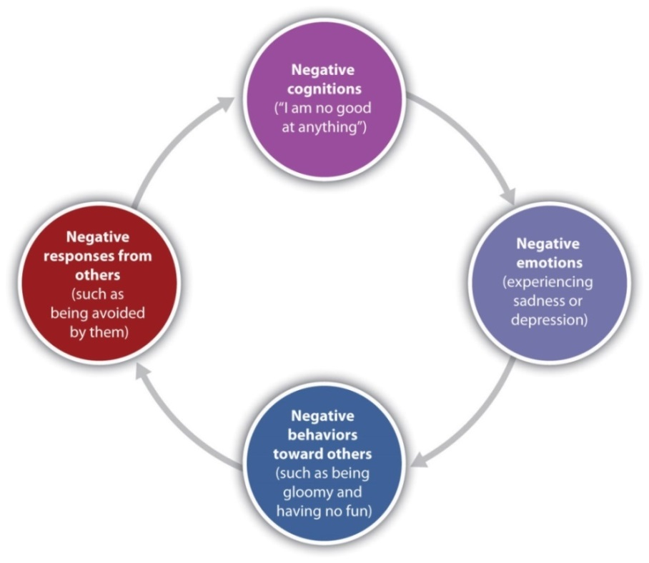
Harry has a core belief that he is boring. He assumes this will mean no one will like him. When he goes to school, negative automatic thoughts keep popping into his head “Those people are laughing at me… If I answer the teachers question they won’t listen anyway… Don’t try out for the school play because you won’t be any good… At lunch I’m going to have to sit by myself the whole time”. Hearing these thoughts in his head makes him feel sad, nervous, and embarrassed. He chooses not to participate in class discussions, doesn’t join any of the school activities, and keeps to himself at lunchtime. Now he believes the thoughts are right, and feels even worse.

Negative Thinking Styles

Negative Automatic Thoughts can come in many forms, we call these Negative Thinking Style. There are lots of negative thinking styles, because as with everything in life, one size does not fit all. Under each thought, style, we have also included example questions of how you can challenge these thoughts; as you read through, try to identify which style you use.
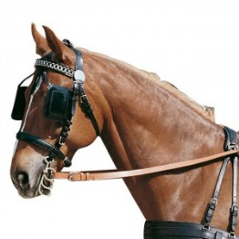
Mental Filter
When we notice only what the filter allows us to notice- things that agree with our belief. Sometimes things don’t fit and we dismiss these as a one off.
Am I only noticing the bad stuff? Am I filtering out the positives?

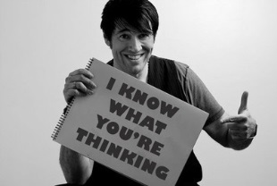
Mind-Reading
Assuming we know what others are thinking (usually about us). You might be giving a speech in class and everyone is quietly watching you and you think “They are all bored and think my speech is terrible”.
Is this their thought or mine? How do I know that is what they are thinking?

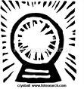
Prediction
Believing we know what’s going to happen in the future. You may feel nervous going to a party and think “I can’t go because nobody will talk to me”. This prediction may stop you from going to the party, when actually you could have made new friends if you went.
Am I thinking that I can predict the future? How likely is it to really happen?

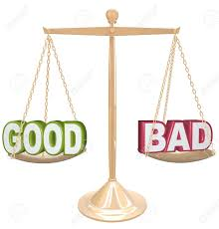
Compare and despair
Seeing only the good and positive aspects in others people and comparing ourselves negatively against them. You may look at a classmate and think “Wow their hair always looks so nice. Mine always looks terrible. I’m so ugly”.
Is there a more balanced way to look at the situation? Are there other areas that I do well in?

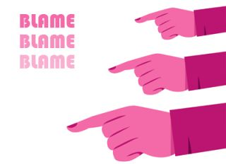
Critical self
Putting ourselves down, self-criticism, blaming ourselves for events or situations that are not totally our responsibility. . Perhaps your group came second in a relay at the sport’s carnival. You might think “I was the last runner so it was my responsibility to win. Because I came over the finish line second it’s my fault that we only came second”.
Is this really my fault? What else could have caused it?

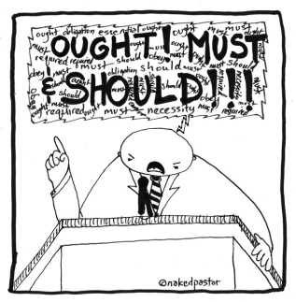
Should’s and Must’s
Thinking or saying ‘I should’ (or shouldn’t) and ‘I must’ puts pressure on ourselves, and sets up unrealistic expectations of how we should behave or perform. Often this leads to rigid rules of how we live our lives and interact with others. You might think “I should always reply to someone’s text within 5 minutes of receiving it”.
Does this have to be done? Is it realistic?

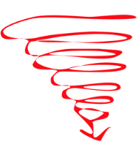
Catastrophising
Imagining and believing that the worst possible thing will happen; thoughts become a downward spiral. If we have asked a friend to catch up on the weekend and they haven’t replied yet we may think “why hasn’t he replied? Maybe he doesn’t want to see me? Maybe we aren’t actually friends?
What’s most likely to happen? Is there another way to explain this?


Emotional Reasoning
Thinking that your emotions reflect the situation. “I feel bad so it must be bad!” “I feel anxious so I must be in danger.”
Thoughts are automatic and cause my body to respond in a certain way.

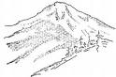
Mountains and Molehills
Exaggerating the risk of danger, or the negatives. Minimising the odds of how things are most likely to turn out, or minimising positives. Imagine you accidently packed your friends book into your bag when you were leaving class. You know it wasn’t on purpose but you may start to panic and think “Oh no! They are going to think I took it on purpose and that I stole it from them! Maybe they’ll contact the school and say I’m a thief.
Is it really that bad? How would someone else see it?


Evaluations / Judgements
Making judgements and assumptions about events, ourselves, others, or the world without any evidence. . You may be walking home from school and there is someone walking behind you and you think “He is walking quite fast; he must want to attack me”.
Could there be another reason for this? What evidence do I have?


Black and white thinking
Believing that something or someone can be only good or bad, right or wrong, rather than anything in-between or ‘shades of grey’. “Dogs always try to bite me”.
Have there ever been times where this didn’t happen? Things are normally grey.

Activity 1
Think about when you have had a ‘hot thought’, what was it and what negative thinking style does this fall into? What could you have asked yourself to challenge the thought?
Negative Thought |  | Thinking Style | Challenging Question

Challenging Negative Thoughts

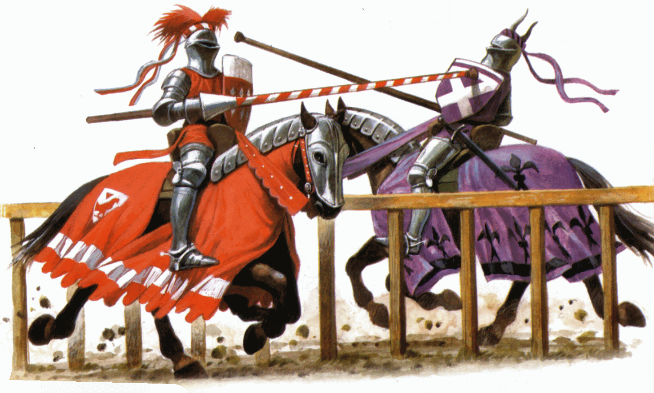

In order to stop a negative thought, you first need to identify when it is that you have them and the consequence of this. A ‘hot thought’ is a thought that is the most common, or a thought that produces the strongest reaction from us. By being able to identify our hot thoughts, we are in a better position to challenge them. To be able to identify a pattern, we must think back to when a thought occurred and what we were doing; good questions to ask yourself are:
- What was my thought when I started feeling this way?
Sara was planning to meet up and go to a café with friends. She worried that they wouldn’t turn up and she would be left there alone.
- Where was I when I started to feel this way?
Sara was in the car getting a lift from her mum
- What were my thoughts when the feeling became really strong?
Sara was thinking of all the reasons her friends may not come “they may have forgotten the plans”, “they may choose to do something without me” “they don’t like going to cafes”
- What did I think would happen?
Sara was convincing herself her friends wouldn’t come
- What might other people say about the situation?

Sara thought the others would laugh at her for waiting for no reason and that shoe would have to tell her mum to pick her up early, which would be embarrassing.
When we break down the thoughts, we can understand why Sara was worried about meeting up with her friends.

The types of negative automatic thoughts we have depends on our style of thinking. Thinking styles are deep set patterns that we stick to in order to make meaning of our world as quickly as possible. Unfortunately using these thoughts to make meaning only reinforces unhelpful core beliefs. In order to change a core belief, or stop negative automatics thoughts, we need to challenge the thought as soon as we have it. The best way to do this is to try to take a step back and pretend to be an observer. There are 3 steps when challenging a thought:
- Look for evidence to prove or disprove it
- What has happened to have this thought?
- Has this happened before? How often?
- Is this thought helpful?
- Am I only noticing the negative things?
- How likely is it to happen?
- Consider alternative options
- What else could happen?
- If this was happening to someone else, what would you think of them?
- If this was happening to someone else what would you tell them?
- What would someone else think if it happened to them?
- Is there another reason the feared situation could happen?
- Reach a conclusion
- Is this thought true?

Weekly Task

Throughout the week, pay attention to the types of thoughts you are having. Are they positive or negative? How do they make you feel? How do they affect your behaviour? Practice challenging the negative thoughts and write the outcomes in the work sheet on the next page.
- | Date/ Time
 | Thought
 | How did you feel?
 | What was your reaction/ how did it affect your behaviour?
 | What negative thought style were you using?
 | How did you challenge the thought?

WEEK 5

DEALING WITH TRICKY SITUATIONS

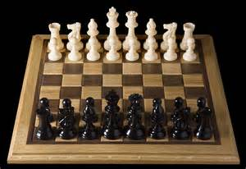

Every day we are faced with situations and challenges that we need to respond to. Making good choices in our responses can have a huge influence on the type of day we have. Last week we learned how to notice the types of thoughts we are having and then challenge the unhelpful thoughts. We found that thoughts affect how we feel and then, in turn, affect what decisions we make, which can then affect the entire outcome of the situation.

This week we are going to focus on how to plan for positive outcomes in tricky situations. Tricky situations can be different for every person. For some people a tricky situation can be asking your parents for permission to stay out late. For others it may be responding to a hurtful comment from another student at school. Tricky situations usually have something to do with how we interact with other people in order to avoid a conflict. Sometimes we can be very good at handling a tricky situation and things work out well, but often, if we don’t know how to handle these situations, things can seem to go downhill and we can end up in fights with our family and friends, hurt by bullies, or in trouble at school. Some of the reasons tricky situations go downhill are when we act without challenging our thinking and act on how we are feeling in the moment.

When we act without challenging our thinking, we can completely misjudge the situation and respond in an unhelpful way. Imagine Sarah is in the playground, feeling nervous about who to play with. Jess says to Sarah “Hey, your hair looks great today”, and Laura who is standing behind Jess starts giggling. Sarah has a negative automatic thought “Jess doesn’t mean it – they are actually teasing me and that is why Laura is laughing”. Sarah wants to stand up for herself and responds without challenging that thought, and says to Jess “Well your hair looks gross”. How do you think this situation would turn out? It is very likely that Jess would feel hurt and not want to play with Sarah, and Jess’ friends would also feel upset on their friend’s behalf. Sarah would be left without anyone to play with, feeling as though she had just been teased by the other girls, and with a reputation for being mean.

When we act on how we are feeling in the moment we can end up making decisions out of proportion to what is happening and making the tricky situation even trickier!
Although we now know how to challenge our thoughts, and know that our thoughts and feelings both influence our behaviour, unless we can learn to stop our reactions in time to use these techniques and knowledge, we won’t be able to change the outcome of a tricky situation. If Sarah was knew how to stop and think about the situation before she responded to Jess, the situation could be completely different. Let’s see how different…

Imagine Sarah is in the playground, feeling nervous about who to play with. Jess says to Sarah “Hey, your hair looks great today”, and Laura who is standing behind Jess starts giggling. Sarah has a negative automatic thought “Jess doesn’t mean it – they are actually teasing me and that is why Laura is laughing”. Instead of immediately responding defensively, Sarah stops for a moment to challenge her thought. “I can’t read Jess’ mind so how do I know she doesn’t mean it. And Laura is reading her phone so it is more likely that she is laughing at that rather than at my hair”. Now that her thought has been challenged she feels much better about the situation and is able to see Jess’ compliment as friendly. Sarah says to Jess “Thanks’, you look good too! What are you all up to this lunchtime?” How do you think this situation would turn out differently? Sarah and Jess become friends and Jess has a new group of friends to play with at lunchtimes.

Activity 1

My Tricky Situation

As you can see, taking time to stop and think about a situation before responding can completely change the outcome for the better. Wouldn’t it be great if we did this every time we were in a tricky situation? Think of two situations where you responded too quickly and made a tricky situation worse. One should be where you didn’t challenge your thinking, and the other should be when you acted based on your emotions. What happened? Now try and think of how this situation could have been changed simply by stopping to think before acting. How would the situation be different? Write these situations and how they could be different into the diagrams on the next page.

Tricky Situation 1 – What happened?

Outcome
Tricky situation
Feelings

Behaviour
Thoughts

Bodily Sensations

Tricky Situation 1 – How could this have been different?

Outcome
Tricky situation
Feelings

Behaviour
Thoughts

Bodily Sensations

Tricky Situation 2 – What happened?

Outcome
Tricky situation
Feelings

Behaviour
Thoughts

Bodily Sensations

Tricky Situation 2 – How could this have been different?

Outcome
Tricky situation
Feelings

Behaviour
Thoughts

Bodily Sensations

Traffic Light Steps

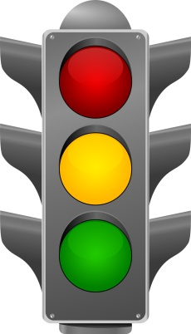

Often, when we are in the habit of responding quickly, it can be difficult to learn to stop before we react. A good way to help ourselves stop is by imagining a traffic light.

The red light reminds us to stop for a moment. Instead of responding straight away to how we feel or what we think is happening. This light interrupts this automatic response and gives us a chance to change the outcome of the situation. In this step we can also choose to do a few breaths of the relaxed deep breathing from week 2. This can help us prepare our minds for the next step.

The amber light reminds us to think about the situation and what should be said or done. In this step we should take the time to challenge our negative thoughts. Is there another way of looking at this tricky situation? In this step we can also plan what we are going to do and think about what outcome we would like. Think about what you could say or do to achieve this outcome.

The green light is a sign to act on our plan. Rather than rush in and respond, say or do what you have planned to in order to achieve the best possible outcome.

It can take a bit of practice to be able to do these three steps well. Like with anything, the more you practice the better you will get. You may feel a little silly at first taking the time to change your reaction. In the short term it is worth taking things a little bit slower to avoid conflict and find a good solution to a tricky situation. In the long term it is worth taking things slowly to practice this new technique. Eventually it will become a good habit and you will be able to stop, think, and go very quickly, without anyone noticing you are doing it.

Activity 2

Traffic Light Steps

As we have learned this week, learning how to stop and think before we go is very important in dealing with tricky situations. You may find it difficult to remember to stop at first. A good way of remembering is to choose little things throughout the day to remind yourself that if a tricky situation comes up, you need to stop first. Below is a diagram of a traffic light. Write or draw all the little things throughout the day that can remind you of the three traffic light steps.

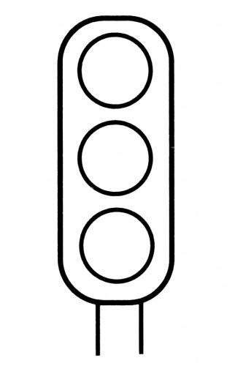

Weekly Task

This week, if you have a tricky situation that you know will come up, perhaps asking for permission for something from a parent or teacher, complete the following worksheet to help you plan in advance and make the Stop, Think, Go, steps easier when the time comes.

What is the tricky situation?

What are the possible solutions to this tricky situation?

Solution Outcome

Now that you have a plan in place, colour in the traffic lights below and place them in places where you will be reminded of the three steps throughout the day. You could keep one in your pocket, one in your wallet, and one stuck somewhere you will see it daily, like the fridge. You could also give one to someone you trust who will be able to discretely remind you of the steps when you need them.

WEEK 6

HEALTHY BODY – HEALTHY MIND



By now, you will have quite a few tools that you can use to help manage your anxiety physically, calm your mind, address your thought patterns, and solve tricky situations. The final tools that we will leave you with are good habits for a healthy lifestyle. Let’s imagine that your lifestyle is the toolbox that supports all the tools that you have collected throughout the past 5 weeks. The three main factors that all work together to create a healthy lifestyle are exercise, diet, and sleep. If you can manage to balance these well, you will notice the benefits in your life, beyond anxiety management.

EXERCISE



Exercise has many benefits for physical health, but has also been found to be greatly beneficial to those who experience anxiety. One way to explain the benefit of exercise is to remember The Cave-Man from Week 1. When he switches your body into Fight/Flight/Freeze mode, this is done by sending a sudden surge of adrenaline throughout your body. Exercise can be a natural alternative to using up this adrenaline when your body is in this mode. In addition, exercise also has other benefits to reducing the physical aspects that can underlie anxiety:
- Decreases muscle tension – having tense muscles can be responsible for feeling tense or uptight.
- Reduces the amount of adrenaline in your bloodstream – increased adrenaline can keep you in the state of Fight/Flight/Freeze.
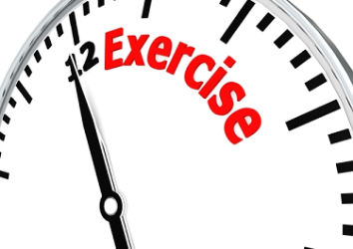
- An opportunity to release frustration – pent up emotions can lead to higher anxiety and panic attacks.
- Increases oxygen levels in the brain – this can increase mental clarity and help you manage your concentration and memory.
- Increases the levels of endorphins (a ‘happy’ hormone) in your blood stream – endorphins increase your sense of well-being.
- Helps maintain a healthy blood acidity levels and blood sugar levels – this can increase energy as well as maintain steady energy levels throughout the day.

Although most people are aware of how beneficial exercise can be to our lives overall, there are plenty of excuses that can be made to avoid exercise. In week 4 we learned about thought detection and thought challenging so if you find yourself making excuses, you are now equipped to challenge these excuses! Below are some example excuses that you may find yourself making and a possible solution.

- Not enough time
Whenever there is something we want to do, we find it easy to make time to include it in our lives. It seems to fit in easily. This is because we are prioritising this activity over other aspects of our lives. If you find you don’t have enough time for exercise, this may be because you aren’t prioritising it – remind yourself how important exercise is to managing anxiety. Start out small and think of ways you can add a small bit of exercise each day, and gradually increase it.

- Too tired
One of the most common excuses for not exercising is being too tired. This can be solved by adding a short spurt of exercise first thing in the morning rather than after a busy day. Remember that exercise actually increases energy. Try waking up 10 mins earlier than normal to go for a quick jog around the block. As hard as it might be to start, you will find you are wide awake by the time you are home and ready to embrace the day. If you enjoy this you can always increase the duration.

- Boring!
No-one wants to repeatedly do an activity that they find boring! Get creative – think of different types of exercise you might enjoy. You may even enjoy exercising with a friend for company. Remember, all exercise is going to be hard at first if you are not used to it, but after your two week trial period, you may find that you enjoy the benefits so much that you are happy to do it anyway.

- Nowhere to go
If you don’t feel comfortable exercising in public there are plenty of ways you can exercise at home. Youtube has quite a few fitness channels of short daily workouts that you could try out. You could put music on and dance around to increase your heart rate. Jump rope is a very good way to increase your heart rate and muscle tone in your legs. Get creative with what you have at home and finds ways to increase fitness levels in the house.

- I’m too unfit
If you are starting exercise from scratch and feel as though your fitness levels are currently too low to sustain physical activity, be kind to yourself and reassess your expectations. This is not a competition against other, more fit, people – this is about making small changes to your current lifestyle to be healthier. Start with something small like walking around the block or climbing the stairs in your house 3 times each morning. Gradually your fitness level will increase and you will be able to sustain the activity for longer and even try different types!

Activity 1

How Active Are You?

Exercise needs to increase your heart rate, be regular, and for at least half an hour to impact your anxiety levels. Below is a short worksheet for you to fill out and see what level of activity you currently engage in.

NTENSITY  How much effort does it take? | FREQUENCY  How many times each week? | DURATION  How long do you exercise?
Heavy = 5 points (fast cycling, running, aerobic dancing) | 3 or more = 5 points | 30 mins – 60 mins = 5 points
Moderate = 3 points (jogging, cycling, very fast walking) | 1-2 times = 2 points | 10 – 30 mins = 3 points
Light = 1 point (golf, strolling, housework) | Not at all = 0 points | 10 mins or less = 1 point

Add your score:
Intensity = + | Frequency = + | Duration = + | Total =

TOTAL SCORE | FITNESS LEVEL | RECOMMENDED ACTION
13-15 | Good | Maintain current level
8-12 | Average | Increase intensity, frequency and/or duration
Less than 7 | Low | Begin exercising!

NUTRITION



Another aspect of a healthy lifestyle that can greatly affect mood and anxiety is nutrition or diet. What you eat can have a direct impact on how you feel, immediately, later in the day, and in our general day to day wellbeing. There has been a lot of research over the past couple of decades into how diet affects mood and it is now well known that there are some foods that increase stress and anxiety levels. Once you are aware of how these foods are connected to mood and anxiety, you are then equipped to make smart choices when choosing food –choosing your food is like choosing your mood.

Some of the food and drink that increase anxiety are:

- Stimulants: Caffeine and Nicotine
Lots of people feel as though they can’t get through the morning or day without a coffee, partly because of its addictive nature, and partly because of the stimulating effect it has on the Nervous System. Caffeine releases Norepinephrine (a hormone that causes you to feel alert), but also causes adrenaline to be produced which sets of the Cave Man threat perception. This is a way of overriding the emotional regulation of anxiety, and directly introducing a Fight/Flight/Freeze response without any external threats being present.

Caffeine also depletes the levels of Vitamin B1 in the body (a vitamin that supports the Nervous System and increases resilience to stress), so all in all, regular intake of caffeine has no benefits to those who experience heightened anxiety. Some of the foods and drinks that contain caffeine are:
- Coffee
- Tea
- Soft drinks
- Energy drinks and snacks
- Chocolate

Another stimulant that is regularly used in our society is nicotine. Nicotine is found in cigarettes and is known to increase heart rate and anxiety levels. Often smokers say that smoking calms their nerves; however research has shown that smokers experience more heightened anxiety and panic attacks, and sleep less well than non-smokers. Although there are other health reasons to stop smoking, if you experience anxiety and panic attacks, this is a very good reason to stop.

- Salt:
Too much salt in our diet causes stress to the normal way the body works. The reason that it has an effect on anxiety is because it depletes the body of potassium, which is a mineral that helps the Nervous System (the Cave-Man switch) function healthily. High salt foods include

- Bacon, ham, salami and smoked meats
- Pickles
- Salted and dry roasted nuts
- Salt fish and smoked fish
- Soy sauce
- Fast food and take-away’s
- Microwave meals
- Junk food in general.

If you find yourself heading to McDonalds most days for lunch or even a snack, it is very likely that there is too much salt in your diet.

- Sugar:
Although sugar is well known as a ‘naughty’ food, we do need sugar in order for our brains and bodies to function properly. Before you rush off to the cookie jar, remember that there are different types of sugar; some which help our brains and bodies work well, and others which cause problems in our functioning and can increase anxiety and decrease mood.

The sugars that help our bodies to function well and provide us with sustained energy are called complex carbohydrates. This type of sugar is broken down slowly by the digestive system and is then used slowly by the body throughout the day, as if on an hourly ration. Examples of complex carbohydrates:
- Fruits and vegetables
- Grains
- Oats
- Potatoes


The other type of sugars are called simple carbohydrates and are broken down quickly by the digestive system and then used by the body in a quick spurt of energy, however leaving the body with low energy levels in the long run. This is like the body having a quick party using the food we have given it, you may feel an emotional high, and then having nothing to provide energy after this party. We then feel low in mood and energy levels. The symptoms of this sugar slump are light headedness, anxiety, trembling, weakness, irritability, heart racing. Do any of these sound familiar? They are very similar symptoms to a panic attack! Although your anxiety levels may not be purely due to a sugar low, you may find that sugar slumps can aggravate current levels of anxiety and be a contributing factor. When sugar levels drop too low, the body can then release a jolt of adrenaline to help you function better for a short while, which is another way of overriding The Cave-Man’s regulation of anxiety, and directly introducing a Fight/Flight/Freeze response without any external threats being present. Examples of simple carbohydrates:
- Soft drinks
- Chocolate
- Sweets
- Fast-food
- Microwave meals and processed foods

As you can see, what you eat can have a large impact on how you feel and how much anxiety you may experience. Some simple guidelines for healthy eating are:
- Limit the caffeine and nicotine in your day
- Choose food that is not high in salt
- Choose complex carbohydrates over simple carbohydrates

Activity 2

How Healthy Is Your Diet?

Below is a short worksheet for you to fill out and see what type of foods you eat on an average day. Fill out what type of foods you usually eat on an average day. Refer back to the previous sections when completing each type of food to see which food belongs in which row. Some foods may belong in more than one row e.g.: A McDonalds meal belongs in the following rows, Salty Food, Caffeine, and Simple Carbohydrates.

My Daily Diet

Type of food | Breakfast | Lunch | Dinner | Snacks | Drinks | Total
Caffeine
And Nicotine
Salty
Food
Simple Carbohydrates
Complex Carbohydrates

Once you have completed the table tally up the amount of food in each row. The top three rows are foods that increase anxiety and are foods you should aim to avoid. The bottom row is foods that maintain a healthy lifestyle. Ideally, as many of your meals throughout the day should be recorded into this row. Have a look at where most of your meals are recorded. Is your diet increasing your anxiety levels or increasing good health?

SLEEP



The third aspect of a healthy lifestyle is good sleep habits. Adolescents have a different internal clock to adults, which means that they don’t feel sleepy until later and end up staying up late and sleeping in. So, when your alarm goes off at 7am on a school day, it can feel like the middle of the night because you didn’t fall asleep until late. Unfortunately, the school day isn’t shifting to start later (though it should!), so you need to figure out how to get enough sleep. Sleep is very important. A good night’s sleep, which is at least 9 hours, significantly improves your mood and helps you better manage stress and anxiety.

Some signs that you are not getting enough sleep are:
- Being cranky and irritable, and not much fun to be around
- Low energy and generally feeling low
- A fuzzy brain, which means you’ll have trouble paying attention and remembering things
- Trouble dealing with stress and solving problems

A good night’s sleep can be as hard as exercise to fit in. What with social media, hanging out with friends, completing homework, favourite TV shows, and even lying in bed worrying, sleep can have a hard time competing.
Experiment with some of these strategies to see if they help you re-set your sleep cycle and get a better night’s sleep:
- Set times to go to bed and wake up
Try to go to bed when you’re sleepy, and stick to a set time to get up every morning. Yes, even on the weekends. Sleeping in on the weekend messes with your sleep cycle and prevents you from getting enough sleep during the week.

- Exercise
Being physically active helps you feel sleepy at bedtime and improves the quality of your sleep. But try to avoid exercising at least 2 hours before going to bed or you will feel too pumped and awake!
- Set the stage for sleep
Make your room and bed comfy, find the right temperature (slightly cooler is better), turn down the lights and cut out noise. Remember The Cave-Man is used to sleeping in caves!

- Use your bed only for sleeping
Try to avoid watching TV, surfing the net, playing on your phone, reading, or studying in bed. By only using bed to sleep in, it teaches our body that bed = sleep.

- Relax
About an hour before bed, turn off your TV, phone, and tablet. Dim the lights, turn on some soothing music, and do something relaxing (meditation, breathing exercises, warm bath, hot shower, cuddle a pet, journal about things that make you feel good, draw). This stops the brain needing to be so active and sends the message to your brain that it’s time to go to sleep. You could also include the exercises from Week 2 to help you unwind and feel sleepy.

- Wake up to bright lights
Light helps send your brain the message it’s time to get up and be alert! So try turning on all the lights and opening your blinds first thing in the morning. This will help you feel more awake.
Things that interfere with sleep:
- Naps
It’s tempting to have a nap when you’re tired from staying up late, but napping will interfere with you feeling sleepy at bedtime causing you to stay up too late and being tired again the next day.

- Stimulants
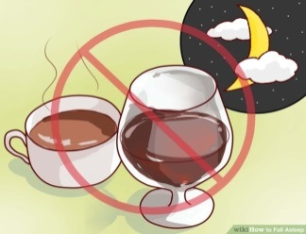
Even though these foods and drink can give you a boost when you’re tired, they interfere with you feeling sleepy at night and having a restful sleep. So try limiting these things especially in the afternoon and evening.

- Alcohol or weed
You might think it helps you feel relaxed and fall asleep, but it interferes with the quality of your sleep by stopping you going into the most restful part of your sleep cycle and so you don’t feel as rested.

- Blue Light
Avoid tablets, phones and computers right before bed. The blue light spectrum coming from electronics keeps you alert and makes you less tired so it’s harder to fall asleep.

- Worrying
This can be hard, especial if you worry about not being asleep.. Remember the activities we learned in Week 3 on how to calm your mind. Try some of these activities before bed, as well as the relaxation activities from week 2, to help you feel calm and sleepy.

Activity 3
Planning A Good Night’s Sleep
A great way to get enough sleep is to make a plan for it and stick to it. Below is an activity to plan an evening timeline to help you get into a sleepy state in time for a good night’s sleep.
My Sleep Plan
What time do I need to wake up? _________________
To get 9 hours sleep, what time will I need to be asleep by? (Count back 9 hours from the previous question) ______________________
What time do I need to start winding down? (Count back another hour from the previous question) _________________________
What activities do I normally do in the evening before bed? Are they helping me sleep?
ACTIVITY HELPFUL? /
- _________________________ ______________
- _________________________ ______________
- _________________________ ______________
- _________________________ ______________
- _________________________ ______________
- _________________________ ______________
- _________________________ ______________
- _________________________ ______________
- _________________________ ______________
- _________________________ ______________
What activities can I do during my wind down hour that will help me sleep?
ACTIVITY Will I enjoy this? /
- _________________________ ______________
- _________________________ ______________
- _________________________ ______________
- _________________________ ______________
- _________________________ ______________
- _________________________ ______________
- _________________________ ______________
- _________________________ ______________
- _________________________ ______________
- _________________________ ______________

WEEKLY TASK

Exercise

If you have found that you need to increase your exercise levels, or in fact begin exercising, here are some tips to help you get started.
- Start out slowly. Changes in lifestyle are more sustainable if you gradually add them into your life. If you need to increase your current exercise levels then add a few minutes onto your current workout each time, or add one day extra to start with.
- Allow a trial period. If you are starting exercise for the first time, it can be overwhelming. Rather than think about it in all or nothing terms, give yourself a 2 week trial period to see how you go. You may find that you need to go slower than anticipated, or even better, are able to include more than expected! This is your healthy lifestyle and it needs to suit your current fitness level.
- Choose an activity you enjoy. You are more likely to keep up an activity if you enjoy it and look forward to it than if you dread it – be kind to yourself!

Below is a table for you to fill in over the next two weeks of your trial period.

DAILY EXERCISE 2-WEEK TRIAL

Date | Time | Type | Duration | Satisfaction level (1-10) | Excuse for not exercising
Nutrition

Have a look at the diet recorded into this week’s Activity 2. This week, whenever you are choosing, try to make choices that are going to support your body rather than increase anxiety. Record all the food you eat on the following table – there is enough room for an entire week.
MY WEEKLY DIET
MONDAY
Type of food | Breakfast | Lunch | Dinner | Snacks | Drinks | Total
Caffeine
And Nicotine
Salty
Food
Simple Carbohydrates
Complex Carbohydrates
TUESDAY
Type of food | Breakfast | Lunch | Dinner | Snacks | Drinks | Total
Caffeine
And Nicotine
Salty
Food
Simple Carbohydrates
Complex Carbohydrates
WEDNESDAY
Type of food | Breakfast | Lunch | Dinner | Snacks | Drinks | Total
Caffeine
And Nicotine
Salty
Food
Simple Carbohydrates
Complex Carbohydrates
THURSDAY
Type of food | Breakfast | Lunch | Dinner | Snacks | Drinks | Total
Caffeine
And Nicotine
Salty
Food
Simple Carbohydrates

Complex Carbohydrates
Friday
Type of food | Breakfast | Lunch | Dinner | Snacks | Drinks | Total
Caffeine
And Nicotine
Salty
Food
Simple Carbohydrates
Complex Carbohydrates
SATURDAY
Type of food | Breakfast | Lunch | Dinner | Snacks | Drinks | Total
Caffeine
And Nicotine
Salty
Food
Simple Carbohydrates
Complex Carbohydrates
SUNDAY
Type of food | Breakfast | Lunch | Dinner | Snacks | Drinks | Total
Caffeine
And Nicotine
Salty
Food
Simple Carbohydrates
Complex Carbohydrates

SLEEP

Use the sleep plan created in this week’s Activity 3 to prepare yourself for bed each night. Below is a sleep diary for you to complete to track how effective this sleep plan is.

MY SLEEP DIARY

 | Monday | Tuesday | Wednesday
What did I do to relax last night?
What time did I start to relax last night?
What time did I go to sleep last night?
What time did I wake up today?
How many hours sleep did I get last night?
What was my mood like today?
What was my anxiety level today (1-10)
 | Thursday | Friday | Saturday
What did I do to relax last night?
What time did I start to relax last night?
What time did I go to sleep last night?
What time did I wake up today?
How many hours sleep did I get last night?
What was my mood like today?
What was my anxiety level today (1-10)

Feedback Form

We hope you have found this manual useful and have noticed a change in your anxiety levels, and the way you are now able to face situations that caused anxiety with more confidence. However, we are always eager to ensure we are doing the best we can for clients and would therefore appreciate your feedback on the manual. Once completed, please send the form back to the clinic- Thank You in advance.

- How helpful did you find this guide?
Not Very Helpful Helpful

- What did you find most helpful?

- What did you find not as helpful?

- Is there anything you would change in order to improve the manual?
Yes No

If yes, what would you change?

- Any other comments?

